*In-Silico* Prediction of Phytochemicals for Decolonization of *Pseudomonas aeruginosa* from Human Respiratory Tract



MS Thesis  
by  
Afra Muhammad  
CIIT/FA21-RBT-023/ATD

**COMSATS University Islamabad**

**Pakistan  
Spring 2023**



*In-Silico* Prediction of Phytochemicals for Decolonization of *Pseudomonas aeruginosa* from Human Respiratory Tract

A thesis submitted to  
COMSATS University Islamabad

In partial fulfilment  
of the requirements for the degree of

Master of Science  
in  
Biotechnology

by  
Afra Muhammad  
CIIT/FA21-RBT-023/ATD

Department of Biotechnology

**COMSATS University Islamabad**

**Pakistan**

**Spring 2023**

*In-Silico* Prediction of Phytochemicals for Decolonization of *Pseudomonas aeruginosa* from Human Respiratory Tract

This thesis is submitted to the department of Department of Biotechnology in partial  
fulfillment of the requirements for the award of the degree of Master of Science in  
Biotechnology.

|  |  |
| --- | --- |
| Name | Registration Number |
| Afra Muhammad | CIIT/FA21-RBT-023/ATD |

**Supervisory Committee**

|  |  |
| --- | --- |
| **Supervisor**  Dr. Muhammad Ali  Assistant Professor Department of Biotechnology COMSATS University Islamabad (CUI) Abbottabad Campus |  |
| **Member**  Dr. Raza Ahmad Professor Department of Biotechnology COMSATS University Islamabad (CUI) Abbottabad Campus | **Member**  Dr. Syed Tatheer Alam Naqvi Associate Professor Department of Biotechnology COMSATS University Islamabad (CUI) Abbottabad Campus |
|  |  |

**Certificate of Approval**

This thesis titled

*In-Silico* Prediction of Phytochemicals for Decolonization of *Pseudomonas aeruginosa* from Human Respiratory Tract

By

Afra Muhammad  
CIIT/FA21-RBT-023/ATD

Has been approved

For COMSATS University Islamabad, Abbottabad Campus

External Examiner:

_____________________________  
Dr. Nighat Sultana

Associate Professor  
Department of Biochemistry

Hazara University Mansehra

Supervisor:

_____________________________  
Dr. Muhammad Ali

Assistant Professor  
Department of Biotechnology

CUI Abbottabad Campus

Head of Department:

_____________________________  
Prof. Dr. Raza Ahmad

Department of Biotechnology

CUI Abbottabad Campus

**Author’s Declaration**

I Afra Muhammad, CIIT/FA21-RBT-023/ATD, hereby declare that I have  
produced the work presented in this thesis, during the scheduled period of study. I also  
declare that I have not taken any material from any source except referred to wherever  
due to that amount of plagiarism is within an acceptable range. If a violation of HEC  
rules on research has occurred in this thesis, I shall be liable to punishable action under the plagiarism rules of HEC.

Date:

Afra Muhammad

CIIT/FA21-RBT-023/ATD

**Certificate**

It is certified that Afra Muhammad (CIIT/FA21-RBT-023/ATD) has carried out all the  
work related to this thesis under my supervision at the Department of Biotechnology, COMSATS University Islamabad, Abbottabad Campus and the work fulfills  
the requirements for the award of MS degree.

Date:

Supervisor:

_________________________  
Dr. Muhammad Ali  
Assistant Professor  
Department of Biotechnology  
COMSATS University Islamabad  
Abbottabad Campus

**Dedication**

I dedicate this thesis to my beloved parents, my husband and my family who are always great sources of inspiration and motivation to me, for their unconditional love and support

Thank you my parents and my husband for the support :

**Muhammad Arif**

**Sumaira Akhtar**

**Ammar Tariq**

**Acknowledgments**

In the name of Allah, the most gracious, the most merciful, I humbly offer my deepest gratitude and praise to Almighty Allah, who has blessed me with the strength and ability to embark on and complete this research work. I also express my heartfelt thanks to the Holy Prophet (P.B.U.H) for illuminating our path with divine guidance.

I sincerely thank my supervisor, Dr. Muhammad Ali for his encouragement and support. He has guided me in every step of the research work, this project would not have been possible without the motivation and inspiration of him. I respect him for all his efforts to complete the research project in limited timeframe. I would like to appreciate all my classmates, for their help and support.

The unwavering support of my parents and teachers has been the base of my academic journey, enabling me to achieve my career goals. I am forever grateful for their guidance and encouragement throughout this research.

I must extend my sincerest acknowledgments to Prof. Dr. Muhammad Maroof Shah and Dr. Muhammad Amjad Hassan and Prof. Dr. Raza Ahmad for their remarkable assistance, insightful advice, and unwavering support during the two years of my degree. Their mentorship has left an permanent mark on my academic and personal growth.

Lastly, I would like to express my appreciation to the institution, CUI, for encouraging a conducive learning environment and providing the necessary facilities and opportunities for research work.

In conclusion, I recognize that this achievement would not have been possible without the grace of Allah and the unwavering support of all the individuals mentioned above. I pray that this research work may prove beneficial to society and contribute to the advancement of knowledge in the field.

Afra Muhammad

CIIT/FA21-RBT-023/ATD

**Abstract**

*In-Silico* Prediction of Phytochemicals for the Decolonization of *Pseudomonas aeruginosa* from Human Respiratory Tract  
By  
Afra Muhammad

*Pseudomonas aeruginosa* has the ability to adapt and exhibit multidrug resistance that posed significant challenges to treatment. The colonization of *P. aeruginosa* in the human respiratory tract leads to chronic lung infection, primarily in patients with cystic fibrosis (CF). In this context, alternative therapeutic strategies were explored, with a particular focus on phytochemical-based medicines. To combat these infections, targeting the virulence factors of *P. aeruginosa* had emerged as a potential therapeutic approach.The present study aims to investigate the effectiveness of phytochemicals for the inhibition of the colonization of *P. aeruginosa* in the human respiratory tract. The study utilized molecular docking analysis, employing target protein structures obtained from the Protein Data Bank. The analysis of the active binding sites of the target protein was performed. A compound library of 276,518 compounds from the LOTUS database was analysed against 19 virulence proteins of *P. aeruginosa*. Furthermore, the study included the prediction of pharmacokinetic properties of the compound library. Molecular docking approach were used to assess the binding affinity of selected compounds. The results obtained from AutoDock Vina revealed that a number of compounds bound with different proteins, among which four compounds Betulinic acid, Rosadiene, Resveratrol, and Stigmasterol outperformed the others in terms of the most efficient docking with the least binding energy and favorable interactions. These four compounds exhibited docking scores ranging from −8.7 to −7. These compounds belong to the terpenoids class (Betulinic acid), polyphenols class (Rosadiene and Resveratrol), and phytosterol class (Stigmasterol) of phytochemicals and have numerous health benefits, such as antioxidant, anti-inflammatory, anti-cancer, and anti-microbial effects. In conclusion, this research work has identified four promising phytochemicals as potential candidates for addressing the challenges posed by *P. aeruginosa*, a highly resistant pathogen.

**Table of Contents**

Chapter 1 Introduction 1

1.1 Background 1

1.1.1 *Pseudomonas aeruginosa* Infections 1

1.1.1.1 *Pseudomonas aeruginosa* Acute Infections 1

1.1.1.2 *Pseudomonas aeruginosa* Chronic Infections 2

1.1.2 *Pseudomonas aeruginosa* Infection in Cystic Fibrosis (CF) 2

1.1.3 Antibiotic Resistance 3

1.2 Significance of this study 5

1.3 Statement of the problem 6

1.4 Purpose of the Study 7

1.5 Objectives 7

Chapter 2 Literature Review 8

2.1 Emerging Therapies to Combat *P. aeruginosa* Infections 10

2.1.1 Therapeutics Targeting *P. aeruginosa* Virulence Factors 10

2.1.1.1 T3SS (type III secretion system) 10

2.1.1.1.1 ExoU, ExoY and ExoT 11

2.1.1.2 Other Released Products 12

2.1.1.2.1 Proteolytic Enzymes 12

2.1.1.2.2 LasA and LasB elastases and Alkaline protease (AprA) 12

2.1.1.2.3 Type IV protease (PIV) 13

2.1.1.3 Flagella 13

2.1.1.3.1 FliC and FliD proteins 14

2.1.1.4 Type IV Pili 14

2.1.1.4.1 PilA, PilB, PilY and PilT Proteins 15

2.1.1.5 Outer Membrane proteins 16

2.1.1.5.1 Porins: OprF, OprH, and OprD Superfamily 16

2.1.1.5.2 OprQ, OprG proteins and EstA autotransporter 17

Chapter 3 Methodology 19

3.1 Structure based Drug design approach: Accession of target proteins 19

3.1.1 Modelling target proteins repair pathway 19

3.1.2 Prediction of target active sites 20

3.2 Ligands selection 20

3.2.1 Ligands pharmacokinetics properties prediction 20

3.2.2 Accessed structures of selected ligands 22

3.2.3 Preparation of ligands 22

3.3 Target protein preparation 23

3.4 Molecular docking virtual screening 23

3.4 Analysis of docking parameters 23

Chapter 4 Results and Discussion 26

4.1 Evaluating structures of proteins for structure-based drug design 26

4.2 Analysis of target active site 26

4.3 Screening of LOTUS library 33

4.4 Molecular docking analyses of screened compounds against *P. aeruginosa* 34

4.5 Selected potential ligands plant source and their health benefits 38

4.5.1 Betulinic acid 38

4.5.2 Rosadiene 38

4.5.3 Resveratrol 39

4.5.4 Stigmasterol 40

4.6 Molecular interaction and binding modes 41

4.6.1 Molecular interaction and binding modes of protein EstA with potential compounds 41

4.6.2 Molecular interaction and binding modes of protein OprD with selected potential ligands 43

4.6.3 Molecular interaction and binding modes of protein ExoT protein with selected potential ligands 45

4.6.4 Molecular interaction and binding modes of protein LasB protein with selected potential ligands 47

4.6.5 Molecular interaction and binding modes of protein AprA protein with selected potential ligands 49

4.6.6 Molecular interaction and binding modes of protein OprH protein with selected potential ligands 51

4.6.7 Molecular interaction and binding modes of protein OprQ protein with selected potential ligands 53

4.6.8 Molecular interaction and binding modes of protein PIV protein with selected potential ligands 55

4.6.9 Molecular interaction and binding modes of protein PilB protein with selected potential ligands 57

4.6.10 Molecular interaction and binding modes of protein PilY protein with selected potential ligands 59

4.6.11 Molecular interaction and binding modes of protein FliC protein with selected potential ligands 61

4.6.12 Molecular interaction and binding modes of protein PilT protein with selected potential ligands 63

4.6.13 Molecular interaction and binding modes of ExoU protein with selected potential ligands 65

4.6.14 Molecular interaction and binding modes of ExoY protein with selected potential ligands 67

4.6.15 Molecular interaction and binding modes of OprG protein with selected potential ligands 69

4.6.16 Molecular interaction and binding modes of OprF protein with selected potential ligands 71

4.6.17 Molecular interaction and binding modes of LasA protein with selected potential ligands 73

4.6.18 Molecular interaction and binding modes of PilA protein with selected potential ligands 75

4.6.19 Molecular interaction and binding modes of FliD protein with selected potential ligands 77

Chapter 5 Conclusion 79

References 80

Appendix I Library of phytochemicals used in this study 88

Appendix II Detail procedure of Autodock Vina 102

Appendix III List of tools and databases 105

Appendix IV Molecular docking results 107

**List of Figures**

Figure 1.1 : The 2D representation of CFTR illustrates its structure. 3

Figure 2.1 : The type III secretion system (T3SS) and its four main effectors. 12

Figure 2.2 : The type II secretion system (T2SS) of *P. aeruginosa*. 13

Figure 2.3 : Structure of flagella of *P. aeruginosa*. Flagellins FliC and FliD incorporated within the flagellar structure 14

Figure 2.4 : Structure of Type 4 pili of *P. aeruginosa* 15

Figure 2.5 : Lipopolysaccharide (LPS) and Outer membrane proteins (OMPs) of *P.* *aeruginosa* 18

Figure 4.1 : Active sites of membrane proteins of *P. aeruginosa*. 27

Figure 4.2 : Active sites of type I and III secretion system of *P. aeruginosa*. 28

Figure 4.3 : Active sites of type II secretion system of *P. aeruginosa*. 29

Figure 4.4 : Active sites of type IV pili proteins of *P. aeruginosa*. 30

Figure 4.5 : Active sites of flagella proteins of *P. aeruginosa*. 31

Figure 4.6 : Evaluation of LOTUS library 34

Figure 4.7 : Chemical structures (3D structure) of four promising compounds displaying strong binding affinity against *Pseudomonas aeruginosa* virulence proteins 36

Figure 4.8 : 2D diagram representing the interaction between four selected potential ligands and the EstA protein. 42

Figure 4.9 : 2D diagram representing the interaction between four selected potential ligands and the OprD protein. 43

Figure 4.10 : 2D diagram representing the interaction between four selected potential ligands and the ExoT protein. 45

Figure 4.11 : 2D diagram representing the interaction between four selected potential ligands and the LasB protein. 47

Figure 4.12 : 2D diagram representing the interaction between four selected potential ligands and the AprA protein. 49

Figure 4.13 : 2D diagram representing the interaction between four selected potential ligands and the OprH protein. 51

Figure 4.14 : 2D diagram representing the interaction between four selected potential ligands and the OprQ protein. 53

Figure 4.15 : 2D diagram representing the interaction between four selected potential ligands and the PIV protease. 55

Figure 4.16 : 2D diagram representing the interaction between four selected potential ligands and the PilB protein. 57

Figure 4.17 : 2D diagram representing the interaction between four selected potential ligands and the PilY protein. 59

Figure 4.18 : 2D diagram representing the interaction between four selected potential ligands and the FliC protein. 61

Figure 4.19 : 2D diagram representing the interaction between four selected potential ligands and the PilT protein. 63

Figure 4.20 : 2D diagram representing the interaction between four selected potential ligands and the ExoU protein. 65

Figure 4.21 : 2D diagram representing the interaction between four selected potential ligands and the ExoY protein. 67

Figure 4.22 : 2D diagram representing the interaction between four selected potential ligands and the OprG protein. 69

Figure 4.23 : 2D diagram representing the interaction between four selected potential ligands and the OprF protein. 71

Figure 4.24 : 2D diagram representing the interaction between four selected potential ligands and the LasA protein. 73

Figure 4.25 : 2D diagram representing the interaction between four selected potential ligands and the PilA protein. 75

Figure 4.26 : 2D diagram representing the interaction between four selected potential ligands and the FliD protein. 77

**List of Tables**

Table 1.1 : List and chemical structures of antibiotics used to treat *P. aeruginosa* 5

Table 2.1 : Summary of *In-silico* work on *P. aeruginosa* 9

Table 3.1 : List of target proteins and their accession numbers 19

Table 3.2 : List of file formats and their purposes 24

Table 4.1 : List of protein names and their active site residues 31

Table 4.2 : ADMET analysis of potential compounds 36

Table 4.3 : Comparison of previously reported ligand and ligand present in this study 37

Table 4.4 : Potential compounds plant source and their health benefits 40

**List of Abbreviations**

CF Cystic fibrosis

CFTR Cystic fibrosis conductance regulator

SCV Small-colony variants

PDB Protein data bank

RMSD Root-Mean square Deviation

PRAS Protein Repair and Analysis Server

# Introduction

*Pseudomonas aeruginosa* is a type of bacteria that belongs to the Gram-negative class and is known to be an opportunistic pathogen. Gram-negative bacteria are identified as those that do not retain their stain during the staining process. Compared to other bacteria that have been sequenced, *Pseudomonas aeruginosa* has a relatively large genome, which ranges from 5.5 to 7 million base pairs in size (Pang *et al.*, 2019a). It’s typical habitat includes soil and aqueous surfaces, but due to its versatility and innate ability to resist antibiotics, it can survive in various natural environment mostly in hospitals. This makes it a potential threat to human health (Gellatly & Hancock, 2013a).

* 1. Background

1.1.1 *Pseudomonas aeruginosa* Infections

*P. aeruginosa* poses significant challenge as a pathogen due to a pathogen since it can cause severe acute and chronic illnesses, leading to high death rate, with reported rates up to 40%. Characters that sets it apart is its remarkable resistance to a multiple antibiotics currently available, further complicating treatment options. It is a prominent pathogen responsible for a significant number of hospital-acquired infections. It is frequently detected on medical devices such as ventilators due to its preference for thriving on moist surfaces (Wood *et al.,* 2023a).

1.1.1.1 *Pseudomonas aeruginosa* Acute Infections

*P. aeruginosa* is known to induce severe acute infections, which encompass a range of conditions ventilator-associated pneumonia(VAP) and hospital-acquired pneumonia (HAP), urinary tract infections (UTIs) and respiratory tract infection (Wood *et al*., 2023b).

Numerous factors have been related with increased mortality rates in *P. aeruginosa* infections. The degree of antibiotic resistance displayed by infected *P. aeruginosa* strains, such as multidrug resistant (MDR) clinical separates, as well as certain virulence features, like the type 3 secretion system (T3SS) prevalent in clinical isolates, are some of these. Furthermore, co-illnesses such diabetes, obesity and advanced age have all been independently linked to higher mortality rates in *P. aeruginosa*-related VAP and HAP cases (Karaiskos & Giamarellou, 2014).

1.1.1.2 *Pseudomonas aeruginosa* Chronic Infections

One of the most serious chronic infections caused by *P. aeruginosa* affects people with cystic fibrosis (CF) in their lungs. The leading cause of death and a significant factor in the loss in lung capacity in CF patients is *P. aeruginosa*. Leukocytes that infiltrate the lungs of CF patients with chronic *P. aeruginosa* infections generate collateral damage that contributes to the pathology that results from the infection persistence. The majority of CF patients become colonized with *P. aeruginosa* early in life, either from exposure in the community or in medical facilities, and the infection lasts chronically throughout their lifetimes (Sousa & Pereira, 2014a).

1.1.2 *Pseudomonas aeruginosa* Infection in Cystic Fibrosis (CF)

Due to the lack of effective antipseudomonal medications, cystic fibrosis (CF) patients are especially at risk of being chronically colonized and experiencing recurring infections (Sousa & Pereira, 2014b). Cystic fibrosis (CF), a genetic disorder, is brought on by mutations in both copies of the gene that codes for the protein cystic fibrosis transmembrane conductance regulator (CFTR). This mutation results in development of a thick mucus layer on the surfaces of the airways in CF patients. This mucus layer impairs the clearance of mucus by the cilia, reduces the ability of lung epithelial cells to take up bacteria, and inhibits the action of antimicrobial peptides (Kunz Coyne *et al.,* 2022a).

Cystic fibrosis (CF) is an genetic disorder resulting from at chromosome 7, the cystic fibrosis conductance regulator (CFTR) gene has an autosomal recessive mutation (J. C. Davies, 2002). CFTRs has important role in the regulation of various channels involved in maintaining the balance of sodium, potassium, chloride, calcium, bicarbonate, and water movement (Kreda *et al.,* 2012).

Structurally, CFTR is characterized by its arrangement of 12 transmembrane spanning helices, forming two transmembrane domains that resemble each other in a pseudo-symmetrical manner. In addition, CFTR has two nuclear-binding domains (NBDs) that are responsible for binding and hydrolysing ATP. These NBDs contain several motifs that are highly conserved among CFTR proteins (Bhagirath *et al.,* 2016a).

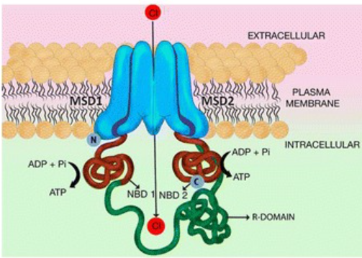

Figure 1.1 : The 2D representation of CFTR illustrates its structure.

CFTR (Cystic Fibrosis Transmembrane Conductance Regulator) channel is a protein channel found in epithelial cells of organs like the lungs and pancreas. It consists of transmembrane domains (TMDs) that form a chloride ion-conducting pore, nucleotide-binding domains (NBDs) that bind and hydrolyze ATP for channel gating, a regulatory domain (R domain) with phosphorylation sites controlling channel opening, and intracellular loops (CL1 and CL2) for stability (Bhagirath et al., 2016a).

*P. aeruginosa* exhibits remarkable adaptability due to its expansive genome, which contains nearly 6000 genes. This genome contains virulence factors, genes linked to a variety of metabolic pathways, transport mechanisms and chemotaxis, among other capabilities. The extraordinary adaptability of the bacterium is influenced by these genetic elements. Additionally, *P. aeruginosa* may coordinate its metabolic pathways and maximize its nutritional and reproductive capacity in accordance with the environmental factors and resources that are accessible. As a result, it may thrive and spread in a variety of environments while also causing illnesses (Sousa & Pereira, 2014c).

1.1.3 Antibiotic Resistance

Antibiotics are used to treat bacterial infections. Antibiotic resistance (AR) has been brought on by the inappropriate and excessive use of antibiotics in numerous bacterial species. Multidrug-resistant *P. aeruginosa* is a common bacterial species. The World Health Organization (WHO) has designated it as a "critical" pathogen, calling for urgent research and the development of new antibiotics (Botelho *et al.,* 2019).

Traditional antipseudomonal beta lactam antibiotics have frequently been utilized in the past as an initial treatment for *P. aeruginosa* that is widely or multidrug resistant. However, these conventional treatments frequently fail because *P. aeruginosa* can build resistance through a variety of ways. Combining a second antibiotic from a different class with the standard beta-lactam antibiotic increases the likelihood that empiric therapy will be effective. The risk of antibiotic toxicity and secondary infections like Chloridoids difficile may rise with this combination therapy. Recently, a number of new medications, including beta-lactam/beta-lactamase inhibitor combination, have shown in vitro activity against MDR. Antibiotics used to treat *P. aeruginosa* are listed in **Table 1.1** (Kunz Coyne *et al.,* 2022b).

Table 1.1 : List and chemical structures of antibiotics used to treat *P. aeruginosa*

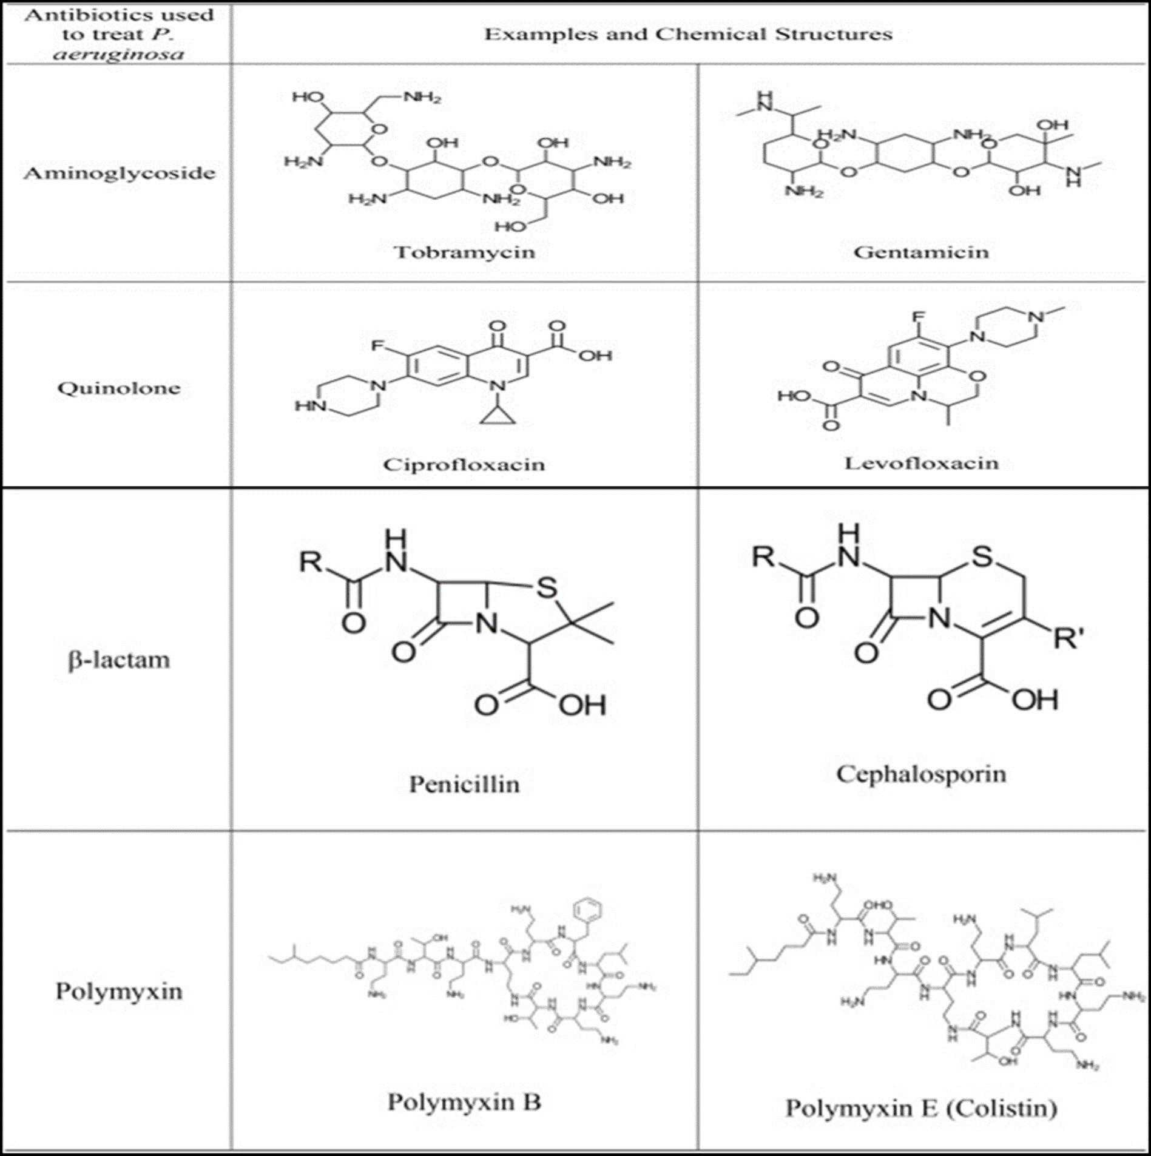

1.2 Significance of this study

The significance of this study lies in its efforts to tackle the substantial challenges posed by *P. aeruginosa* as a highly resistant pathogen. *P. aeruginosa* infections are associated with severe acute and chronic illnesses, leading to significant morbidity and mortality rates worldwide. Furthermore, the pathogen remarkable resistance to a wide range of antibiotics complicates treatment options and contributes to its prominence as a causative agent of hospital-acquired infections.

By investigating multiple virulence factors and employing *In-silico* screening and molecular docking techniques, this study identifies potential compounds that can effectively inhibit *P. aeruginosa* pathogenicity and colonization. The discovery of compounds as promising candidates offers new possibilities for developing targeted therapeutic interventions against *P. aeruginosa* infections mainly CF infections.

Moreover, the study focus on outer membrane proteins, pili flagella, secretion systems and other released products such as proteases represents critical areas in which *P. aeruginosa* exerts its resistance and pathogenicity. By targeting these virulence factors, the study opens avenues for developing novel treatment strategies that can address the multifactorial nature of *P. aeruginosa* infections and potentially overcome the challenges posed by antibiotic resistance.

The findings of this research have significant implications for both clinical practice and drug discovery. The identification of potential lead compounds and the understanding of their interactions with *P. aeruginosa* virulence proteins provide valuable insights for the development of new therapeutics. Additionally, the study emphasizes the importance of *in vitro* and *in vivo* validation studies, hit-to-lead optimization, and comprehensive pharmacokinetic and toxicity profiling to advance these potential candidates towards clinical applications.

Overall, this study contributes to our understanding of *P. aeruginosa* resistance mechanisms and virulence factors, while also offering promising candidates for further investigation. Ultimately, the outcomes of this research may pave the way for the development of more effective treatments to combat *P. aeruginosa* infections, addressing a critical need in healthcare and improving patient outcomes.

* 1. Statement of the problem

The colonization of *Pseudomonas aeruginosa* in the human respiratory tract leads to chronic lung infection, primarily in patients with cystic fibrosis (CF).

1.4 Purpose of the Study

The present *In-silico* study aims to explore the potential phytochemicals and drugs to inhibit binding and colonization of *P. aeruginosa* in human respiratory tract.

1.5 Objectives

1. To prepare library of phytochemicals.
2. To predict the potential binding of phytochemicals with host colonizing factors of *P. aeruginosa* and to explore the best inhibitor through molecular docking approaches.

# Literature Review

In the case of cystic fibrosis (CF) infections, *P. aeruginosa* has a global prevalence of about 100,000 cases. To bind with the extracellular matrix of the lungs, *P. aeruginosa* utilizes multiple receptors, including outer membrane proteins, pili, and flagella (Karaiskos & Giamarellou, 2014).

While *in-silico* work has been conducted on *P. aeruginosa*, it has primarily focused on other virulence factors. However, in this study, phytochemicals from previous study were used as controls. These phytochemicals served as a baseline for comparison in the study. The multidrug efflux system MexXY-OprM, which belongs to the resistance-nodulation-division family, emerged as a major determinant of aminoglycoside resistance in *Pseudomonas aeruginosa*. In an effort to identify potential efflux pump inhibitors among natural compounds, an alkaloid was found to be a putative inhibitor of MexXY-OprM. This alkaloid includes compounds such as Limonin, Oleanolic Acid, and tobramycin, which effectively inhibit the efflux pump and are widely used in the treatment of pulmonary infections (Laudadio *et al.,*2019).

Another study demonstrated that lanatoside C shows promise as an efflux pump inhibitor and can be effective in combination therapy against drug-resistant strains of *P. aeruginosa* *and E. coli.* (Aparna et al.,2014).This study showed a good correlation between *in-silico* screening and positive efflux inhibitory activity in vitro. It was also reported that a flavonoid present in the compound library used in the study has antimicrobial activity against *P. aeruginosa* (Rajarathinam *et al.,*2014).

In combating *P. aeruginosa*, silver nanoparticles have been used against the outer membrane proteins of the pathogen. The ligand docked deeply into the binding pockets of the outer membrane proteins (OMPs) of both *E. coli* and *P. aeruginosa*. The results demonstrated that silver may serve as a strong antibacterial agent against both pathogens, with a greater antibacterial action observed in the case of *P. aeruginosa* (Srivastava et al., 2019). The pathogenicity of *P. aeruginosa* is largely driven by the quorum sensing (QS) system. Previous studies have targeted LasA and LasB to inhibit *P. aeruginosa* progression (Ghosh *et al.,* 2022).

Following an assiduous study *P. aeruginosa* host colonizing factor against CF infection remained our validated target receptors. In this study, a thorough investigation of host colonizing factors was conducted, focusing on multiple virulence factors such as outer membrane proteins, pili, and flagella, which enable *P. aeruginosa* to bind to the extracellular matrix of the lungs and utilize effector-dependent pathogenicity by releasing various proteolytic enzymes to establish colonization.

Table 2.1 : Summary of *In-silico* work on *P. aeruginosa*

|  |  |  |
| --- | --- | --- |
| **Target** | **Title of research paper** | **Reference** |
| Multidrug efflux system MexXY | Natural Alkaloid Berberine Activity against *Pseudomonas aeruginosa* MexXY-Mediated Aminoglycoside Resistance: *In- silico* and in Vitro Studies | (Laudadio *et al,.*2019) |
| Alkaline phosphatase enzyme of *P. aeruginosa* | An *In-silico* structural, functional and phylogenetic analysis with three dimensional protein modelling of alkaline phosphatase enzyme of *Pseudomonas aeruginosa* | (Pramanik *et al.,*2016) |
| Antimicrobial peptide DP7 | A novel *In-silico* antimicrobial peptide DP7 combats MDR *Pseudomonas aeruginosa* and related biofilm infections | (Yin *et al.,*2020) |
| MexAB-OprM and AcrAB-TolC( tripartite efflux pump) compound (lanatoside C and daidzein) | Identification of Natural Compound Inhibitors for Multidrug Efflux Pumps of *Escherichia coli and Pseudomonas aeruginosa* Using *In-Silico* High-Throughput Virtual Screening and In Vitro Validation | (Aparna *et al.,*2014) |
| FabZ | Antibacterial activity of flavonoid isolated from Trianthema decandra against Pseudomonas aeruginosa and molecular docking study of FabZ | (Rajarathinam *et al.,*2018) |
| [Outer membrane proteins](https://www.sciencedirect.com/topics/medicine-and-dentistry/outer-membrane-protein) (OMPS) | Production, characterization and antibacterial activity of silver nanoparticles produced by Fusarium oxysporum and monitoring of protein-ligand interaction through *In-silico* approach | (Srivastava *et al.,*2019) |
| Bioactive Compounds from Honeyweed (Leonurus sibiricus) | Analysis of Antibiofilm Activities of Bioactive Compounds from Honeyweed (Leonurus sibiricus) Against *P. aeruginosa*: an In-Vitro and *In-Silico* Approach | (Ghosh *et al.,*2022) |
| LasR and RhlR | Anti-quorum sensing and anti-biofilm activity of 5-hydroxymethylfurfal against *Pseudomonas aeruginosa* PAO1: Insights from in vitro, in vivo and *In- silico* studies | (Rajkumari *et al.,*2022) |
| LasB [elastase](https://www.sciencedirect.com/topics/medicine-and-dentistry/elastase), [chitinase](https://www.sciencedirect.com/topics/medicine-and-dentistry/chitinase) | Mosloflavone attenuates the quorum sensing controlled virulence phenotypes and biofilm formation in Pseudomonas aeruginosa PAO1: In vitro, in vivo and *In-silico* approach | (Hnamte *et al.,*2019) |
| PqsR | *In-silico* Selection and Experimental Validation of FDA-Approved Drugs as Anti-quorum Sensing Agents | (Melanin *et al.,*2019) |
| ABC transporter and efflux pumps | An *In-silico* approach towards identification of virulence factors in red complex pathogens targeted by reserpine | (Ushanthika *et al.,*2019) |
| FabH | In Vitro and *In-Silico* Studies of Quinoline-2-Carbaldehyde Hydrazone Derivatives as Potent Antimicrobial Agents | (Celik *et al.,*2020) |
| Hypothetical Proteins of Pseudomonas aeruginosa | Targeting Essential Hypothetical Proteins of *Pseudomonas aeruginosa* PAO1 for Mining of Novel Therapeutics: An *In-silico* Approach | (Rahman *et al.*,2022) |

2.1 Emerging Therapies to Combat *P. aeruginosa* Infections

2.1.1 Therapeutics Targeting *P. aeruginosa* Virulence Factors

The pathogenesis of *P. aeruginosa* is attributed to a collection of virulence factors that are either associated with the bacterial cells or secreted by them. Consequently, the strategy of reducing *P. aeruginosa* virulence in vivo as a therapeutic approach is gaining momentum and is considered a logical and promising strategy(Jurado-Martín *et al.*, 2021a).

*P. aeruginosa* exhibits a wide array of virulence factors, both extracellular and cell-associated, that play a crucial role in its pathogenesis. These factors are regulated by highly intricate, providing *P. aeruginosa* with remarkable adaptability and flexibility.

2.1.1.1 T3SS (type III secretion system)

The T3SS (Type III Secretion System) is a vital *P. aeruginosa* virulence structure that express it during disease. Without the presence of T3SS, these strains become avirulent and are unable to cause disease (Goldufsky *et al*., 2015) (Warrener *et al*., 2014).

T3SS functions as a syringe-like "injectosomes" enabling the direct delivery of toxic effectors into the cytosol of host cells. The secretion apparatus, which is in charge of moving the effectors across bacterial membranes, and the translocation apparatus, which makes it possible for the effectors to move through the membrane of the host cell, are the two main parts of this complex system, which is made up of at least 20 proteins. (Jurado-Martín *et al*., 2021b).

While it is not necessary for infection, the presence of T3SS (Type III Secretion System) impacts to severity of disease. T3SS empowers *P. aeruginosa* to induce damage to the epithelial cells, spread throughout the bloodstream, and evade the host's innate immune responses, either through mechanisms that do not rely on effector proteins or by utilizing effector proteins (Anantharajah *et al*., 2016).

2.1.1.1.1 ExoU, ExoY and ExoT

ExoU is considered the primary cytotoxin of T3SS, as it exerts the most significant influence on the severity of the disease, being linked to severe sepsis, acute lung injury and mortality (Shaver & Hauser, 2004) (de Lima *et al*., 2012). More than 89% of *P. aeruginosa* isolates express ExoY, the second most common exotoxin (Javanmardi *et* *al*., 2019). It works as a soluble adenylate cyclase that raises intracellular concentrations of different cyclic nucleotides after being injected into mammalian cells. This causes protein kinases to become active (He *et al.,* 2017). ExoT is a dual-function exotoxin that inhibits phagocytosis and compromises epithelial barriers by simultaneously acting as a GTPase activating protein (GAP) and an adenosine diphosphate ribosyl transferase (ADPRT) (Hauser, 2009)

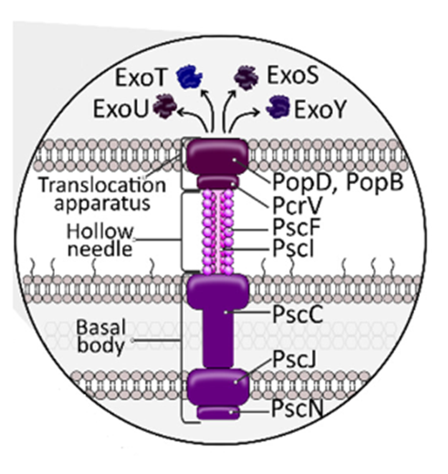

Figure 2.1 : The type III secretion system (T3SS) and its four main effectors (Jurado-Martín *et al*., 2021).

2.1.1.2 Other Released Products

2.1.1.2.1 Proteolytic Enzymes

During acute infections, *Pseudomonas aeruginosa* secretes various extracellular proteases that play a crucial role in invasion. These include LasB elastases, LasA, alkaline protease (AprA), and type IV protease (PIV).

2.1.1.2.2 LasA and LasB elastases and Alkaline protease (AprA)

Elastases including LasA and LasB are produced by *P. aeruginosa* through the Type II Secretion System, which is regulated by QS (Quorum Sensing) systems (Strateva & Mitov 2011a). These elastases are responsible for degrading host elastin. Among them, LasB elastase, also known as "elastase" or "pseudolysin," is the highly available protease and it also considered as the important virulence factor present extracellularly. Furthermore, LasB elastase affects biofilm formation (Yu *et al.,* 2014). On the other hand, the *lasA* gene produces the serine protease known as LasA, also called staphylolysin. Although LasA elastinolytic activity is restricted, by cleaving the glycine-glycine links in elastin, it can improve the activity of other proteases, such as LasB (Strateva & Mitov, 2011b). Antibiotic resistance has recently been linked to LasA expression in clinical isolates of *P. aeruginosa*. (Yang *et al*., 2017). Alkaline protease, is a zinc-dependent metalloendopeptidase that is produced by the *aprA* gene and secreted by the T1SS (Type I Secretion System) (Gellatly & Hancock, 2013b). Fibronectin and laminin, two elements of the endothelium, are its main targets (Iiyama *et al*., 2017).

2.1.1.2.3 Type IV protease (PIV)

The Type IV protease is a serine protease that is secreted by the T2SS (Type II Secretion System) and is a member of the chymotrypsin family S1 (Conibear *et al*., 2012). Its expression is controlled by the Las QS (Quorum Sensing) system and is encoded by the *PIV* gene. Although it is largely important for corneal virulence, *P. aeruginosa* pathogenesis in the cystic fibrosis (CF) lung also depends on it (Park *et al.,* 2014). In doing so, it causes tissue invasion and injury by degrading fibrinogen and surfactant proteins (SP-A, SP-D, and SP-B) (Smith *et al*., 2006).

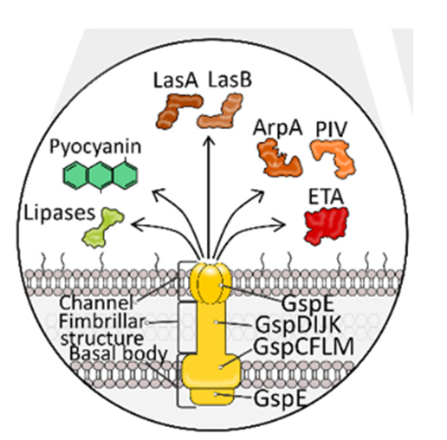

Figure 2.2 : The type II secretion system (T2SS) of *P. aeruginosa*.

It releases compounds to the extracellular matrix: lytic enzymes (lipases, proteases (AprA and PIV) and elastases (LasA and LasB)), exotoxin A (ETA), and pyocyanin ( Jurado-Martín *et al.,* 2021)

2.1.1.3 Flagella

*P. aeruginosa* possesses a solitary flagellum located at one end of the bacterium (Haiko & Westerlund-Wikström, 2013a). Although *P. aeruginosa* is capable of swarming on solid surfaces, its flagellum primarily enables motion in water. The flagellum achieves this generating a propelling force that pushes the bacterium forward. This swimming motility, facilitated by the flagellum, have important role in *P. aeruginosa* initial binding with airway epithelia individuals with CF, as bacterium utilizes chemotaxis to direct its flagella-driven movement concerning these cells. Thus, the flagellum is believed a significant virulence factor (Sampedro *et al.,* 2014)(Schwarzer *et al.,* 2016).

2.1.1.3.1 FliC and FliD proteins

This flagellum is composed of a filament, which is made up of flagellin (FliC) proteins that are arranged in a helical structure. Additionally, the flagellum consists of specific cap protein (FliD). In addition to its role in motility, the FliC protein of *P.aeruginosa* is responsible for binding to various molecules (Ketko *et al*., 2013). FliC can also bind to the surfactant protein SP-A, while the FliD protein mediates adhesion to human respiratory MUC1 mucin (Haiko & Westerlund-Wikström, 2013b).

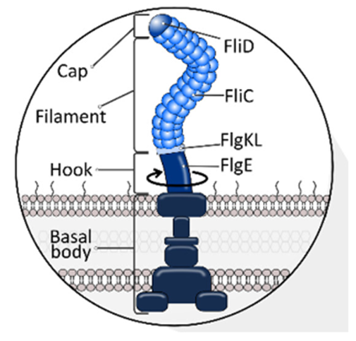

Figure 2.3 : Structure of flagella of *P. aeruginosa*. Flagellins FliC and FliD incorporated within the flagellar structure (Jurado-Martín *et al*., 2021)

2.1.1.4 Type IV Pili

The classification of T4P (type IV pili) into five groups (I, II, III, IV, and V) corresponds to the distinct patterns of biofilm development and multidrug resistance (MDR) that each group exhibits (Jacobsen *et al*., 2020). Pili promote adhesion and motility, acting as crucial structures for starting infections. They regulate twitching motility, which facilitates quick colonization of various surfaces. The force needed to move the cell forward is produced by a sequence of sequential actions including the extension, adhesion, and retraction of T4P fibers (Burrows, 2012a). T4P play a crucial role in biofilm development, aggregation, and the formation of mushroom-like cap structures within biofilms because of their sticky and motility capabilities. Additionally, the pilus tip has the ability to bind DNA, which probably facilitates natural metamorphosis and the development of biofilms (Lindestam Arlehamn & Evans, 2011).

2.1.1.4.1 PilA, PilB, PilY and PilT Proteins

Two ATPases (PilB and PilT) connected to the cytoplasmic membrane control the extension and retraction of pili. At the pili base, PilB polymerizes PilA subunits while PilT depolymerizes them (Burrows, 2012b). The host receptor found on the surface of epithelial cells is specifically recognized by the minor tip pilin PilY1. Along with other minor pilins, PilY1 is also in charge of the production and stability of T4P and is regarded as a mechanosensor for *P. aeruginosa* attachment-induced pathogenicity. Additionally, pili may interact with glycolipids like asialo-GM1 and asialo-GM2 via the C-terminal region of pilin A, which is mediated by the tip (Heiniger *et al*., 2010).

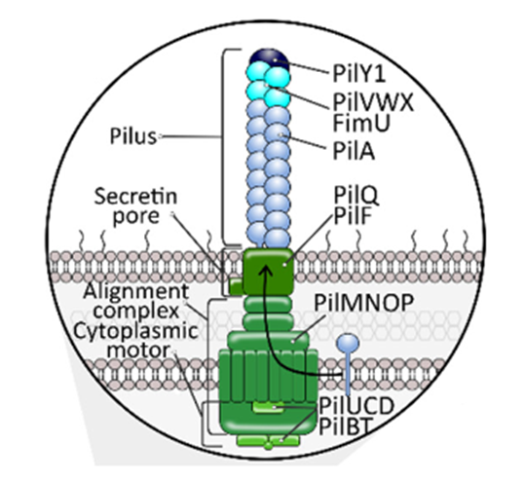

Figure 2.4 : Structure of Type 4 pili of *P. aeruginosa* (Jurado-Martín *et al*., 2021)

2.1.1.5 Outer Membrane proteins

*Pseudomonas aeruginosa* outer membrane (OM) exhibits an asymmetric bilayer structure, serving as a protective barrier against harmful substances. It consists of a lipopolysaccharide (LPS) outer layer and phospholipid inner layer. The LPS layer, containing approximately 300 embedded proteins known as outer membrane proteins (OMPs), fulfills various functional roles (Montor *et al*., 2009).

2.1.1.5.1 Porins: OprF, OprH, and OprD Superfamily

Although many of these proteins have numerous functions, *P. aeruginosa* expresses 26 distinct beta-barrel channel proteins that enable the exchange of different chemicals (Chevalier *et al.,* 2017a). The most prevalent non-lipoprotein outer membrane protein (OMP) of the OmpA family among these proteins is the main porin OprF. *P. aeruginosa* virulence and integrity depend on OprF. It can take on both open and closed conformations, although over 95% of the OprF population prefers the closed form, which helps explain the extraordinarily low permeability of the outer membrane. Under low osmolarity conditions, OprF helps to maintain the integrity of the outer membrane and cell shape (Mishra *et al.,* 2015).

Mutants missing OprF display diminished capacities for cell attachment and the production of virulence factors such pyocyanin (PYC) and elastase (LasB). Although mixed results have been found, OprF is particularly abundant on the outer membrane of sessile cells, suggesting that it may have an impact on the formation of biofilms (Song *et al.,* 2018). Additionally, OprF influences the type III secretion system (T3SS) and its effectors during both the extracellular and intracellular phases of the macrophage life cycle (Pang *et al*., 2019b).

One of the smallest porins in the bacterium, OprH is a member of the OmpW family and is found in *P. aeruginosa*. During respiratory tract infections, it has been seen to bind to laminin and surfactant protein A (SP-A). It is assumed that through interacting with lipopolysaccharides (LPS), it helps to maintain the integrity of the outer membrane (Qadi *et al.,* 2016). Additionally, it is thought that OprH participates in the conformational modifications necessary for the transport of tiny amino acids and hydrophobic compounds. Its job involves making it easier for these molecules to cross the outer membrane (Kucharska *et al*., 2016).

There are 19 members of the OprD (Occ) superfamily, and while they have a high similarities, their substrate specificities vary (Garai *et al*., 2019). These individuals are further separated into two subfamilies, OccD and OccK, which are both engaged in the uptake of negatively charged cyclic compounds and basic amino acids, respectively. OprD (OccD1), the second most important porin protein and a key player in the transport of carbapenem antibiotics, basic amino acids, peptides, and perhaps gluconate among these members. It has protease activity and is widely distributed in outer membrane vesicles (OMVs) generated from biofilm samples. OprD has a binding affinity for laminin that is comparable to OprG (Chevalier *et al.*, 2017c).

2.1.1.5.2 OprQ, OprG proteins and EstA autotransporter

Human fibronectin (Fn) is bound by OprQ, an outer membrane protein of *P. aeruginosa* and a member of the OprD superfamily. While research comparing wild-type and mutant *P. aeruginosa* strains have demonstrated that *oprQ* gene inactivation does not slow the growth rate, several OprD subfamily members are known to be necessary for nutrient uptake. OprQ is not directly involved in food intake, yet its absence regularly causes *P. aeruginosa* to take longer to double in size (Arhin & Boucher, 2010).

It has been determined that the third-highest affinity laminin receptor is OprG, a major porin in *P. aeruginosa*. The outer membrane-derived loops of this protein, a tiny beta-barrel shaped molecule, protrude externally. Fe2+ ion acquisition is its main purpose. OprG is a member of the OmpW-family of membrane proteins, which are widely distributed among different Gram-negative bacterial species. In one of the research, OmpW-family member attaches to the extracellular matrix (ECM), despite OmpW recently being connected to adhesion to respiratory epithelial cells (Paulsson *et al*., 2019a).

EstA, which belongs to the class of autotransporters, has been discovered to be an excreted catalytic enzyme that is essential to *P. aeruginosa* pathogenicity in a rat model of chronic respiratory infection. Notably, EstA binds to laminin with the greatest affinity. EstA is expected to be located on the outer membrane with its N-terminal region exposed, according to its signal peptide. However, EstA has been found in *P. aeruginosa* periplasm and outer membrane vesicles (OMVs) (Paulsson *et al*., 2019b).

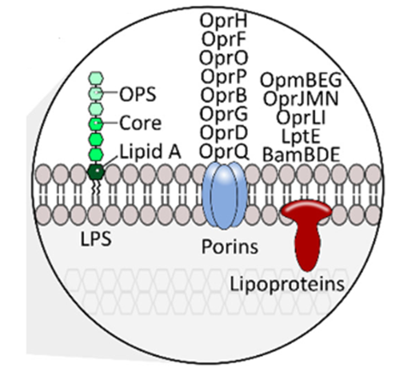

Figure 2.5 : Lipopolysaccharide (LPS) and Outer membrane proteins (OMPs) of *P.* *aeruginosa* (Jurado-Martín *et al.,* 2021)

# Methodology

3.1 Structure based Drug design approach: Accession of target  
proteins

The 3D structures *Pseudomonas aeruginosa* target proteins associated with virulence in the respiratory tract was retrieved from RCSB Protein Data Bank (PDB) website, available at <http://www.rcsb.org/pdb> (Berman, 2000) and AlphaFold protein structure database available at <https://alphafold.ebi.ac.uk/> (Jumper *et al*., 2021).

Table 3.1 : List of target proteins and their accession numbers

|  |  |  |  |
| --- | --- | --- | --- |
| **Sr No.** | **Target proteins** | **Accession number** | **Databases** |
| **1.** | **OprF** | 5U1H |  |
| **2.** | **OprD** | 3SY7 |  |
| **3.** | **OprG** | 2X27 |  |
| **4.** | **EstA** | 3KVN |  |
| **5.** | **PilT** | 3JVV |  |
| **6.** | **FliD** | 5FHY | **Protein Data Bank** |
| **7.** | **ExoT** | 6GNN |  |
| **8.** | **ExoY** | 5XNW |  |
| **9.** | **LasA** | 3IT5 |  |
| **10.** | **LasB** | 1EZM |  |
| **11.** | **AprA** | 1KAP |  |
| **12.** | **OprH** | AF-G3XD11-F1 |  |
| **13.** | **OprQ** | AF-Q9I083-F1 |  |
| **14.** | **PilA** | AF-P04739-F1 |  |
| **15.** | **PilB** | AF-P22608-F1 | **AlphaFold Database** |
| **16.** | **PilY** | AF-Q9HVM8-F1 |  |
| **17.** | **FliC** | AF-P21184-F1 |  |
| **18.** | **Protease IV** | AF-A0A5K1S6V9-F1 |  |
| **19.** | **ExoU** | AF- A0A2N7Z8Z2-F1 |  |

3.1.1 Modelling target proteins repair pathway

After downloading protein structure from protein databank, next step was to repair missing residues of protein structures.

Missing residues of protein structures was repaired by using onlineProtein Repair and Analysis Server (PRAS) available at <https://www.protein-science.com/>(Nnyigide *et al*., 2022). The main function of the Protein Repair and Analysis Server (PRAS) is to provide a user-friendly web-based platform for repairing and analysing proteins. The PRAS generates output files, analysis reports, and visualizations, allowing to explore the repaired protein structure and access valuable insights into protein properties and interactions.

3.1.2 Prediction of target active sites

The active binding sites of the target protein were analysed by examining the coordinates of the ligand within the original protein grids (Srivastava *et al*., 2019). The active site of the proteins were analysed by using literature search and also online web based server COACH server <https://zhanggroup.org/COACH/> (Yang *et al*., 2013). The COACH server used for protein-ligand site prediction, offering valuable insights into potential binding sites on target proteins. Protein structures were submitted to the server, and it employs computational algorithms and machine learning techniques to analyse the protein surface and predict regions that are likely to interact with ligands. Following Table 4.1 demonstrate the active site residues of each target protein.

3.2 Ligands selection

Downloaded the library of natural product from LOTUS database available at <https://lotus.naturalproducts.net/download> (Rutz *et al*., 2022). Total library of 276,518 compounds were downloaded from LOTUS database in SMILES format.

3.2.1 Ligands pharmacokinetics properties prediction

ADMET properties of ligands were predicted by using HelixADMET (H-ADMET)available at <https://paddlehelix.baidu.com/app/drug/admet/train> (Zhang *et al*., 2022). The library of 276,518 compounds underwent a comprehensive process where they were uploaded and subjected to an evaluation of their drug-likeness profile. This evaluation involved the application of various filters and criteria to assess the compound suitability as potential drugs.

ADMET stands for Absorption, Distribution, Metabolism, Excretion, and Toxicity. These are essential properties to consider when evaluating the potential of a compound as a drug candidate. Here are the full forms and a brief explanation of their importance:

* MV (Molecular Weight): This rule suggests that the molecular weight of a drug candidate should be less than 500. This criterion is important because compounds with a higher molecular weight may have difficulties crossing cell membranes and reaching their target sites. Smaller molecular weight is often associated with better drug-like properties.
* Log P (Partition Coefficient): Log P measures the lipophilicity of a compound, which reflects its ability to dissolve in lipids or oils. A Log P value of <= 5 indicates moderate lipophilicity, which is optimal for drug absorption and distribution in the body. Compounds with appropriate lipophilicity are more likely to have good bioavailability.
* HBA (Hydrogen Bond Acceptors): This parameter counts the number of hydrogen bond acceptor sites in a molecule. A lower HBA value (<= 10) is desirable because it indicates a lower number of functional groups capable of accepting hydrogen bonds. This can improve oral bioavailability and reduce the risk of unwanted interactions with biological targets.
* HBD (Hydrogen Bond Donors): HBD measures the number of hydrogen bond donor sites in a molecule. A HBD value of <= 5 suggests a lower number of functional groups capable of donating hydrogen bonds. Similar to HBA, a lower HBD value is desirable to improve drug-like properties.
* Acute Oral Toxicity on Rodent: This parameter assesses the toxicity of a compound when administered orally to rodents. A value closer to 0 indicates lower toxicity, making it safer for potential human use. It is crucial to identify compounds with low toxicity to avoid harmful effects on patients.
* Acute Oral Toxicity on Human: Similar to acute oral toxicity on rodents, this parameter evaluates the potential toxicity when administered orally to humans. A value of <= 0.3 indicates low toxicity, which is essential for drug safety during clinical development.
* Carcinogenicity: This parameter measures the likelihood of a compound causing cancer. A value of <= 0.3 suggests a lower probability of being carcinogenic, which is crucial to avoid long-term adverse effects on patients.
* Ames Mutagenicity: The Ames test assesses the mutagenic potential of a compound. A value of <= 0.3 indicates a lower likelihood of causing mutations, which is critical to minimize the risk of genetic damage.
* Synthetic Accessibility: This score reflects the ease of synthesizing a compound. A score of <= 5 suggests that the compound is relatively easy to synthesize, which is vital for cost-effective and scalable production during drug development.
* Water Solubility (logS): This parameter measures the ability of a compound to dissolve in water. A logS value greater than -6 indicates good water solubility, which is essential for drug absorption, distribution, and bioavailability.

By considering these ADMET properties helps to identify potential drug candidates that have a higher probability of being effective and safe during the drug development process. It increases the chances of success in finding viable pharmaceutical agents.

3.2.2 Accessed structures of selected ligands

Selected ligands structure were downloaded by using SMILIES format PubChem database available <https://pubchem.ncbi.nlm.nih.gov/> (Kim *et al.,* 2016). All the structures were downloaded in SDF formatand also in3D conformer**.** In an effort to gain deeper insights into ligand-based research, a meticulous process was undertaken to selectively download and acquire ligand structures from the vast PubChem database. By utilizing the SMILES format, the chosen ligands were precisely targeted and captured, while preserving their structural information in the widely recognized SDF (Structure-Data File) format. Additionally, to enhance analysis and exploration, 3D conformers were downloaded, offering valuable insights into the ligands spatial arrangement and potential interactions within biological systems.

3.2.3 Preparation of ligands

Ligand structures files were prepared for subsequent docking by using Open babel GUI softwareavailable at<https://openbabel.org/wiki/Main_Page> (Melville & Hirst, 2007). In order to optimize molecular docking investigations, a pivotal pre-docking phase involved the utilization of the Open Babel GUI software. This comprehensive preparation encompassed two key steps. Firstly, hydrogen atoms were added to the ligand structures, ensuring the incorporation of all essential atomic constituents for accurate docking calculations. Furthermore, the ligand structures were converted from the SDF (Structure-Data File) format to the PDBQT (Protein Data Bank-Partial Charge-Quick Prep) format as it is required format of Autodock Vina.

3.3 Target protein preparation

Before docking the ligand into the active site of the protein, preparatory step was performed in MGL Tools <https://ccsb.scripps.edu/mgltools/downloads/> (Sanner, 1999) that involved the removal of all water molecules and hetero atoms. These exclusions were necessary to focus specifically on the interaction between the ligand and the protein. Additionally, hydrogen atoms Kollman charges were added to the protein structure. Grid boxes for each protein were set according to the predicted active site residues. This was done to ensure that the correct ionization and tautomeric states of the amino acid residues were defined accurately. Furthermore, additional chains of protein having no ligand binding site were removed. These adjustments were essential to provide a more accurate representation of the protein active site and to enable a reliable docking process for studying ligand-protein interactions.

3.4 Molecular docking virtual screening

In order to gain insights into the protein target specificity and uncover the underlying structural basis, a computational ligand-target docking approach was employed, by using Autodock Vina <https://vina.scripps.edu/downloads/> (Trott & Olson, 2009). This approach involved the analysis of structural complexes formed between the target protein and various ligands. The detailed procedure of running Autodock Vina is discussed in Appendix II.

3.4 Analysis of docking parameters

The analysis of hydrogen bonding interactions and pi-pi bonding potentials between ligand molecules and specific amino acids on bacterial surface proteins were conducted using the BIOVIA Discovery Studio Visualizer <https://discover.3ds.com/discovery-studio-visualizer-download> (Sharma *et al.,* 2019).This analysis aimed to identify key amino acids involved in the ligand binding site and understood their role in ligand recognition and binding. The selection of top hit compounds was based on a comprehensive evaluation of factors such as affinity scores, hydrogen bond count, and bond distance. By considering these parameters, we were prioritize the ligands that exhibit strong binding affinity, form favourable hydrogen bonding interactions, and maintain optimal bond distances with the target amino acids. This approach enabled the identification of potential hit compounds that hold promise for further development as effective therapeutics or modulators targeting bacterial virulence proteins.

Table 3.2 : List of file formats and their purposes

|  |  |  |  |
| --- | --- | --- | --- |
| Sr. No | File Format | Full Forms | Purpose |
| 1. | PDB | Protein Data Bank | Store structural information about biological macromolecules, mainly proteins and nucleic acids |
| 2. | PDBQT | Protein data bank partial charge(Q),and Atom Type(T) | Automated continuous docking of large ligand databases |
| 3. | SMILES | Simplified Molecular Input Line Entry System | Storing and exchanging molecular structures in a concise and human-readable form |
| 4. | SDF | Structure-Data File | Store chemical structure information and associated data |
| 5. | DSV file | Delimiter-Separated Values | Store structured data and data analysis. |

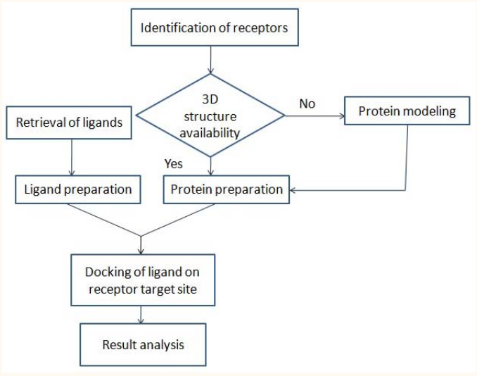

ADMET prediction

Figure 7 : Basic steps of molecular docking methodology.

# Results and Discussion

4.1 Evaluating structures of proteins for structure-based drug design

Once a target protein is identified, obtaining accurate structural information becomes essential. In this study, the structures of 19 selected proteins were thoroughly analysed. These proteins play a significant role in the virulence and progression of *Pseudomonas aeruginosa*. Crystal structures, which are widely used as a primary source of structural information for drug design, were primarily considered. However, for certain proteins, NMR (Nuclear Magnetic Resonance) spectroscopy-based structures were downloaded and utilized (Berman, 2000).

4.2 Analysis of target active site

The analysis of the active binding sites of the target protein involved a detailed examination of the ligand positioning within the original protein grids. For drugs or inhibitors to effectively bind to a target protein, it is crucial to target the biologically active site accurately. However, due to limited experimental data, identifying the precise active binding sites for novel protein targets can be challenging.

To overcome this challenge, computational prediction methods were employed in this study. The active sites of the 19 selected virulence proteins were primarily predicted based on existing literature. For proteins whose active sites were not reported in the literature, the COACH server was utilized for predictive analysis.

By leveraging literature data and computational predictions, the study generated a Table4.1 that outlines the predicted active sites of the proteins. This comprehensive approach provided valuable insights into the potential binding sites of the virulence proteins, aiding in the understanding of their functional roles and facilitating the design of targeted drug molecules (Yang *et al.,* 2013).

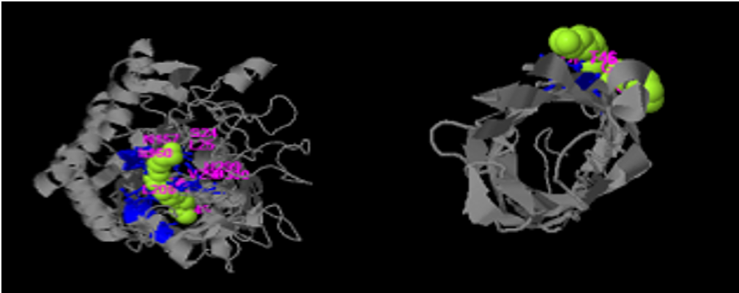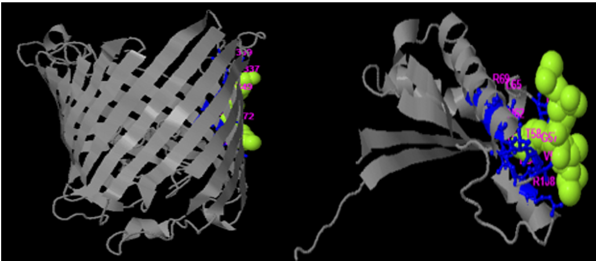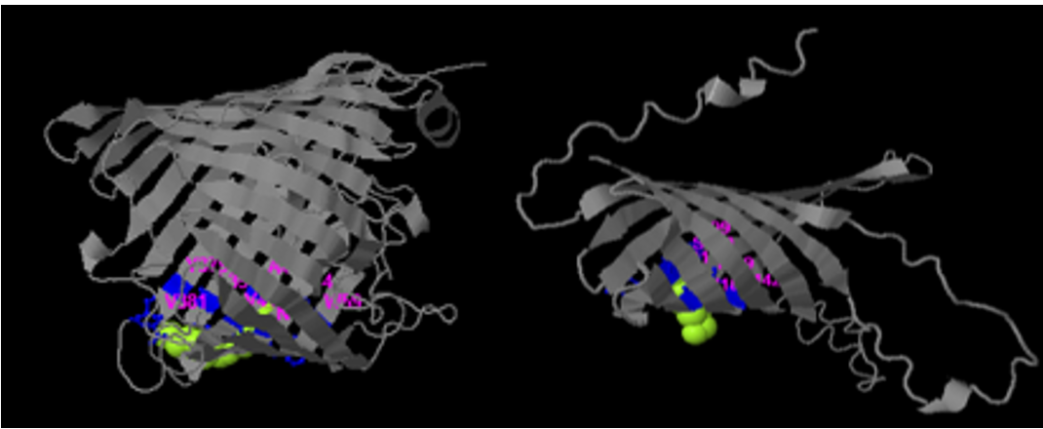

(a)

(b)

(f)

(e)

(d)

(c)

Figure 4.1 : Active sites of membrane proteins of *P. aeruginosa*.

(a) autotransporter EstA (b) OprG (c) OprD (d) OprF (e) OprQ and (f) OprH . The representation utilizes a color-coded scheme to enhance clarity, with ligands (molecules that bind to the protein) depicted as green clusters, the protein structures displayed as grey ribbon shapes, and critical amino acid residues shown in pink within the active site.

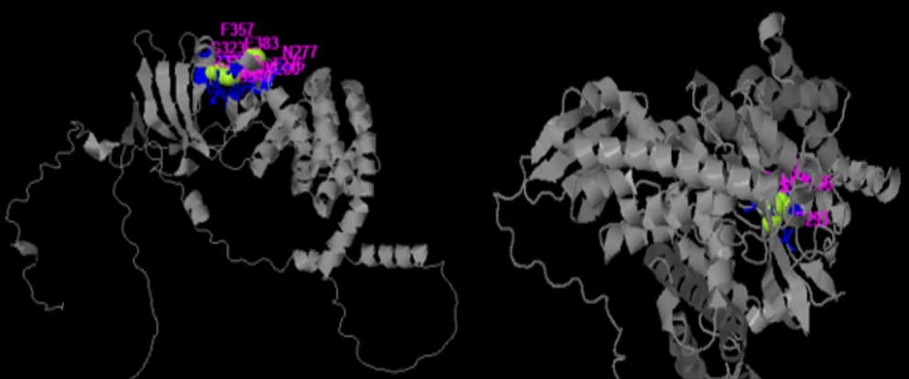

(a)

(b)

(c)

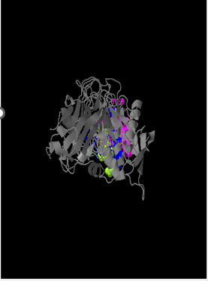

(d)

Figure 4.2 : Active sites of type I and III secretion system of *P. aeruginosa*.

(a)ExoT (b) ExoU (c) ExoY proteins and (d) Alkaline protease AprA. The representation utilizes a color-coded scheme to enhance clarity, with ligands (molecules that bind to the protein) depicted as green clusters, the protein structures displayed as grey ribbon shapes, and critical amino acid residues shown in pink within the active site.

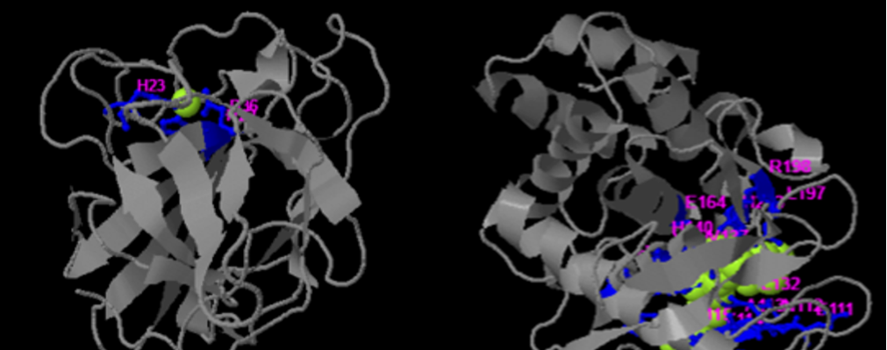

(a)

(c)

(b)

Figure 4.3 : Active sites of type II secretion system of *P. aeruginosa*.

(a) LasA (b) LasB and (c) Protease IV proteins. The representation utilizes a color-coded scheme to enhance clarity, with ligands (molecules that bind to the protein) depicted as green clusters, the protein structures displayed as grey ribbon shapes, and critical amino acid residues shown in pink within the active site.

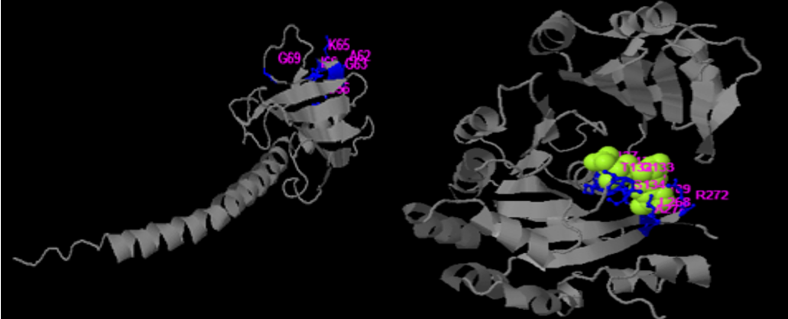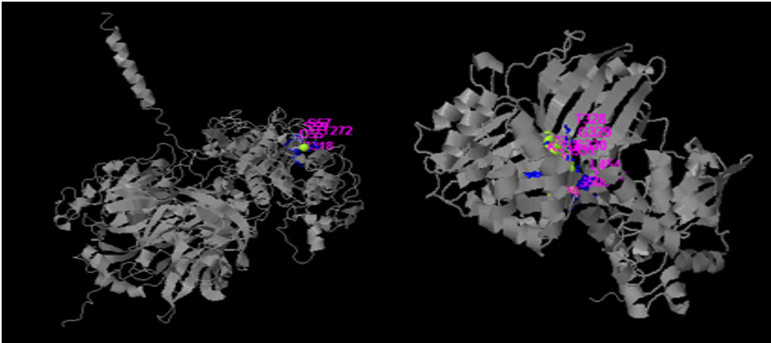

(a)

(d)

(c)

(b)

Figure 4.4 : Active sites of type IV pili proteins of *P. aeruginosa*.

(a)PilA (b)PilT (c)PilY and (d) PilB proteins. The representation utilizes a color-coded scheme to enhance clarity, with ligands (molecules that bind to the protein) depicted as green clusters, the protein structures displayed as grey ribbon shapes, and critical amino acid residues shown in pink within the active site.

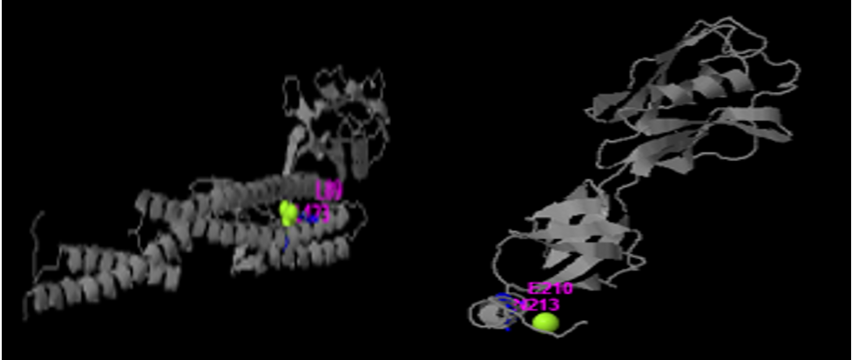

(a)

(b)

Figure 4.5 : Active sites of flagella proteins of *P. aeruginosa*.

FliC and (b) FliD proteins. The representation utilizes a color-coded scheme to enhance clarity, with ligands (molecules that bind to the protein) depicted as green clusters, the protein structures displayed as grey ribbon shapes, and critical amino acid residues shown in pink within the active site.

Table 4.1 : List of protein names and their active site residues

|  |  |  |
| --- | --- | --- |
| Sr. No | Proteins | Active Site Residues |
| 1. | EstA | PRO24, ALA25, ASN156, ASP157, ALA160, GLY198, PRO200, ASN242, PHE246, ILE298, ALA299, ASP300 |
| 2. | OprG | GLY14, GLY15, PHE16, THR46, VAL201 |
| 3. | OprD | ASN25, TYR27, PHE36, ARG337, ILE339, MET349, LEU372, ALA374 |
| 4. | OprH | GLY99, SER100, TYR101, ALA118, THR119, ALA142 |
| 5. | OprQ | ASN42, THR44, TRP59, GLN379, VAL381, LEU391, ALA416, VAL418 |
| 6. | OprF | SER19, LYS20, VAL53, GLY54, ASP56, ALA57, TYR58, LEU62, ARG65, ALA69, ASN108, GLU112 |
| 7. | PilA | SER56, ALA62, GLY63, LYS65, ILE66, GLY69 |
| 8. | PilB | LEU301, THR328, GLY329, SER330, GLY331, LYS332, THR33, VAL334, LEU454, ARG504, GLY506 |
| 9. | PilT | ARG82, LEU109, THR132, GLY133, SER134, GLY135, LYS136, SER137, THR138, LEU268, LYS272, ARG274 |
| 10. | PilY | ASP55, SER57, SER59, THR272, ASP318 |
| 11. | FliC | LEU89, LEU123 |
| 12. | FliD | ASP210, THR213 |
| 13. | ExoU | GLY61, GLY62, GLY63, SER92, VAL93, THR266, ASP293, VAL389 |
| 14. | ExoT | GLN276, LEU277, LEU280, ARG322, ASP323, ASN346, LEU347, THR348, LEU357, TRP383, TRP385 |
| 15. | ExoY | GLN56, ARG187, SER189, GLN224 |
| 16. | LasA | HIS23, ASP36, HIS122 |
| 17. | LasB | GLU111, ASN112, ALA113, TYR114, TRP115, LEU132, VAL137, HIS140, GLU141, HIS144, THR155, GLU164, LEU197, ARG198, HIS223 |
| 18. | AprA | VAL76, ILE79, GLY133, ALA134, ALA135, PHE136, ALA137, PHE138, LEU139, HIS169, HIS176, GLU177, HIS180, HIS186, ASN191, ALA192, ARG209, TYR216, TRP217 |
| 19. | Protease IV | HIS283, SER409, TYR429, GLY430, GLY431 |

4.3 Screening of LOTUS library

In this study, a thorough screening of the LOTUS database was conducted to identify antibacterial compounds against *P. aeruginosa* that adhere to Lipinski's rule of five (RO5) for drug-likeness. The research focused on employing a structure-based drug design approach for *Pseudomonas aeruginosa* virulence proteins. Initially, a vast library of 276,518 compounds consisting of natural products was screened.

To ensure drug-likeness, the library was evaluated based on several filters outlined in the methodology. After applying Lipinski's rules, 184,798 compounds remained. Further refinement was carried out by applying other drug-likeness filters. These filters included restrictions on parameters such as acute oral toxicity on rodents and humans ≤ 0.3 (considered favorable), carcinogenicity ≤ 0.3, Ames mutagenicity ≤ 0.3, synthetic accessibility (selecting compounds with a score ≤ 5), and water solubility (logS) > -6.

Following the application of these filters, 444 compounds were selected as potential candidates for further investigation shown in Figure 13. High-throughput virtual screening was then performed using a molecular docking approach to assess the antibacterial activity of these selected compounds.

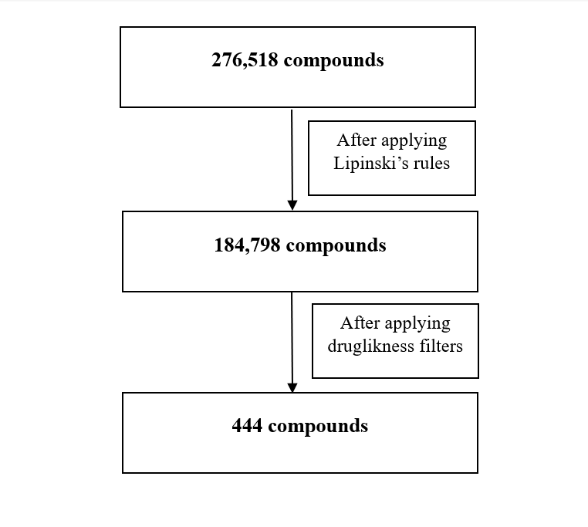

Figure 4.6 : Evaluation of LOTUS library

4.4 Molecular docking analyses of screened compounds against *P. aeruginosa*

Computer-aided drug design studies employ various techniques, and among them, docking strategy emerges as a crucial method with numerous applications. It plays a pivotal role in predicting the binding mode between a ligand and its target, prioritizing a library of compounds based on docking scores, and establishing a correlation between these scores and potential activity. Furthermore, docking proves valuable in understanding the impact of specific amino acid mutations on ligand activity profiles. Additionally, visualizing the interaction images generated by docking software provides valuable insights and guidance for optimizing existing ligands to enhance their affinity (Trott & Olson, 2009).

In this particular study, employed docking to rank 444 compounds selected from a pharmacokinetic search. The objective was not only to predict the plausible binding mode between these compounds and their target but also to identify the most promising leads.

The results obtained from AutoDock Vina revealed that 119 compounds bound with protein EstA, 12 compounds bound with OprG protein, 49 compounds bound with OprD, 9 compounds bound with OprF, 85 compounds bound with ExoT, 59 compounds bound with LasA, 22 compounds bound with LasB, 45 compounds bound with AprA, 19 compounds bound with OprH, 34 compounds bound with OprQ, 99 compounds bound with PIV, 4 compounds bound with PilA, 30 compounds bound with PilB, 93 compounds bound with PilY, 14 compounds bound with FliC, 27 compounds bound with PilT, 4 compounds bound with FliD, 144 compounds bound with ExoU, 12 compounds bound with ExoY, their names and energies are shown in Appendix IV.

So the protein ExoU bound with the highest number of compounds. These four compounds, Betulinic acid, Rosadiene, Resveratrol, and Stigmasterol (306, 350, 372, and 371), chemical structures of these compounds shown in Figure 14, outperformed the others in terms of docking score, as shown in Appendix IV. These four compounds exhibited docking scores ranging from −8.7 to −7, indicating strong interactions with multiple proteins shown in Appendix IV. Additionally, they demonstrated more than two conventional hydrogen bonds, highlighting their favorable binding characteristics. These 4 compounds also fulfilled the criteria of drug likeness properties, as shown in Table 4.2.

Based on these findings, the four compounds were selected for further analysis due to their superior docking scores, strong binding affinity, and noteworthy interaction patterns. This in-depth analysis would provide valuable insights into their potential as drug candidates and table 4.3 shows the comparison of previously reported ligands and ligand use in this study to guide the optimization of existing ligands to develop compounds with enhanced affinity and therapeutic efficacy(Laudadio *et al*., 2019).

* **Threshold: -6.6 to -8.7 (in our study)**

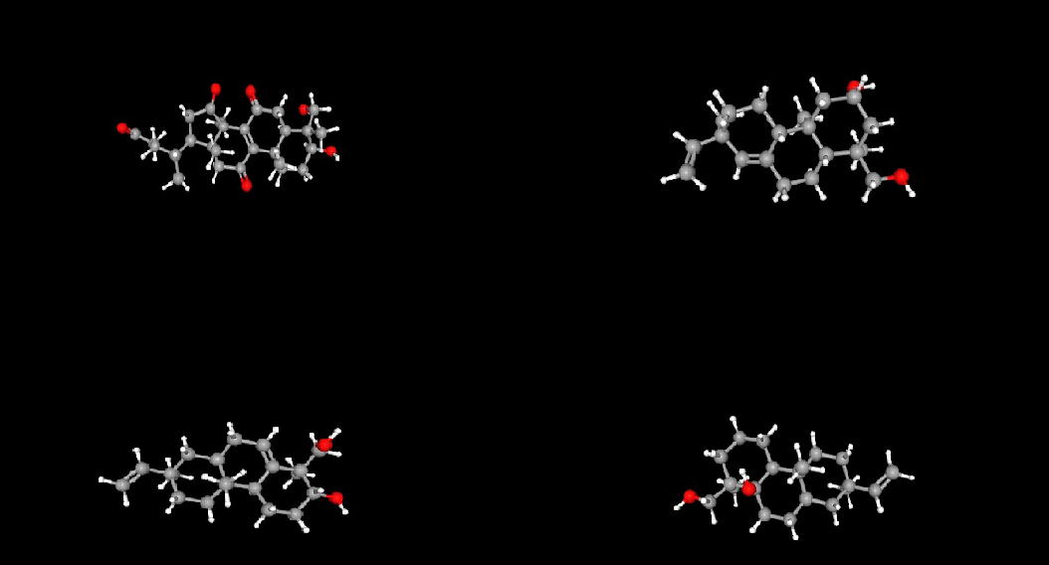

Figure 4.7 : Chemical structures (3D structure) of four promising compounds displaying strong binding affinity against *Pseudomonas aeruginosa* virulence proteins

Table 4.2 : ADMET analysis of potential compounds

|  |  |  |  |  |
| --- | --- | --- | --- | --- |
| Parameters/Models | Betulinic acid | Rosadiene | Resveratrol | Stigmasterol |
| Molecular weight | 474.594 | 304.474 | 304.474 | 306.49 |
| H-bond acceptors | 6 | 2 | 2 | 2 |
| H-bond donors | 3 | 2 | 2 | 2 |
| Molar refractivity | 123.666 | 90.376 | 90.376 | 90.47 |
| Log P | 3.107 | 4.085 | 4.085 | 4.309 |
| Water solubility (log) | -4.41 | -4.169 | -4.169 | -4.323 |
| Oral bioavailability | 0.783 | 0.907 | 0.891 | 0.645 |
| Acute oral toxicity on rodents | 0.49 | 0.047 | 0.075 | 0.148 |
| Acute oral toxicity on human | 0.285 | 0.292 | 0.271 | 0.267 |
| Carcinogenicity | 0.266 | 0.273 | 0.273 | 0.211 |
| Ames mutagenicity | 0.188 | 0.18 | 0.141 | 0.148 |
| SA, Synthetics Accessibility Score | 4.941 | 4.793 | 4.859 | 4.837 |
| Lipinski violations | 0 | 0 | 0 | 0 |

Table 4.3 : Comparison of previously reported ligand and ligand present in this study

|  |  |  |  |  |
| --- | --- | --- | --- | --- |
| S. No | Ligands used in this study with their energy kcal/mol | Reported ligands with their energy kcal/mol | Reported ligands binding with receptors | References |
| 1. | Limonin (-7.1) | Limonin (-11.44) | MexXY mediated aminoglycoside resistance | (Laudadio et al., 2019) |
| 2. | Lanatoside c (-6.1) | Lanatoside c (−8.05) | MexAB-OprM and AcrAB-TolC | (Aparna et al., 2014) |
| 3. | 6-Deoxyaltritol (-5.5) | 6-Deoxyaltritol (-6.6) | FabZ | (Geethalakshmi et al., 2018) |
| 4. | Linalool (-6.5) | Linalool (-8.8) | 3ELJ for cell cycle | (Haque, 2021) |

4.5 Selected potential ligands plant source and their health benefits

4.5.1 Betulinic acid

Betulin, or naturally occurring triterpene, possesses promising antiproliferative activity.   Chol-8-en-24-oic acid, 3-hydroxy-4-(hydroxymethyl)-4,14-dimethyl-7,11,15-trioxo-, (3beta,4alpha,5alpha) is a natural product found in *Ganoderma lucidum*. *Ganoderma lucidum*, also known as Lingzhi or Reishi, is a medicinal mushroom that has been used for centuries in traditional Chinese medicine. *Ganoderma lucidum* have many health benefits due to its high concentration of bioactive compounds, including polysaccharides, triterpenes, and peptidoglycans (Taofiq *et al.,*2017).Top of Form

Assuming the findings from this study, as well as previous research, betulinic acid possesses diverse therapeutic properties such as antioxidant, anti-inflammatory, immune-modulating, and cytotoxic effects. The investigation of betulinic acid derivatives modified at the C-28 position further supports its potential as an anticancer agent (Pęcak *et al*., 2022). Moreover, the proposed genetic and epigenetic effects against breast cancer could pave the way for novel treatments targeting cancer cells (Hewida H. Fadel, 2022). Additionally, in this study observed antibacterial activity against *P. aeruginosa* virulence proteins suggests betulinic acid potential application in combating bacterial infections. Overall, these assumptions highlight the promising prospects of betulinic acid as a valuable compound for various therapeutic applications, necessitating continued research and exploration (Ahmed *et al.,* 2019).

4.5.2 Rosadiene

Rosadiene belongs to the terponoid class of phytochemicals. 1R,3S,4aR,4bS,7R,10aR)-7-ethenyl-1-(hydroxymethyl)-1,4a,7-trimethyl-3,4,4b,5,6,9,10,10a-octahydro-2H-phenanthren-3-ol is a natural product found in *Amentotaxus formosana*. *Amentotaxus formosana*, also known as the Taiwan Amentotaxus or Taiwan Yew, is a species of evergreen tree that is native to Taiwan and parts of China. In traditional Chinese medicine, the bark and leaves of *Amentotaxus formosana* have been used for their medicinal properties. They are believed to have Astringent, Antidiarrheal and antitumor effects among other potential health benefits (Ferrez *et al*.,2018).

Rosadiene, a natural compound found in plants, has shown versatile therapeutic potential based on previous studies. It has been investigated for its antidiabetic mechanism *In-silico*, in vitro, and in vivo, making it a potential candidate for diabetes management. Additionally, rosadiene exhibited activity against Anopheles gambiae mosquito larvae, suggesting its potential as an insecticidal agent for combating malaria transmission (Ratna Wulan *et al.,* 2015). Furthermore in this study its observed as antibacterial activity against *P. aeruginosa* virulence proteins highlights its potential application in combating bacterial infections, especially those with antibiotic resistance. Overall, these findings underscore the promising prospects of rosadiene as a valuable compound for various therapeutic applications (Lin *et al*.,2009).Top of Form

4.5.3 Resveratrol

Resveratrol (3,5,4′-trihydroxy-trans-stilbene) belongs to polyphenols group, possessing two phenol rings linked to each other by an ethylene bridge. It is found in *Trichomania salviifolia* plant. *Trichomania salviifolia* is a species of flowering plant in the family Asteraceae, which is commonly known as the Brazilian tea tree. It is native to Brazil and other parts of South America. In traditional Brazilian medicine, the leaves of *Trichomania salviifolia* have been used for their medicinal properties. The leaves are often brewed as a tea and used to treat respiratory infections, digestive issues, and fever (Galiniak *et al.,*2019).

Reveratrol have anticancer properties and could potentially be used as a natural treatment for certain types of cancer. It is a phytoalexin that acts against pathogens, including bacteria and fungi (Baraza *et al.,* 2008). As a natural food ingredient, numerous studies have demonstrated that resveratrol possesses a very high antioxidant potential (Novak *et al.,* 2023). Resveratrol (RES is reported to be able to slow the progression of cancer and cardiovascular disease and improve the health of mice on a high-calorie diet (Singh *et* *al.*, 2019). Furthermore in this study its observed as antibacterial activity against *P. aeruginosa* virulence proteins highlights its potential application in combating bacterial infections, especially those with antibiotic resistance.

4.5.4 Stigmasterol

Stigmasterol belongs to phytosterol class of phytochemicals. 2R,4aR,4bS,8R,8aR,10aR)-2-ethenyl-8-(hydroxymethyl)-2,4a,8-trimethyl-1,3,4,4b,5,6,7,9,10,10a-decahydrophenanthren-8a-ol) is a natural product found in *Trichogonia villosa*. *Trichogonia villosa* is a species of flowering plant in the family Asteraceae, which is commonly known as the hairy Trichogonia or in Portuguese, "Capim lanudo". In traditional Brazilian medicine, the leaves of *Trichogonia villosa* have been used for their medicinal properties.

Currently, stigmasterol has been examined via in vitro and in vivo assays and molecular docking for its various biological activities on different metabolic disorders. The findings indicate potent pharmacological effects such as anticancer, anti-osteoarthritis, anti-inflammatory, anti-diabetic, immunomodulatory, antiparasitic, antifungal, antibacterial, antioxidant, and neuroprotective properties (Bakrim *et al.,* 2022). In one of previous *In-silico* study stigmasterol indicates as a potential therapeutical agent against Alzheimer disease (Rajeev *et al.,* 2021). Furthermore in this study its observed as antibacterial activity against *P. aeruginosa* virulence proteins highlights its potential application in combating bacterial infections, especially those with antibiotic resistance (Tavaras *et al.,*2008). Summary of all the four potential compounds shown in table 4.4.

Table 4.4 : Potential compounds plant source and their health benefits

|  |  |  |  |
| --- | --- | --- | --- |
| Sr. No | Ligands and their phytochemical class | Plant source | Health benefits |
| 1. | Betulinic acid (306)  (terpenoids) | *Ganoderma lucidum* (Lingzhi) | Antioxidant, anti-inflammatory, anti-tyrosinase, antimicrobial and cytotoxic effects and anticancer effect((Taofiq *et al.,*2017) |
| 2. | Resveratrol (372)  (terpenoids) | *Trichomania salviifolia* (Taiwan Yew), skin of red grapes, berries, peanuts. | Anti-inflammatory, analgesic, neurodegeneration, several types of cancer, aging and antimicrobial effects (Galiniak *et* *al.,*2019) |
| 3. | Rosadiene(350)  (polyphenol) | *Amentotaxus formosana* (Brazilian tea tree) | Antimicrobial activity (Ferrez *et al.,*2018) |
| 4. | Stigmasterol(371)  (phytosterols) | *Trichogonia villosa* (hairy Trichogonia)*,* Soybeans, legumes and spinach | anti-inflammatory, analgesic, and diuretic effects (Tavaras *et al.,*2008) |

4.6 Molecular interaction and binding modes

Hydrogen bonds play a crucial role in the binding of ligands. They have a significant impact on drug selectivity, metabolism, and adsorption, making it essential to consider hydrogen-bonding characteristics during drug design. The detailed results and visual representation can be observed in the following figures**.**

4.6.1 Molecular interaction and binding modes of protein EstA with potential compounds

In this study, the top four compounds were analysed for their docking parameters and their 2D binding interactions with the protein Est A.

Pi-alkyl and alkyl bonds play crucial roles in docking interactions, influencing the binding affinity and stability between ligands and their target proteins. Pi-alkyl interactions involve the interaction between aromatic groups and electron-deficient alkyl moieties, contributing to stability and additional binding energy. Alkyl bonds, on the other hand, rely on dispersion forces and van der Waals interactions between hydrocarbon chains, providing hydrophobic contacts within protein binding pockets. These interactions enhance binding stability, increase specificity, and affect ligand conformation. Understanding and considering the significance of pi-alkyl and alkyl bonds in docking studies can aid in rational drug design and the discovery of effective therapeutic agents.

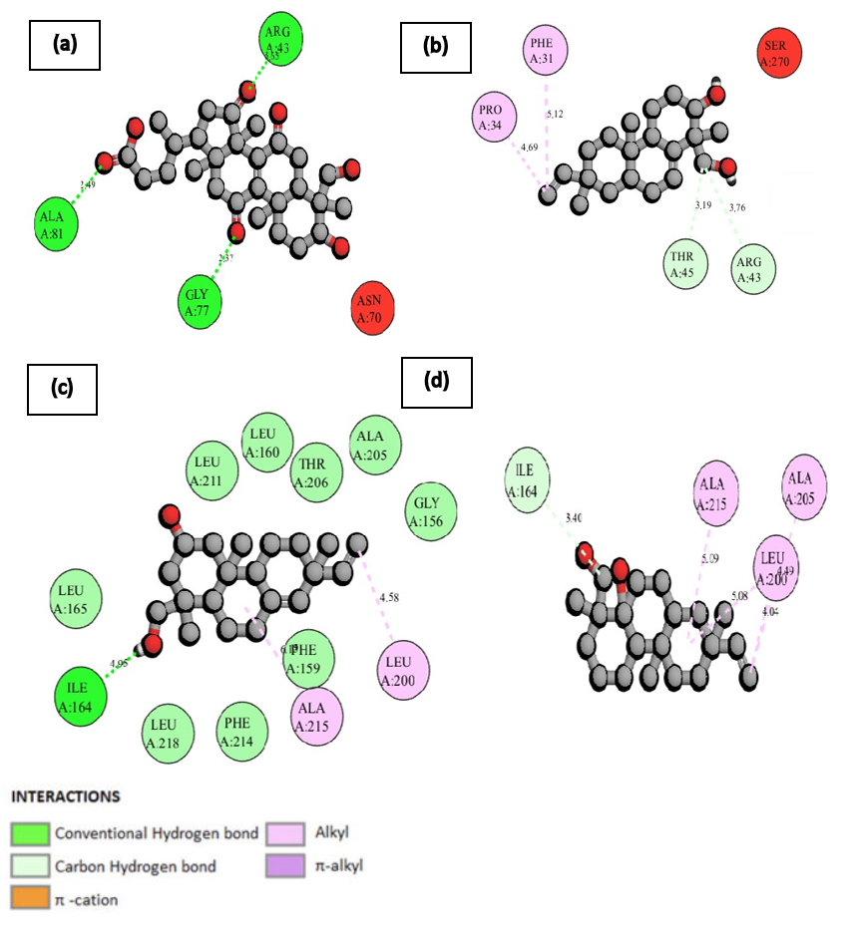

Figure 4.8 : 2D diagram representing the interaction between four selected potential ligands and the EstA protein.

(a) Betulinic acid (b) Rosadiene (c) Resveratrol (d) Stigmasterol. The representation utilizes a color-coded scheme to enhance clarity, with ligands (molecules that bind to the protein) depicted in gray using ball and stick form. Critical amino acid residues are shown in three-letter code and different colors based on the type of interaction within the active site, and dotted lines indicate the type and strength of binding. A, B, and C represent the chains.

4.6.2 Molecular interaction and binding modes of protein OprD with selected potential ligands

The selected 4 potential ligands Betulinic acid, Rosadiene, Resveratrol and Stigmasterol (306, 350, 372, and 371) exhibits conventional hydrogen bonds, alkyl, pi alkyl and pi sigma bonds with amino acids.

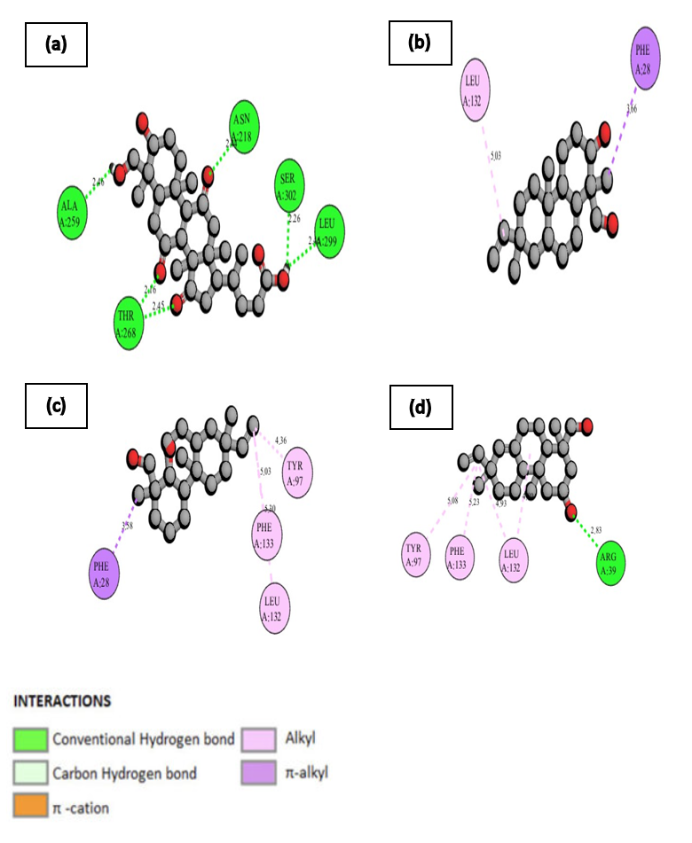

Figure 4.9 : 2D diagram representing the interaction between four selected potential ligands and the OprD protein.

(a) Betulinic acid (b) Rosadiene (c) Resveratrol (d) Stigmasterol. The representation utilizes a color-coded scheme to enhance clarity, with ligands (molecules that bind to the protein) depicted in gray using ball and stick form. Critical amino acid residues are shown in three-letter code and different colors based on the type of interaction within the active site, and dotted lines indicate the type and strength of binding. A, B, and C represent the chains.

4.6.3 Molecular interaction and binding modes of protein ExoT protein with selected potential ligands

The selected 4 potential ligands Betulinic acid, Rosadiene, Resveratrol and Stigmasterol (**306, 350, 372, and 371)** exhibits favourable interactions with amino acids.

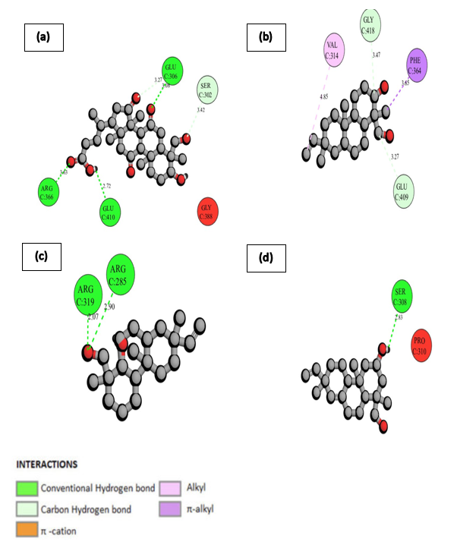

Figure 4.10 : 2D diagram representing the interaction between four selected potential ligands and the ExoT protein.

(a) Betulinic acid (b) Rosadiene (c) Resveratrol (d) Stigmasterol. The representation utilizes a color-coded scheme to enhance clarity, with ligands (molecules that bind to the protein) depicted in gray using ball and stick form. Critical amino acid residues are shown in three-letter code and different colors based on the type of interaction within the active site, and dotted lines indicate the type and strength of binding. A, B, and C represent the chains.

4.6.4 Molecular interaction and binding modes of protein LasB protein with selected potential ligands

The selected 4 potential ligands Betulinic acid, Rosadiene, Resveratrol and Stigmasterol (306, 350, 372, and 371) exhibits favourable interactions with amino acids.

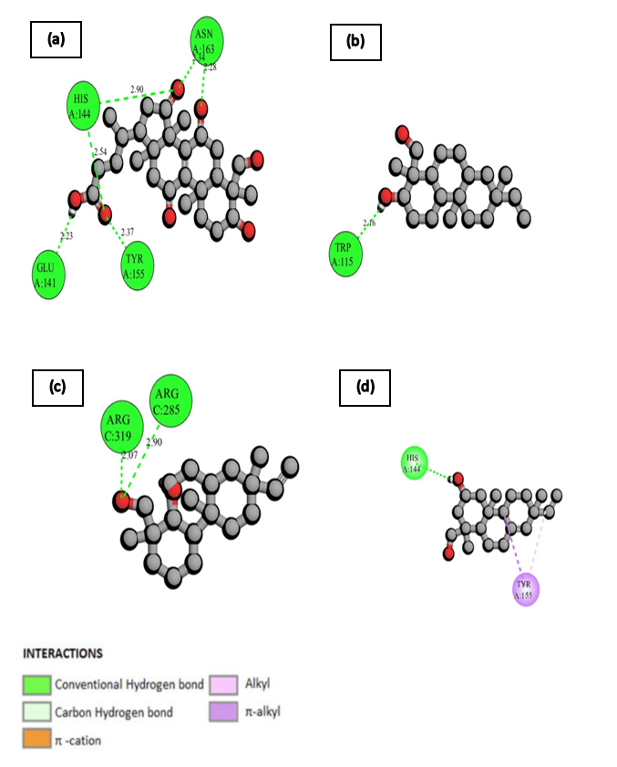

Figure 4.11 : 2D diagram representing the interaction between four selected potential ligands and the LasB protein.

(a) Betulinic acid (b) Rosadiene (c) Resveratrol (d) Stigmasterol. The representation utilizes a color-coded scheme to enhance clarity, with ligands (molecules that bind to the protein) depicted in gray using ball and stick form. Critical amino acid residues are shown in three-letter code and different colors based on the type of interaction within the active site, and dotted lines indicate the type and strength of binding. A, B, and C represent the chains.

4.6.5 Molecular interaction and binding modes of protein AprA protein with selected potential ligands

The selected 4 potential ligands Betulinic acid, Rosadiene, Resveratrol and Stigmasterol (306, 350, 372, and 371) exhibits favourable interactions with amino acids.

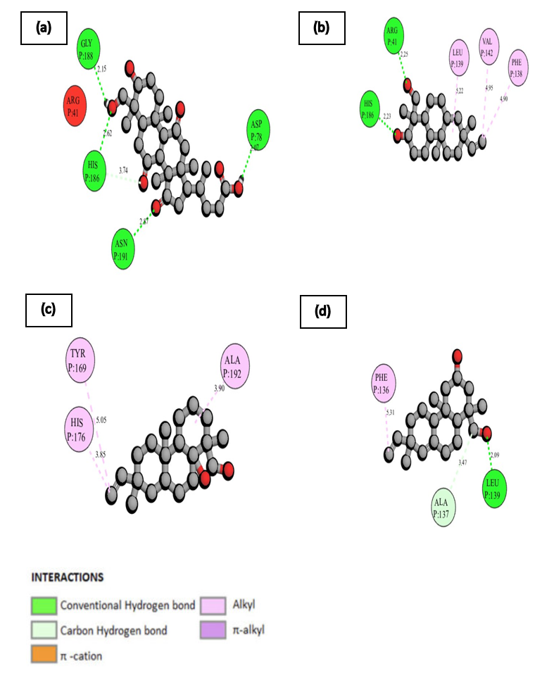

Figure 4.12 : 2D diagram representing the interaction between four selected potential ligands and the AprA protein.

(a) Betulinic acid (b) Rosadiene (c) Resveratrol (d) Stigmasterol. The representation utilizes a color-coded scheme to enhance clarity, with ligands (molecules that bind to the protein) depicted in gray using ball and stick form. Critical amino acid residues are shown in three-letter code and different colors based on the type of interaction within the active site, and dotted lines indicate the type and strength of binding. A, B, and C represent the chains.

4.6.6 Molecular interaction and binding modes of protein OprH protein with selected potential ligands

The selected 4 potential ligands Betulinic acid, Rosadiene, Resveratrol and Stigmasterol (306, 350, 372, and 371) exhibits favourable interaction with amino acids.

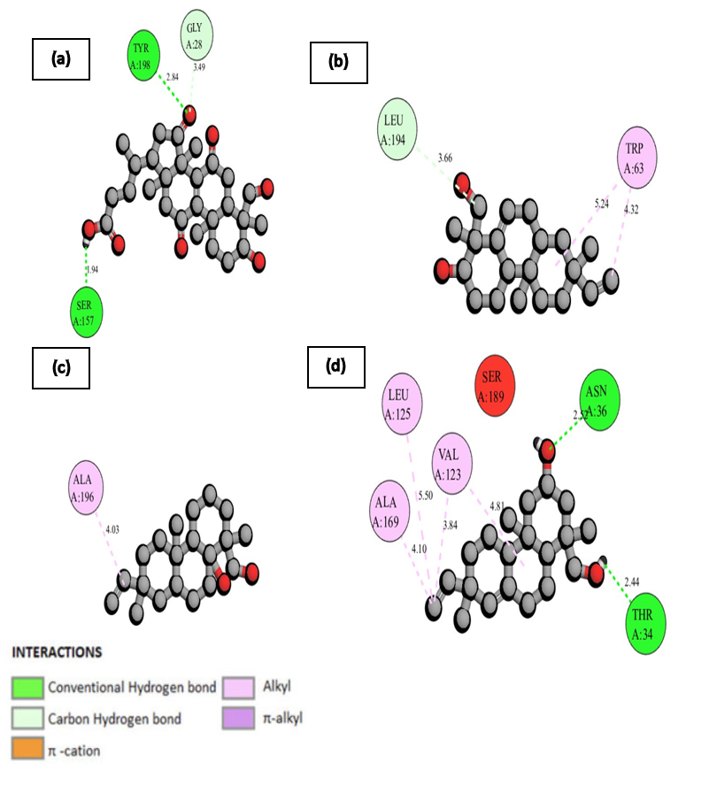

Figure 4.13 : 2D diagram representing the interaction between four selected potential ligands and the OprH protein.

(a) Betulinic acid (b) Rosadiene (c) Resveratrol (d) Stigmasterol. The representation utilizes a color-coded scheme to enhance clarity, with ligands (molecules that bind to the protein) depicted in gray using ball and stick form. Critical amino acid residues are shown in three-letter code and different colors based on the type of interaction within the active site, and dotted lines indicate the type and strength of binding. A, B, and C represent the chains.

4.6.7 Molecular interaction and binding modes of protein OprQ protein with selected potential ligands

The selected 4 potential ligands Betulinic acid, Rosadiene, Resveratrol and Stigmasterol (306, 350, 372, and 371) exhibits favourable interaction with amino acids.

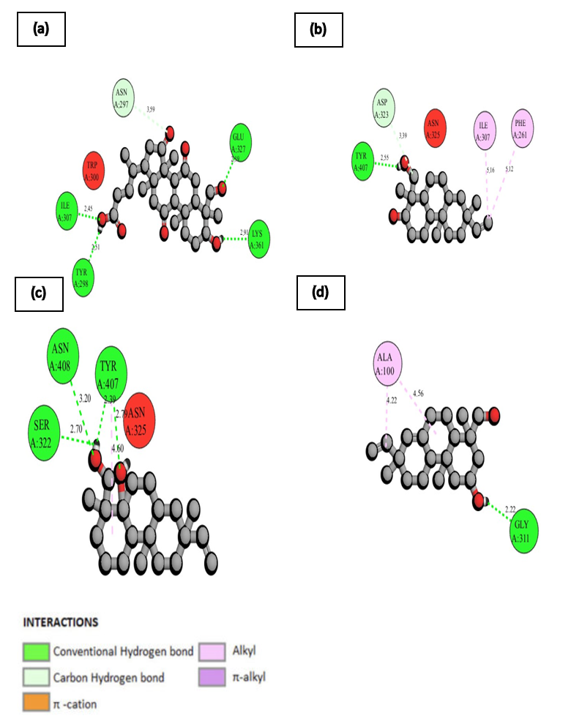

Figure 4.14 : 2D diagram representing the interaction between four selected potential ligands and the OprQ protein.

(a) Betulinic acid (b) Rosadiene (c) Resveratrol (d) Stigmasterol. The representation utilizes a color-coded scheme to enhance clarity, with ligands (molecules that bind to the protein) depicted in gray using ball and stick form. Critical amino acid residues are shown in three-letter code and different colors based on the type of interaction within the active site, and dotted lines indicate the type and strength of binding. A, B, and C represent the chains.

4.6.8 Molecular interaction and binding modes of protein PIV protein with selected potential ligands

The selected 4 potential ligands Betulinic acid, Rosadiene, Resveratrol and Stigmasterol (306, 350, 372, and 371) exhibits favourable interaction with amino acids.

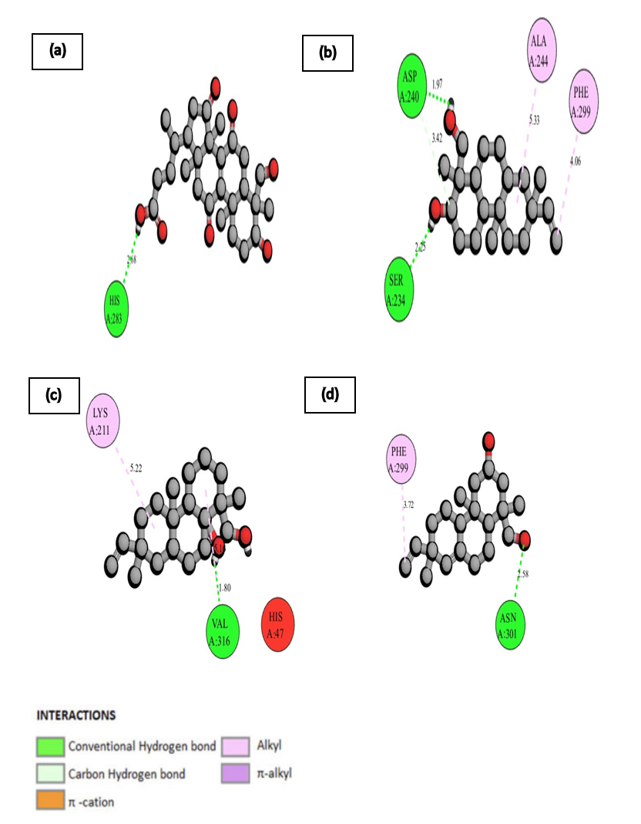

Figure 4.15 : 2D diagram representing the interaction between four selected potential ligands and the PIV protease.

(a) Betulinic acid (b) Rosadiene (c) Resveratrol (d) Stigmasterol. The representation utilizes a color-coded scheme to enhance clarity, with ligands (molecules that bind to the protein) depicted in gray using ball and stick form. Critical amino acid residues are shown in three-letter code and different colors based on the type of interaction within the active site, and dotted lines indicate the type and strength of binding. A, B, and C represent the chains.

4.6.9 Molecular interaction and binding modes of protein PilB protein with selected potential ligands

The selected 4 potential ligands Betulinic acid, Rosadiene, Resveratrol and Stigmasterol (306, 350, 372, and 371) exhibits favourable interaction with amino acids.

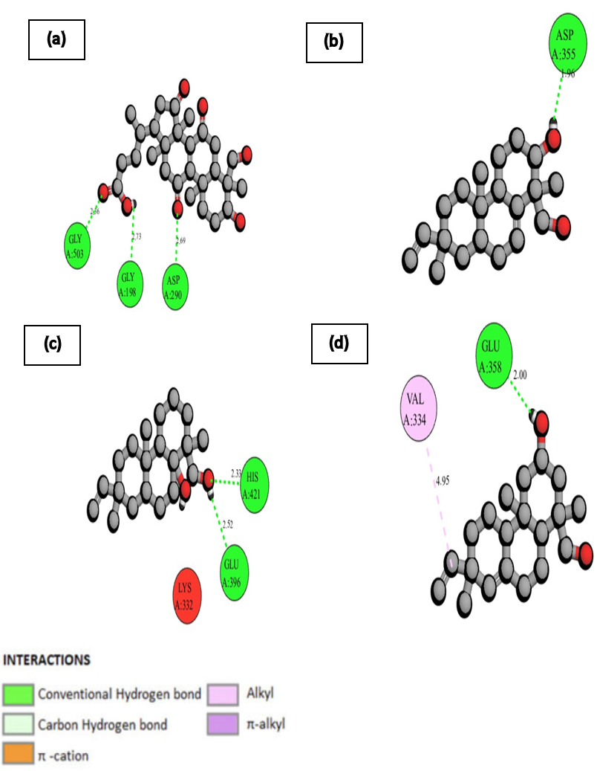

Figure 4.16 : 2D diagram representing the interaction between four selected potential ligands and the PilB protein.

(a) Betulinic acid (b) Rosadiene (c) Resveratrol (d) Stigmasterol. The representation utilizes a color-coded scheme to enhance clarity, with ligands (molecules that bind to the protein) depicted in gray using ball and stick form. Critical amino acid residues are shown in three-letter code and different colors based on the type of interaction within the active site, and dotted lines indicate the type and strength of binding. A, B, and C represent the chains.

4.6.10 Molecular interaction and binding modes of protein PilY protein with selected potential ligands

The selected 4 potential ligands Betulinic acid, Rosadiene, Resveratrol and Stigmasterol (306, 350, 372, and 371) exhibits favourable interaction with amino acids.

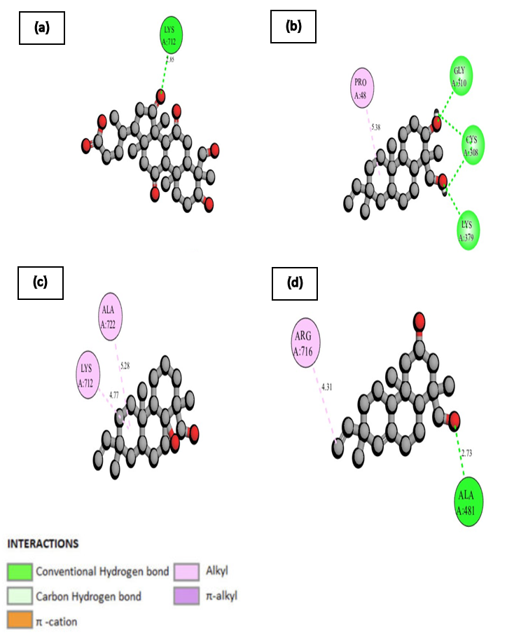

Figure 4.17 : 2D diagram representing the interaction between four selected potential ligands and the PilY protein.

(a) Betulinic acid (b) Rosadiene (c) Resveratrol (d) Stigmasterol. The representation utilizes a color-coded scheme to enhance clarity, with ligands (molecules that bind to the protein) depicted in gray using ball and stick form. Critical amino acid residues are shown in three-letter code and different colors based on the type of interaction within the active site, and dotted lines indicate the type and strength of binding. A, B, and C represent the chains.

4.6.11 Molecular interaction and binding modes of protein FliC protein with selected potential ligands

The selected 4 potential ligands Betulinic acid, Rosadiene, Resveratrol and Stigmasterol (306, 350, 372, and 371) exhibits favourable interaction with amino acids.

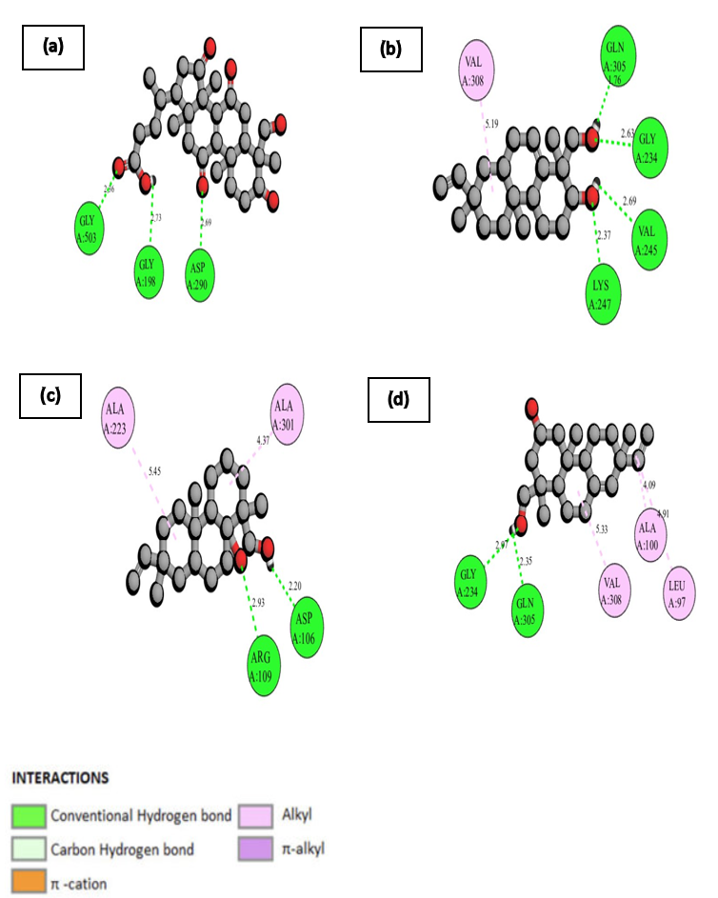

Figure 4.18 : 2D diagram representing the interaction between four selected potential ligands and the FliC protein.

(a) Betulinic acid (b) Rosadiene (c) Resveratrol (d) Stigmasterol. The representation utilizes a color-coded scheme to enhance clarity, with ligands (molecules that bind to the protein) depicted in gray using ball and stick form. Critical amino acid residues are shown in three-letter code and different colors based on the type of interaction within the active site, and dotted lines indicate the type and strength of binding. A, B, and C represent the chains.

4.6.12 Molecular interaction and binding modes of protein PilT protein with selected potential ligands

The selected 4 potential ligands Betulinic acid, Rosadiene, Resveratrol and Stigmasterol (306, 350, 372, and 371) exhibits favourable interaction with amino acids.

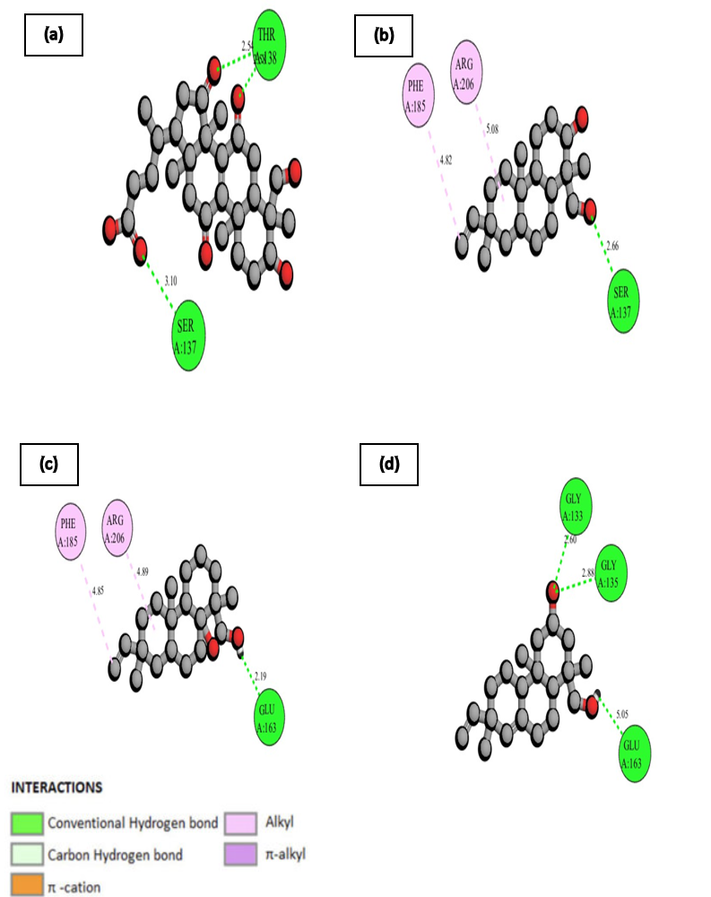

Figure 4.19 : 2D diagram representing the interaction between four selected potential ligands and the PilT protein.

(a) Betulinic acid (b) Rosadiene (c) Resveratrol (d) Stigmasterol. The representation utilizes a color-coded scheme to enhance clarity, with ligands (molecules that bind to the protein) depicted in gray using ball and stick form. Critical amino acid residues are shown in three-letter code and different colors based on the type of interaction within the active site, and dotted lines indicate the type and strength of binding. A, B, and C represent the chains.

4.6.13 Molecular interaction and binding modes of ExoU protein with selected potential ligands

The selected 4 potential ligands Betulinic acid, Rosadiene, Resveratrol and Stigmasterol (306, 350, 372, and 371) exhibits favourable interaction with amino acids.

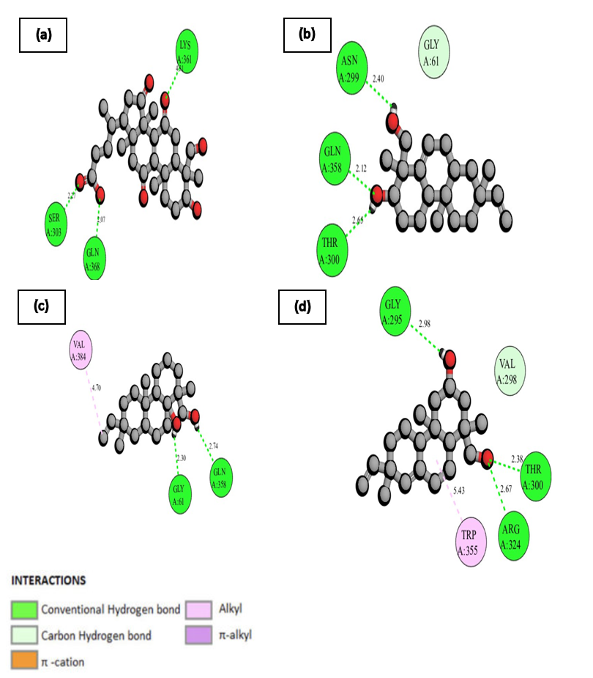

Figure 4.20 : 2D diagram representing the interaction between four selected potential ligands and the ExoU protein.

(a) Betulinic acid (b) Rosadiene (c) Resveratrol (d) Stigmasterol. The representation utilizes a color-coded scheme to enhance clarity, with ligands (molecules that bind to the protein) depicted in gray using ball and stick form. Critical amino acid residues are shown in three-letter code and different colors based on the type of interaction within the active site, and dotted lines indicate the type and strength of binding. A, B, and C represent the chains.

4.6.14 Molecular interaction and binding modes of ExoY protein with selected potential ligands

The selected 4 potential ligands Betulinic acid, Rosadiene, Resveratrol and Stigmasterol (306, 350, 372, and 371) exhibits favourable interaction with amino acids.

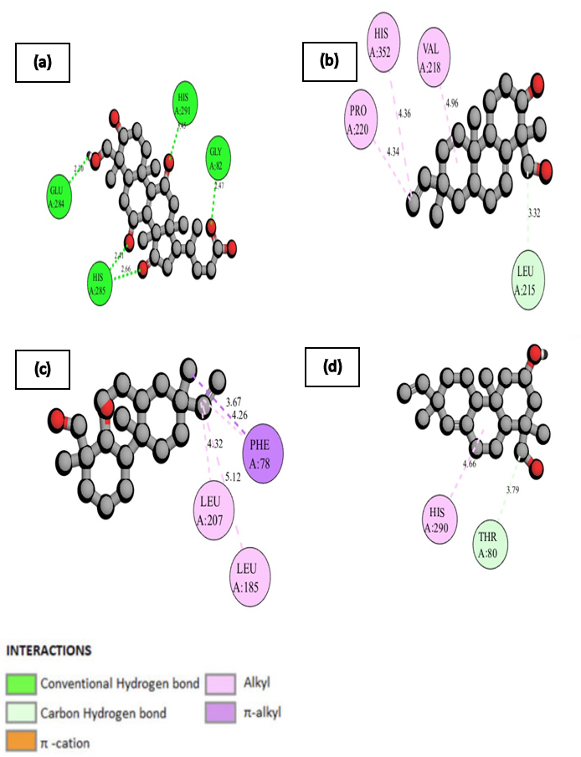

Figure 4.21 : 2D diagram representing the interaction between four selected potential ligands and the ExoY protein.

(a) Betulinic acid (b) Rosadiene (c) Resveratrol (d) Stigmasterol. The representation utilizes a color-coded scheme to enhance clarity, with ligands (molecules that bind to the protein) depicted in gray using ball and stick form. Critical amino acid residues are shown in three-letter code and different colors based on the type of interaction within the active site, and dotted lines indicate the type and strength of binding. A, B, and C represent the chains.

4.6.15 Molecular interaction and binding modes of OprG protein with selected potential ligands

The selected 4 potential ligands Betulinic acid, Rosadiene, Resveratrol and Stigmasterol (306, 350, 372, and 371) exhibits favourable interaction with amino acids.

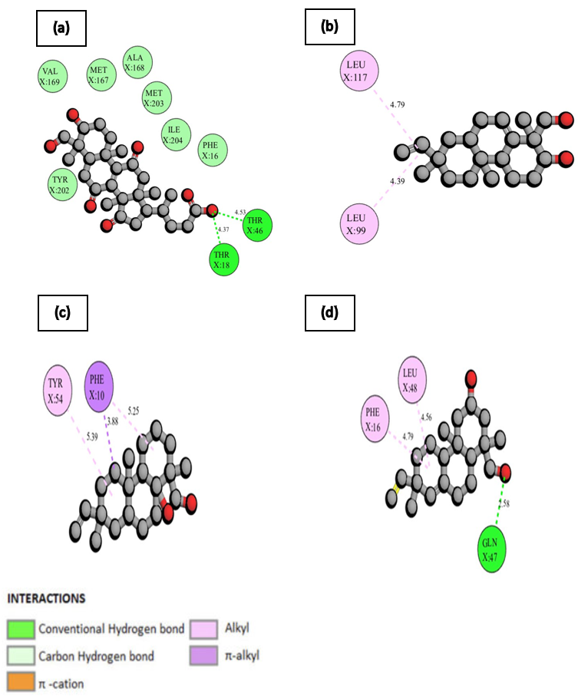

Figure 4.22 : 2D diagram representing the interaction between four selected potential ligands and the OprG protein.

(a) Betulinic acid (b) Rosadiene (c) Resveratrol (d) Stigmasterol. The representation utilizes a color-coded scheme to enhance clarity, with ligands (molecules that bind to the protein) depicted in gray using ball and stick form. Critical amino acid residues are shown in three-letter code and different colors based on the type of interaction within the active site, and dotted lines indicate the type and strength of binding. A, B, and C represent the chains.

4.6.16 Molecular interaction and binding modes of OprF protein with selected potential ligands

The selected 4 potential ligands Betulinic acid, Rosadiene, Resveratrol and Stigmasterol (306, 350, 372, and 371) exhibits favourable interaction with amino acids.

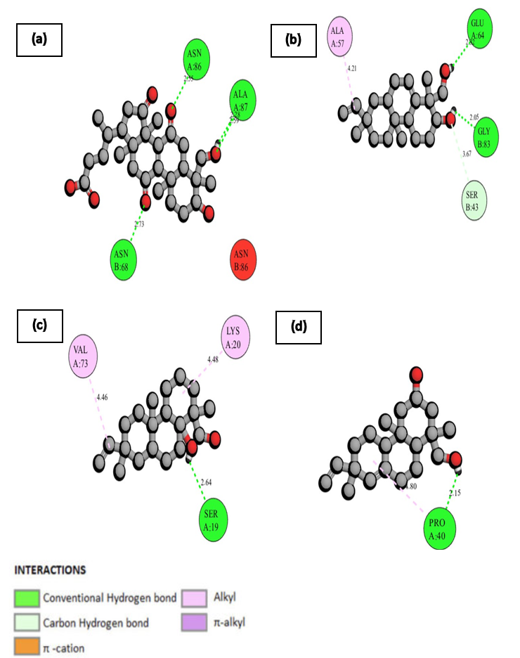

Figure 4.23 : 2D diagram representing the interaction between four selected potential ligands and the OprF protein.

(a) Betulinic acid (b) Rosadiene (c) Resveratrol (d) Stigmasterol. The representation utilizes a color-coded scheme to enhance clarity, with ligands (molecules that bind to the protein) depicted in gray using ball and stick form. Critical amino acid residues are shown in three-letter code and different colors based on the type of interaction within the active site, and dotted lines indicate the type and strength of binding. A, B, and C represent the chains.

4.6.17 Molecular interaction and binding modes of LasA protein with selected potential ligands

The selected 4 potential ligands Betulinic acid, Rosadiene, Resveratrol and Stigmasterol (306, 350, 372, and 371) exhibits favourable interaction with amino acids.

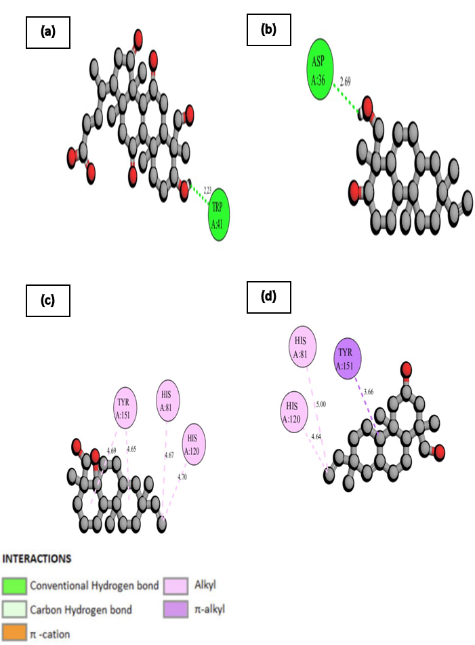

Figure 4.24 : 2D diagram representing the interaction between four selected potential ligands and the LasA protein.

(a) Betulinic acid (b) Rosadiene (c) Resveratrol (d) Stigmasterol. The representation utilizes a color-coded scheme to enhance clarity, with ligands (molecules that bind to the protein) depicted in gray using ball and stick form. Critical amino acid residues are shown in three-letter code and different colors based on the type of interaction within the active site, and dotted lines indicate the type and strength of binding. A, B, and C represent the chains.

4.6.18 Molecular interaction and binding modes of PilA protein with selected potential ligands

The selected 4 potential ligands Betulinic acid, Rosadiene, Resveratrol and Stigmasterol (306, 350, 372, and 371) exhibits favourable interaction with amino acids.

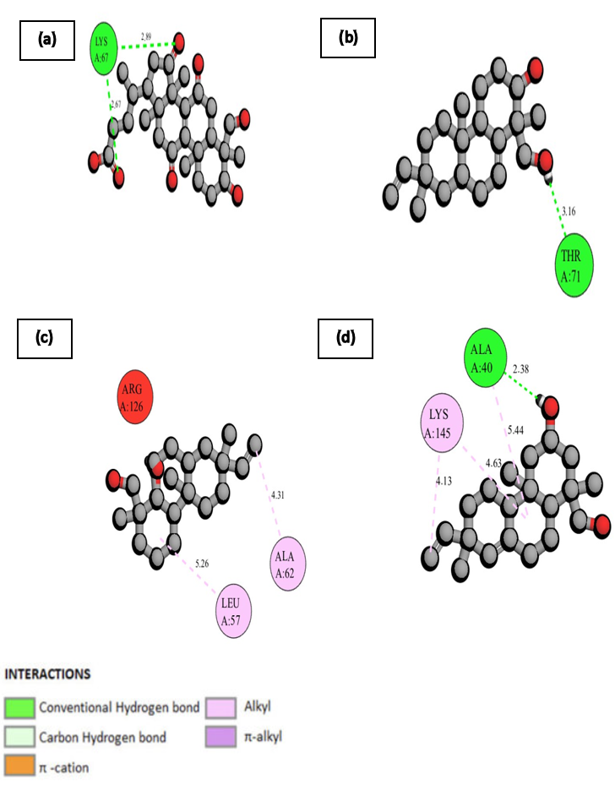

Figure 4.25 : 2D diagram representing the interaction between four selected potential ligands and the PilA protein.

(a) Betulinic acid (b) Rosadiene (c) Resveratrol (d) Stigmasterol. The representation utilizes a color-coded scheme to enhance clarity, with ligands (molecules that bind to the protein) depicted in gray using ball and stick form. Critical amino acid residues are shown in three-letter code and different colors based on the type of interaction within the active site, and dotted lines indicate the type and strength of binding. A, B, and C represent the chains.

4.6.19 Molecular interaction and binding modes of FliD protein with selected potential ligands

The selected 4 potential ligands Betulinic acid, Rosadiene, Resveratrol and Stigmasterol (306, 350, 372, and 371) exhibits favourable interaction with amino acids.

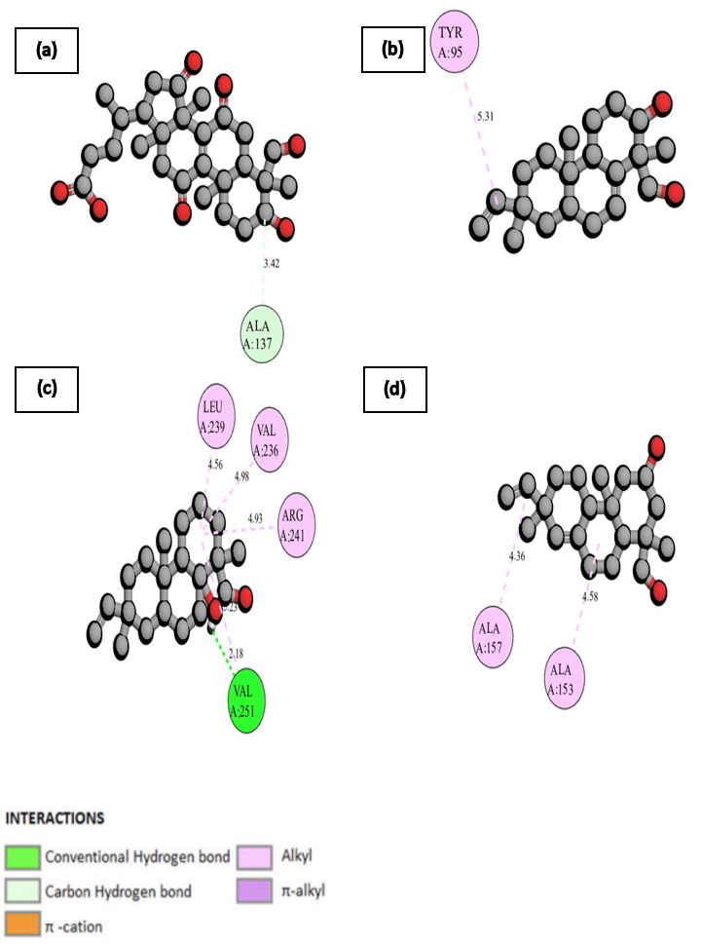

Figure 4.26 : 2D diagram representing the interaction between four selected potential ligands and the FliD protein.

(a) Betulinic acid (b) Rosadiene (c) Resveratrol (d) Stigmasterol. The representation utilizes a color-coded scheme to enhance clarity, with ligands (molecules that bind to the protein) depicted in gray using ball and stick form. Critical amino acid residues are shown in three-letter code and different colors based on the type of interaction within the active site, and dotted lines indicate the type and strength of binding. A, B, and C represent the chains.

# Conclusion

In conclusion, this research work has made significant steps in understanding and addressing the challenges posed by *P. aeruginosa* as a highly resistant pathogen. Through *In-silico* screening and molecular docking, four promising compounds, namely Betulinic acid, Rosadiene, Resveratrol, and Stigmasterol, were identified as potential candidates for further study. These compounds demonstrated strong interactions with multiple virulence proteins of *P. aeruginosa*, indicating their potential as effective antibacterial agents. Additionally, they followed Lipinski's rules of five suggesting their drug-like properties.

Moving forward, the next steps in this research include hit-to-lead optimization of the identified compounds to enhance their efficacy, safety, and specificity. Further studies should focus on *in vitro* cell or tissue-based assays to evaluate the compounds antimicrobial activity, toxicity, and selectivity against *P. aeruginosa*. Furthermore, exploring combination therapy strategies by combining the identified compounds with existing antibiotics or antimicrobial agents can help combat *P. aeruginosa* multifactorial nature and reduce the risk of resistance development in CF infection. Structure-activity relationship studies will provide insights into key structural features for designing more potent analogs. Comprehensive pharmacokinetic and toxicity profiling will be crucial in understanding the compounds absorption, distribution, metabolism, excretion, and potential adverse effects. Ultimately, clinical trials will be necessary to evaluate the safety, efficacy, and therapeutic potential of the lead compounds in patients with *P. aeruginosa* infections, bringing us closer to developing novel and effective treatments for this challenging pathogen.

# References

Ahmed, S., Rakib, A., Islam, Md. A., Khanam, B. H., Faiz, F. B., Paul, A., Chy, Md. N. U., Bhuiya, N. M. M. A., Uddin, M. M. N., Ullah, S. M. A., Rahman, Md. A., & Emran, T. Bin. (2019). *In vivo* and *in vitro* pharmacological activities of *Tacca integrifolia* rhizome and investigation of possible lead compounds against breast cancer through *In-silico* approaches. *Clinical Phytoscience*, *5*(1), 36.

Anantharajah, A., Mingeot-Leclercq, M.P., & Van Bambeke, F. (2016). Targeting the type three secretion system in *Pseudomonas aeruginosa*. *Trends in Pharmacological Sciences*, *37*(9), 734–749.

Aparna, V., Dineshkumar, K., Mohanalakshmi, N., Velmurugan, D., & Hopper, W. (2014). Identification of natural compound inhibitors for multidrug efflux pumps of *Escherichia coli* and *Pseudomonas aeruginosa* using *In-Silico* high-throughput virtual screening and *in vitro* validation. *PLoS ONE*, *9*(7), e101840.

Arhin, A., & Boucher, C. (2010). The outer membrane protein OprQ and adherence of *Pseudomonas aeruginosa* to human fibronectin. *Microbiology*, *156*(5), 1415–1423.

Bakrim, S., Benkhaira, N., Bourais, I., Benali, T., Lee, L.-H., El Omari, N., Sheikh, R. A., Goh, K. W., Ming, L. C., & Bouyahya, A. (2022). Health benefits and pharmacological properties of stigmasterol. *Antioxidants*, *11*(10), 1912.

Baraza, L. D., Joseph, C. C., Munissi, J. J. E., Nkunya, M. H. H., Arnold, N., Porzel, A., & Wessjohann, L. (2008). Antifungal rosane diterpenes and other constituents of *Hugonia castaneifolia*. *Phytochemistry*, *69*(1), 200–205.

Berman, H. M. (2000). The protein data bank. *Nucleic Acids Research*, *28*(1), 235–242.

Bhagirath, A. Y., Li, Y., Somayajula, D., Dadashi, M., Badr, S., & Duan, K. (2016). Cystic fibrosis lung environment and *Pseudomonas aeruginosa* infection. *BMC Pulmonary Medicine*, *16*(1), 174.

Botelho, J., Grosso, F., & Peixe, L. (2019). Antibiotic resistance in *Pseudomonas aeruginosa* mechanisms, epidemiology and evolution. *Drug Resistance Updates*, *44*, 100640.

Burrows, L. L. (2012a). *Pseudomonas aeruginosa* twitching motility: type IV pili in action. *Annual Review of Microbiology*, *66*(1), 493–520.

Chevalier, S., Bouffartigues, E., Bodilis, J., Maillot, O., Lesouhaitier, O., Feuilloley, M. G. J., Orange, N., Dufour, A., & Cornelis, P. (2017). Structure, function and regulation of *Pseudomonas aeruginosa* porins. *FEMS Microbiology Reviews*, *41*(5), 698–722.

Davies, J. C. (2002). *Pseudomonas aeruginosa* in cystic fibrosis: pathogenesis and persistence. *Paediatric Respiratory Reviews*, *3*(2), 128–134.

de Lima, C. D. M., Calegari-Silva, T. C., Pereira, R. M. S., Santos, S. A. de O. L., Lopes, U. G., Plotkowski, M.C. M., & Saliba, A. M. (2012). ExoU Activates NF-κB and increases IL-8/KC secretion during *Pseudomonas aeruginosa* infection. *PLoS ONE*, *7*(7), 41772.

Geethalakshmi, R., Sundaramurthi, J. C., & Sarada, D. V. L. (2018). Antibacterial activity of flavonoid isolated from *Trianthema decandra* against *Pseudomonas aeruginosa* and molecular docking study of FabZ. *Microbial Pathogenesis*, *121*, 87–92.

Gellatly, S. L., & Hancock, R. E. W. (2013a). *Pseudomonas aeruginosa* : new insights into pathogenesis and host defenses. *Pathogens and Disease*, *67*(3), 159–173.

Goldufsky, J., Wood, S. J., Jayaraman, V., Majdobeh, O., Chen, L., Qin, S., Zhang, C., DiPietro, L. A., & Shafikhani, S. H. (2015). *Pseudomonas aeruginosa* uses T3SS to inhibit diabetic wound healing. *Wound Repair and Regeneration*, *23*(4), 557–564.

Haiko, J., & Westerlund-Wikström, B. (2013a). The role of the bacterial flagellum in adhesion and virulence. *Biology*, *2*(4), 1242–1267.

Haque, and B. A. and K. R. and S. M. and A. A. and P. A. and I. A. and Z. R. and S. S. and Z. N. and H. A. and B. R. and R. A. and H. M. (2021). *In-silico* molecular docking study of linalool against 3ELJ for cell cycle arrest and apoptosis in hepg2 cells. *International Journal of Evergreen Scientific Research* , *03*(02), 105–118.

Hauser, A. R. (2009). The type III secretion system of *Pseudomonas aeruginosa*: infection by injection. *Nature Reviews Microbiology*, *7*(9), 654–665.

He, C., Zhou, Y., Liu, F., Liu, H., Tan, H., Jin, S., Wu, W., & Ge, B. (2017). Bacterial nucleotidyl cyclase inhibits the host innate immune response by suppressing TAK1 activation. *Infection and Immunity*, *85*(9).

Iiyama, K., Takahashi, E., Lee, J. M., Mon, H., Morishita, M., Kusakabe, T., & Yasunaga-Aoki, C. (2017). Alkaline protease contributes to pyocyanin production in *Pseudomonas aeruginosa*. *FEMS Microbiology Letters*, *364*(7).

Jacobsen, T., Bardiaux, B., Francetic, O., Izadi-Pruneyre, N., & Nilges, M. (2020). Structure and function of minor pilins of type IV pili. *Medical Microbiology and Immunology*, *209*(3), 301–308.

Javanmardi, F., Emami, A., Pirbonyeh, N., Keshavarzi, A., & Rajaee, M. (2019). A systematic review and meta-analysis on exo-toxins prevalence in hospital acquired *Pseudomonas aeruginosa* isolates. *Infection, Genetics and Evolution*, *75*, 104037.

Jumper, J., Evans, R., Pritzel, A., Green, T., Figurnov, M., Ronneberger, O., Tunyasuvunakool, K., Bates, R., Žídek, A., Potapenko, A., Bridgland, A., Meyer, C., Kohl, S. A. A., Ballard, A. J., Cowie, A., Romera-Paredes, B., Nikolov, S., Jain, R., Adler, J., … Hassabis, D. (2021). Highly accurate protein structure prediction with AlphaFold. *Nature*, *596*(7873), 583–589.

Jurado-Martín, I., Sainz-Mejías, M., & McClean, S. (2021a). *Pseudomonas aeruginosa*: an audacious pathogen with an adaptable arsenal of virulence factors. *International Journal of Molecular Sciences*, *22*(6), 3128.

Karaiskos, I., & Giamarellou, H. (2014). Multidrug-resistant and extensively drug-resistant Gram-negative pathogens: current and emerging therapeutic approaches. *Expert Opinion on Pharmacotherapy*, *15*(10), 1351–1370.

Ketko, A. K., Lin, C., Moore, B. B., & LeVine, A. M. (2013). Surfactant protein A binds flagellin enhancing phagocytosis and IL-1β production. *PLoS ONE*, *8*(12), 82680.

Kim, S., Thiessen, P. A., Bolton, E. E., Chen, J., Fu, G., Gindulyte, A., Han, L., He, J., He, S., Shoemaker, B. A., Wang, J., Yu, B., Zhang, J., & Bryant, S. H. (2016). PubChem substance and compound databases. *Nucleic Acids Research*, *44*(D1), D1202–D1213.

Kreda, S. M., Davis, C. W., & Rose, M. C. (2012). CFTR, mucins, and mucus obstruction in Cystic Fibrosis. *Cold Spring Harbor Perspectives in Medicine*, *2*(9), 009589–009589.

Kucharska, I., Liang, B., Ursini, N., & Tamm, L. K. (2016). Molecular interactions of lipopolysaccharide with an outer membrane protein from *Pseudomonas aeruginosa* probed by solution NMR. *Biochemistry*, *55*(36), 5061–5072.

Kunz Coyne, A. J., El Ghali, A., Holger, D., Rebold, N., & Rybak, M. J. (2022a). Therapeutic strategies for emerging multidrug-resistant *Pseudomonas aeruginosa*. *Infectious Diseases and Therapy*, *11*(2), 661–682.

Laudadio, E., Cedraro, N., Mangiaterra, G., Citterio, B., Mobbili, G., Minnelli, C., Bizzaro, D., Biavasco, F., & Galeazzi, R. (2019). Natural alkaloid berberine activity against *Pseudomonas aeruginosa* MexXY-mediated aminoglycoside resistance: *In Silico* and *in vitro* Studies. *Journal of Natural Products*, *82*(7), 1935–1944.

Melville, J. L., & Hirst, J. D. (2007). TMACC:  Interpretable correlation descriptors for quantitative structure−activity relationships. *Journal of Chemical Information and Modeling*, *47*(2), 626–634.

Mishra, M., Ressler, A., Schlesinger, L. S., & Wozniak, D. J. (2015). Identification of OprF as a complement component C3 binding acceptor molecule on the surface of *Pseudomonas aeruginosa*. *Infection and Immunity*, *83*(8), 3006–3014.

Montor, W. R., Huang, J., Hu, Y., Hainsworth, E., Lynch, S., Kronish, J.-W., Ordonez, C. L., Logvinenko, T., Lory, S., & LaBaer, J. (2009). Genome-wide study of *Pseudomonas aeruginosa* outer membrane protein immunogenicity using self-assembling protein microarrays. *Infection and Immunity*, *77*(11), 4877–4886.

Nnyigide, O. S., Nnyigide, T. O., Lee, S.-G., & Hyun, K. (2022). Protein repair and analysis server: A web server to repair PDB structures, add missing heavy atoms and hydrogen atoms, and assign secondary structures by amide interactions. *Journal of Chemical Information and Modeling*, *62*(17), 4232–4246.

Novak, J., Tseilikman, V. E., Tseilikman, O. B., Lazuko, S. S., Belyeva, L. E., Rahmani, A., & Fedotova, J. (2023). Resveratrol influence the activity of 11β-hydroxysteroid dehydrogenase Type 1 a combined *In Silico* and *in vivo* study. *Pharmaceuticals*, *16*(2), 251.

Pang, Z., Raudonis, R., Glick, B. R., Lin, T.-J., & Cheng, Z. (2019a). Antibiotic resistance in *Pseudomonas aeruginosa*: mechanisms and alternative therapeutic strategies. *Biotechnology Advances*, *37*(1), 177–192.

Paulsson, M., Su, Y.-C., Ringwood, T., Uddén, F., & Riesbeck, K. (2019a). *Pseudomonas aeruginosa* uses multiple receptors for adherence to laminin during infection of the respiratory tract and skin wounds. *Scientific Reports*, *9*(1), 18168.

Pęcak, P., Świtalska, M., Chrobak, E., Boryczka, G., & Bębenek, E. (2022). Betulin acid ester derivatives inhibit cancer cell growth by inducing apoptosis through caspase cascade activation: A comprehensive *In vitro* and *In Silico* study. *International Journal of Molecular Sciences*, *24*(1), 196.

Qadi, M., Lopez-Causapé, C., Izquierdo-Rabassa, S., Mateu Borrás, M., Goldberg, J. B., Oliver, A., & Albertí, S. (2016). Surfactant protein A recognizes outer membrane protein OprH on *Pseudomonas aeruginosa* isolates from individuals with chronic infection. *Journal of Infectious Diseases*, *214*(9), 1449–1455.

Rajeev, R., Marathe, S. D., Niranjan, V., Sharma, B., & Sarojini, S. (2021). *In silico* analysis of stigmasterol from *Saraca asoca* as a potential therapeutic drug against alzheimer’s disease. *Journal of Biologically Active Products from Nature*, *11*(5–6), 516–529.

Ratna Wulan, D., Priyo Utomo, E., & Mahdi, C. (2015). Antidiabetic activity of *Ruellia tuberosa* L., role of *α* -Amylase inhibitor: *In Silico* , *in vitro* , and *in vivo* approaches. *Biochemistry Research International*, *2015*, 1–9.

Rutz, A., Sorokina, M., Galgonek, J., Mietchen, D., Willighagen, E., Gaudry, A., Graham, J. G., Stephan, R., Page, R., Vondrášek, J., Steinbeck, C., Pauli, G. F., Wolfender, J.-L., Bisson, J., & Allard, P.M. (2022). The LOTUS initiative for open knowledge management in natural products research. *ELife*, 11.

Sanner, M. F. (1999). Python: a programming language for software integration and development. *Journal of Molecular Graphics & Modelling*, *17*(1), 57–61.

Schwarzer, C., Fischer, H., & Machen, T. E. (2016). Chemotaxis and binding of *Pseudomonas aeruginosa* to scratch-wounded human cystic fibrosis airway epithelial cells. *PLOS ONE*, *11*(3), e0150109.

Sharma, S., Kumar, P., & Chandra, R. (2019). Applications of BIOVIA materials studio, LAMMPS, and GROMACS in various fields of science and engineering. In *Molecular Dynamics Simulation of Nanocomposites Using BIOVIA Materials Studio, Lammps and Gromacs* (pp. 329–341). Elsevier.

Shaver, C. M., & Hauser, A. R. (2004). Relative Contributions of *Pseudomonas aeruginosa* ExoU, ExoS, and ExoT to virulence in the lung. *Infection and Immunity*, *72*(12), 6969–6977.

Singh, A. P., Singh, R., Verma, S. S., Rai, V., Kaschula, C. H., Maiti, P., & Gupta, S. C. (2019). Health benefits of resveratrol: evidence from clinical studies. *Medicinal Research Reviews*, *39*(5), 1851–1891.

Smith, L., Rose, B., Tingpej, P., Zhu, H., Conibear, T., Manos, J., Bye, P., Elkins, M., Willcox, M., Bell, S., Wainwright, C., & Harbour, C. (2006). Protease IV production in *Pseudomonas aeruginosa* from the lungs of adults with cystic fibrosis. *Journal of Medical Microbiology*, *55*(12), 1641–1644.

Song, F., Wang, H., Sauer, K., & Ren, D. (2018). Cyclic-di-GMP and OprF Are involved in the response of *Pseudomonas aeruginosa* to Substrate material stiffness during attachment on Polydimethylsiloxane (PDMS). *Frontiers in Microbiology*, *9*.

Sousa, A., & Pereira, M. (2014a). *Pseudomonas aeruginosa* diversification during infection development in cystic fibrosis lungs—A Review. *Pathogens*, *3*(3), 680–703.

Srivastava, S., Bhargava, A., Pathak, N., & Srivastava, P. (2019). Production, characterization and antibacterial activity of silver nanoparticles produced by *Fusarium oxysporum* and monitoring of protein-ligand interaction through *In*-*silico* approaches. *Microbial Pathogenesis*, *129*, 136–145.

Strateva, T., & Mitov, I. (2011a). Contribution of an arsenal of virulence factors to pathogenesis of *Pseudomonas aeruginosa* infections. *Annals of Microbiology*, *61*(4), 717–732.

Trott, O., & Olson, A. J. (2009). AutoDock Vina: Improving the speed and accuracy of docking with a new scoring function, efficient optimization, and multithreading. *Journal of Computational Chemistry*, NA-NA.

Warrener, P., Varkey, R., Bonnell, J. C., DiGiandomenico, A., Camara, M., Cook, K., Peng, L., Zha, J., Chowdury, P., Sellman, B., & Stover, C. K. (2014). A novel anti-PCRV antibody providing enhanced protection against *Pseudomonas aeruginosa* in multiple animal infection models. *Antimicrobial Agents and Chemotherapy*, *58*(8), 4384–4391.

Wood, S. J., Kuzel, T. M., & Shafikhani, S. H. (2023a). *Pseudomonas aeruginosa*: infections, animal modeling, and therapeutics. *Cells*, *12*(1), 199.

Yang, J., Roy, A., & Zhang, Y. (2013). Protein–ligand binding site recognition using complementary binding-specific substructure comparison and sequence profile alignment. *Bioinformatics*, *29*(20), 2588–2595.

Yu, H., He, X., Xie, W., Xiong, J., Sheng, H., Guo, S., Huang, C., Zhang, D., & Zhang, K. (2014). Elastase LasB of *Pseudomonas aeruginosa* promotes biofilm formation partly through rhamnolipid-mediated regulation. *Canadian Journal of Microbiology*, *60*(4), 227–235.

Zhang, S., Yan, Z., Huang, Y., Liu, L., He, D., Wang, W., Fang, X., Zhang, X., Wang, F., Wu, H., & Wang, H. (2022). HelixADMET: a robust and endpoint extensible ADMET system incorporating self-supervised knowledge transfer. *Bioinformatics*, *38*(13), 3444–3453.

# Appendix I Library of phytochemicals used in this study

| **List of phytochemicals** | **List of phytochemicals** |
| --- | --- |
| (4R)-4-[(3S,4R,5R,10S,13R,14R,17R)-3-hydroxy-4-(hydroxymethyl)-4,10,13,14-tetramethyl-7,11,15-trioxo-1,2,3,5,6,12,16,17-octahydrocyclopenta[a]phenanthren-17-yl]pentanoic acid | Methyl 3-methylpent-3-enoate |
| (1R,3S,4aR,4bS,7R,10aR)-7-ethenyl-1-(hydroxymethyl)-1,4a,7-trimethyl-3,4,4b,5,6,9,10,10a-octahydro-2H-phenanthren-3-ol | (3S)-octan-3-ol |
| 5,15-Rosadiene-3,19-diol | Methyl (3e)-3-methylpent-3-enoate |
| (2R,4aR,4bS,8R,8aR,10aR)-2-ethenyl-8-(hydroxymethyl)-2,4a,8-trimethyl-1,3,4,4b,5,6,7,9,10,10a-decahydrophenanthren-8a-ol | 1-(Pyrrolidin-2-yl)propan-2-one |
| (2S,5S)-5-methyl-2-(4-methylphenyl)heptan-4-one | 2-octenol |
| (2S,5R,10R)-6,10-Dimethyl-2-(1-methylethenyl)spiro[4.5]dec-6-ene | (2e)-oct-2-en-1-ol |
| (4aS,7S,8aR)-4a,8a-dimethyl-7-propan-2-yl-3,4,5,6,7,8-hexahydro-2H-naphthalen-1-one | 3-Octanol |
| Terpinolene | (3R)-octan-3-ol |
| D-Limonene | 7-Octen-4-OL |
| p-Menthan-9-ol | (S)-(+)-2-Octanol |
| P-Menth-1-en-9-al | 6-Methyl-5-hepten-2-one |
| (+)-p-Menta-1-en-9-ol | (2R,3S,4R,5S)-2,3,5-trihydroxy-4-methoxyhexanal |
| Cyclohexene, 1-methyl-3-(1-methylethenyl)- | 6-Deoxyglucose |
| Limonene | L-fuculose |
| (-)-Limonene | 1-deoxy-D-xylulose |
| (S)-1-Methyl-3-isopropenyl-1-cyclohexene | 1,4-Dideoxy-1,4-imino-d-arabinitol |
| 1-Methyl-4-((hydroxymethyl)vinyl)-cyclohex-1-ene | (2S,3R,4R,5S)-2,3,4,5-tetrahydroxyhexanal |
| p-Menth-1-en-9-ol | Hept-2-en-1-ol |
| (2R,5R)-5-[(2R)-1,2-dihydroxypropan-2-yl]-2-methyl-2-(4-oxopentyl)cyclohexan-1-one | L-arabinitol |
| [(2R,4aR,8S,8aR)-2,5-dimethyl-8-propan-2-yl-3,4,4a,7,8,8a-hexahydro-1H-naphthalen-2-yl] thiocyanate | 6-deoxy-L-sorbose |
| (2R)-2-[(1R)-4-methylcyclohex-3-en-1-yl]propane-1,2-diol | Methyl 2-methylpentanoate |
| 2-Cyclohexen-1-ol, 1-methyl-4-(1-methylethyl)-, trans- | Octanal |
| (2S)-2-[(1R)-4-methylcyclohex-3-en-1-yl]propanal | Xylitol |
| (-)-Terpinen-4-ol | 2-Octanone |
| Isofaurinone | 2-deoxy-D-glucose |
| (-)-Valeranone | (2R,3S,4S,5R)-2,4,5,6-Tetrahydroxy-3-methoxyhexanal |
| (-)-Isopulegol | Methyl hex-3-enoate |
| cis-4-(Isopropyl)-1-methylcyclohex-2-en-1-ol | Ribitol |
| (Z)-p-Menth-2-en-1-ol | 1-Methylbutyl acetate |
| (2R)-2-[(1S)-4-methylcyclohex-3-en-1-yl]propane-1,2-diol | L-xylulose |
| [(2S,3aS,4R,5R,7aS)-3a,4,5,7a-tetramethyl-3-methylidene-1,2,4,5,6,7-hexahydroinden-2-yl]methanol | (2S,7S)-Octane-1,2,7,8-tetrol |
| 4-Thujanol | 1-Octanol |
| 1-[(1R,3R)-1,3-dimethyl-2-methylidenecyclohexyl]-4-methylpentan-3-one | 2-Methylbutyl acetate |
| (+)-Lasiol | 1-(Pyrrolidin-2-yl)propan-2-ol |
| (1R,2S,5S)-2-methyl-5-[(2R)-1-oxopropan-2-yl]cyclopentane-1-carboxylic acid | 6-(Hydroxymethyl)piperidin-3-ol |
| (1S)-1-methyl-4-propan-2-ylcyclohex-3-en-1-ol | 2-Piperidineethanamine |
| Isopropylcyclohexane | 2,5-dideoxy-2,5-imino-D-fucitol |
| beta-Terpineol | 2-Methylcyclopentanol |
| gamma-Elemene | (2S,3R,4R,5S)-2-amino-3,4,5-trihydroxyhexanal |
| Lucinone | Dl-fucosamin |
| (3R)-3-methyl-5-[(1S,6R)-1,2,6-trimethylcyclohex-2-en-1-yl]pent-1-en-3-ol | Mycosamine |
| (2S)-2-[4-(hydroxymethyl)cyclohexyl]propane-1,2-diol | L-(+)-Arabinose |
| (betaR,3S)-3alpha-Acetyl-3aalpha,beta-dihydroxy-7aalpha,beta-dimethyl-5alpha-hydrindaneethanol | (2R,3R)-3-hydroxy-2-methylbutanoic acid |
| 3-Cyclohexene-1-carboxaldehyde, 4-(1-methylethyl)- | 5-Oxooctanal |
| (-)-6,7-seco-Eudesm-7(11)-en-6-al | 2-o-Methylgalactose |
| (3z)-3,7-dimethylocta-3,6-dienal | Daunosamine |
| 2,6-Dimethylocta-2,6-diene | (S)-(+)-2-Heptanol |
| (-)-Dihydromyrcene | 1-Deoxy-D-xylitol |
| 3,7-dimethyl-3,6-octadienal | 2-hydroxy-Heptan-3-one |
| (6S)-3-methyl-6-propan-2-ylcyclohex-3-en-1-one | (s)-2-Hydroxy-3-heptanone |
| Methyl (r)-citronellate | Hept-4-en-2-ol |
| (R)-Lavandulol | (2R,3R,4R)-2,3,4,5-tetrahydroxypentanal |
| (1S,2R,5R)-2-methyl-5-[(2R)-1-oxopropan-2-yl]cyclopentane-1-carboxylic acid | D-diginose |
| (3S,4S)-3,7-dimethyloct-6-ene-1,4-diol | propyl (2R)-2-methylbutanoate |
| (-)-Linalool | 1-Deoxy-L-arabinitol |
| 2,6-dimethylocta-3,6-diene-1,2,8-triol | 3-Heptanone |
| 2-[(1S,2S)-1-methyl-2-prop-1-en-2-ylcyclobutyl]ethyl (2R)-2-methylbutanoate | Deoxyribulose |
| Methyl (3s)-3,7-dimethyloct-6-enoate | (2R,3R)-2-methylbutane-1,2,3,4-tetrol |
| (+)-m-Mentha-1(6),8-diene | (3R,6S)-6-hydroxymethylpiperidin-3-ol |
| (3R,4S)-3,7-dimethyloct-6-ene-1,4-diol | (2R,3S,4S,5R)-2,3,4,5,6-pentahydroxyhexanal |
| 4-Ethylcyclohexanone | 2-C-Hydroxymethyl-D-ribose |
| (2r,3e,6e)-2,6-dimethylocta-3,6-diene-1,2,8-triol | 6-deoxy-3-O-methyl-allose |
| 4-ethenyl-2,5-dimethylhexa-2,5-dien-1-ol | (2S,3S,4R)-2,3,4,5-tetrahydroxypentanal |
| (2e)-4-ethenyl-2,5-dimethylhexa-2,5-dien-1-ol | DL-Xylose |
| (3r,4s,5r)-4-hydroxy-4-[(1e,3r)-3-hydroxybut-1-en-1-yl]-3-(hydroxymethyl)-3,5-dimethylcyclohexan-1-one | (2r,3s,4s)-2-(Hydroxymethyl)pyrrolidine-3,4-diol |
| (-)-Citronellol | 2-Methylhexan-1-ol |
| (2s,3e,6e)-2,6-dimethylocta-3,6-diene-1,2,8-triol | 4-Methyl-1-hexanol |
| 2,6-Dimethyl-5-heptenal | D-xylulose |
| (3S)-7-methoxy-3,7-dimethyloctanal | 5-Thio-d-mannose |
| (1R,2R,5R)-5-Methyl-2-(prop-1-en-2-yl)cyclohexanol | 1-Hepten-3-OL |
| (3s,8e)-1,3-dihydroxydec-8-en-5-one | Ethyl 2-methylbutyrate |
| Z7Myl7H1AA | ethyl (2R)-2-methylbutanoate |
| (R)-Linalyl acetate | (3S)-2-methylbutane-1,2,3,4-tetrol |
| (3e,6e)-2,6-dimethylocta-3,6-diene-1,2,8-triol | (2R,3R,4R)-pentane-1,2,3,4-tetrol |
| 3,4-Dimethylcyclohexanol | L-Cymarose |
| (3R)-1,3-dihydroxydec-8-en-5-one | D-Rhamnose |
| (1S,2S,5R)-2-acetyl-5-methylcyclopentane-1-carboxylic acid | D-Arabinitol |
| (3R,6S)-2,6-dimethylocta-1,7-diene-3,6-diol | 3,6-Dideoxy-D-ribo-hexose |
| Citronellal | 4-Heptanone |
| (S)-alpha-Citronellal | Sarmentose |
| (2z,6s)-2,6-dimethylocta-2,7-diene-1,6-diol | 4-Oxononanal |
| (3e,6r)-6-hydroxy-6-methylocta-3,7-dien-2-one | 1-Hydroxyheptan-2-one |
| (2R,6R)-2-acetyl-4,4,6-trimethylcyclohexane-1,3-dione | 7-Methyloctanal |
| (1R,2S,4R)-Neo-dihydrocarveol | Disulfide, 1-methylpropyl propyl |
| (+)-Linalyl acetate | (4S,5R)-5-(hydroxymethyl)oxolane-2,4-diol |
| 2,6-dimethylocta-2,7-diene-1,6-diol | 3,6-Dideoxy-D-arabino-hexose |
| (2e,6s)-2,6-dimethylocta-2,7-diene-1,6-diol | 3-Heptanol |
| (6e)-8-hydroxylinalool | L-ribulose |
| (S)-3,7-Dimethyl-1,6-octadien-3-ol | (3R)-heptan-3-ol |
| 3-methylbutyl (2R)-2-methylbutanoate | 2,6-Dideoxy-3-O-methyl-arabino-hexose |
| D-Citronellol | Mycarose |
| (2R)-2-ethenyl-6-methylhept-5-ene-1,2-diol | 2-Deoxy-D-ribose |
| (R)-(+)-Citronellal | 2-C-methyl-D-erythritol |
| (1s,4r)-4-ethylcyclohexan-1-ol | 2-Methylene-butane-1,3,4-triol |
| alpha-1-C-Ethylfagomine | 1-Heptanol |
| Pinidinol | (2S,3R,4R)-2,3,4,5-tetrahydroxypentanal |
| methyl (2R)-2,7-dimethyloct-6-enoate | 4-Methyl-3-penten-1-ol |
| 2-Cyclohexene-1-ethanol | Ribulose |
| (1S)-1-(Hydroxymethyl)-2alpha,3alpha-methano-3-isopropylcyclopentan-1alpha-ol | 2-Methyl-1-pentanol |
| Secothujene | 2,5-Hexanedione |
| Santolinic acid methyl | 2-Heptanol |
| CID 91884924 | 1,4-Dideoxy-1,4-imino-D-ribitol |
| 1-Cyclopentyl-1-propanol | Methyl 2,3-dimethylbutanoate |
| 6-Octene-1,3-diol, 3,7-dimethyl-, (3R)- | D-Cymarose |
| 6-hydroxy-6-methylocta-3,7-dien-2-one | (R)-(-)-2-Heptanol |
| (3R,6S)-6-methyl-2-methylideneoct-7-ene-1,3,6-triol | Hex-2-en-2-ol |
| (1R,2S,5R)-2-methyl-5-[(2S)-1-oxopropan-2-yl]cyclopentane-1-carboxylic acid | (2e)-hex-2-en-2-ol |
| (+)-5-Deoxyadeenophorine | 2-Heptanone |
| 2-Methyl-2-hepten-6-one-1-ol | 2-Deoxy-D-erythro-pentitol |
| 3-Methylcyclohex-3-en-1-one | 3-Ethyl-4-methylpentan-1-ol |
| (2R,3R,4R,5S,6R)-2-(hydroxymethyl)-6-methylpiperidine-3,4,5-triol | (3z)-methyl 3-hexenoate |
| (2S,3S,4S,5R)-2-(Hydroxymethyl)-5-methylpyrrolidine-3,4-diol | methyl (2R,3R)-3-hydroxy-2-methylbutanoate |
| 1,3-dihydroxydec-8-en-5-one | 2-Methylpiperidine |
| Vicodiol | 2-Pyrrolidinemethanol, 3-hydroxy-, (2R,3S)- |
| (2s,6r)-2,6-Dimethyl-1,8-octanediol | 3-Hydroxy-2-(hydroxymethyl)pyrrolidine |
| dec-4-enal | L-Ribose |
| (2z)-non-2-en-1-ol | 2S-Hydroxyhexan-3-one |
| butyl (2R)-2-methylbutanoate | 2-Methyl-3-pentanol |
| (3r,8e)-1,3-dihydroxydec-8-en-5-one | Methyl 2-methylbutyrate |
| Nepetalic acid | 3-Mercapto-2-methylpentan-1-ol |
| (2S,3R,4R,5S,6S)-2-(hydroxymethyl)-6-methylpiperidine-3,4,5-triol | Hex-1-en-1-ol |
| (2R,3S,4S,5S)-2-(2-hydroxyethyl)-5-(hydroxymethyl)pyrrolidine-3,4-diol | (1z)-hex-1-en-1-ol |
| (S)-(-)-Citronellal | Butane-1,2,3,4-tetrol |
| 4-Acetyl-1-methylcyclohexene | D-Threitol |
| 3-Methylhept-3-en-2-one | Heptanal |
| (1S,2S,4S,7S)-7-(hydroxymethyl)-1,7-dimethylbicyclo[2.2.1]heptan-2-ol | Ethylphosphonic acid |
| 4-Methyl-3-heptanone | Erythritol |
| 3-Heptanone, 4-methyl-, (4S)- | 2-o-Methylxylose |
| [(2R)-butan-2-yl] 2-methylpropanoate | Sec-butyl acetate |
| Non-2-en-1-ol | 4-Heptanol |
| (1S,2R,5S)-2-(2-hydroxyethyl)-2,5-bis(hydroxymethyl)cyclohexan-1-ol | D-Erythrose |
| 3-Cyclohepten-1-one | 2-Hydroxyhexan-3-one |
| 4-hydroxy-4-(3-hydroxybut-1-en-1-yl)-3-(hydroxymethyl)-3,5-dimethylcyclohexan-1-one | 1-Deoxy-D-threitol |
| Formic acid (R)-3,7-dimethyl-6-octenyl ester | Cis-3-hexenol |
| propan-2-yl (2R)-2-methylbutanoate | 3-Methyl-2-pentanol |
| 2-(But-2-en-2-yldisulfanyl)but-2-ene | (R)-2-Methylbutanoic acid |
| Ampelomin F | (S)-2-methylbutanoic acid |
| 2,5-imino-2,5,6-trideoxy-D-manno-heptitol | 3-hexenol |
| 2beta-Methyl-6alpha-(hydroxymethyl)piperidine-3alpha,4alpha,5beta-triol | Leaf alcohol |
| 3-Amino-3-deoxyglucose | Ethyl isobutyrate |
| 5-methylheptan-2-one | 2-Methylpentanal |
| 6-Methyl-5-heptenal | L-Erythrulose |
| (2e,4s)-4-ethenyl-2,5-dimethylhexa-2,5-dien-1-ol | 2-Hexanone |
| (2e)-non-2-en-1-ol | hex-4-en-1-ol |
| 2-Ethylhexan-1-ol | 3-Ethoxybutan-2-one |
| 6-Deoxyglucitol | Butanediol |
| Oct-6-EN-2-one | 2-deoxy-D-ribitol |
| Hygroline | 3-Methyl-1-pentanol |
| (1S,3R,4R,5R)-4-(2-hydroxyethyl)-5-(hydroxymethyl)-1-methylcyclopentane-1,3-diol | 4-Methyl-1-pentanol |
| (2e,4r)-4-ethenyl-2,5-dimethylhexa-2,5-dien-1-ol | 2-Hexanol |
| 6-Methylhept-5-en-2-ol | 5-Oxopentanoic acid |
| (S)-(+)-6-Methyl-5-hepten-2-OL | 2-Hydroxy-3-oxopropanoic acid |
| 5alpha-(Hydroxymethyl)cyclohexane-1beta,2alpha,3alpha-triol | 3-Hexanol |
| 3-Methylcyclohexanol | 2-Hydroxy-3-pentanone |
| trans-3-Methylcyclohexanol | (3R)-hexan-3-ol |
| 2,5-Dideoxy-2,5-imino-D-mannitol | 3-Methyl-3-buten-1-OL |
| 2-Cyclohexene-1-methanol | l-Threitol |
| (1S,2R,3R)-3-(2-hydroxyethyl)-2-(hydroxymethyl)-1-methylcyclopentan-1-ol | 3-Hexanone |
| (2S,3S,4R,5R)-2,3,4,5,6-pentahydroxyhexanal | 3-Hydroxy-2-pentanone |
| 6-Deoxy-DMDP | Penta-2,3-dien-1-ol |
| D-arabinofuranose | (R)-3-Hydroxypentan-2-one |
| 5-Methyl-2-heptanol | 3-Methyl-2-buten-1-OL |
| (2R,3R,4S,5R)-2-amino-3,4,5,6-tetrahydroxyhexanal | 5-Hexen-1-ol |
| 4-Methyl-3-heptanol | 2-methyl-2-butenol |
| 6-Methylheptan-3-ol | (2e)-2-methylbut-2-en-1-ol |
| Prenyl acetate | 1-Hexanol |
| L-Fucitol | (2S,3R)-2-methylbutane-1,3-diol |
| L-rhamnulose | Hexanal |
| (3S,5S)-dec-8-ene-1,3,5-triol | 2-Pentanol |
| 1-Deoxy-d-glucitol | (S)-(+)-2-Pentanol |
| 4-ethyl-2,5-dimethylhexa-2,5-dien-1-ol | Pent-2-en-2-ol |
| Octa-1,5-dien-3-ol | (2e)-pent-2-en-2-ol |
| hex-3-enyl (2R)-2-methylbutanoate | sec-Butyl formate |
| (6S)-6-hydroxy-6-methylocta-3,7-dien-2-one | 2,3,4-Trihydroxybutanal |
| (3e,6s)-6-hydroxy-6-methylocta-3,7-dien-2-one | Phosphonoacetaldehyde |
| (2R,3R,4S,5S)-2,3,4,5-tetrahydroxyhexanal | 1,2-Butanediol |
| (1S,3R,4S,6R)-4-amino-6-(hydroxymethyl)cyclohexane-1,3-diol | 1-Deoxy-l-erythritol |
| (z)-3-hexenyl acetate | 5-Aminopentanal |
| Fagomine | Acetoin |
| 3-Isopropyl-3-butene-1-ol | (R)-acetoin |
| Oct-6-en-4-ol | 1,1-Dihydroxypropan-2-one |
| 2-Octanol | Glyceraldehyde |
| 6-Methyl-2-heptanol | 4-Penten-1-OL |
| (2S)-6-Methylheptan-2-OL | 1-Pentanol |
| 1-Hydroxy-3-octanone | 4-Hydroxy-2-butanone |
| 6-Methyl-1-heptanol | 3-(Methylthio)-1-hexanol |
| (2S,3R,4R,5R)-2,3,4,5,6-pentahydroxyhexanal | Cadaverine |
| Fucosamine | 3-Methyl-2-butenal |
| 6-Deoxy-L-altrose | Pent-3-en-1-ol |
| 3-octenol | (3e)-pent-3-en-1-ol |
| (3e)-oct-3-en-1-ol | Succinic semialdehyde |
| 1-Octen-3-OL | Isopropyl acetate |
| Di-sec-butyl disulfide | 2-Methyl-1-butanol |
| (S)-1-Octen-3-ol | 3-Pentanol |
| D-Glucose-13C6,C-d7 | (S)-(-)-2-Methyl-1-butanol |
| Methyl (4z)-hept-4-enoate | 2,3-Butanediol |
| 3-Methylheptan-4-one | Isoamyl alcohol |
| (2e,4s)-4-ethyl-2,5-dimethylhexa-2,5-dien-1-ol | Pent-2-en-1-ol |
| 6-hydroxy-2,6-dimethylocta-2,7-dienal | (2e)-pent-2-en-1-ol |
| (2e,6s)-6-hydroxy-2,6-dimethylocta-2,7-dienal | 2-Pentanone |
| 5-Hydroxy-4-octanone | Methyl isobutyrate |
| 3-Octanone | Glycerol |
| 1,3-Octanediol | 3-Mercapto-1-hexanol |
| (S)-3-Ethyl-4-methylpentanol | Methyl dihydrogen phosphate |
| 3-hexenyl acetate | Cis-2-pentenol |
| (3e)-3-hexenyl acetate | 6-Mercapto-1-hexanol |
| 4-Methyl-1-heptanol | (r)-4-(Methylsulfanyl)butan-2-ol |
| 2,2-Dimethylhexanal | 4-(Methylsulfanyl)butan-2-ol |
| (2S,3S,4S,5R)-2-(2-hydroxyethyl)-5-(hydroxymethyl)pyrrolidine-3,4-diol | 3-Pentanone |
| (2S,3S,4S,5S)-2,5-bis(hydroxymethyl)pyrrolidine-3,4-diol | 3-(Methylthio)-2-butanone |
| Conhydrine | 1,4-Diaminobutane |
| (2R,3S,4R,5R)-2,3,4,5,6-pentahydroxyhexanal | 3-Oxopropanoic acid |
| N-Methylglucosamine | Diethanolamine |
| 3,4-epi-Fagomine | 1-Hydroxybutan-2-one |
| (2S)-2-hydroxy-2-methyl-3-oxobutanoic acid | Pentanal |
| (2R,3R,4R,5R)-2,3,4,5,6-pentahydroxyhexanal | Dimethyl fluorophosphate |
| 6-Deoxyaltritol | 3-Hydroxy-butyraldehyde |
| aldehydo-D-talose | 4-Aminobutanal |
| Methyl hept-4-enoate | 2-Methoxy-1-propanol |
| 6-Methylheptanal | Methionol |
| 2,5-Heptanedione | 3-(Methylthio)propionaldehyde |
| CID 179414 |  |

# Appendix II Detail procedure of Autodock Vina

Input Files:

For running Autodock Vina, created the receptor structure in PDBQT format and all the ligand structures in PDBQT format and placed in one folder.

Setting up the Configuration File:

a. In Notepad , created a configuration file named config.txt for Autodock Vina.

b. Specified receptor path in PDBQT file in the config.txt file, using the receptor keywords.

c. Additionally, defined the search space for docking(active site) by specifying the center coordinates (center_x, center_y, center_z) and the dimensions (size_x, size_y, size_z) of the search box.

d. Made sure to include any other relevant parameters such as exhaustiveness, number modes, energy range, seed value and the output directory.

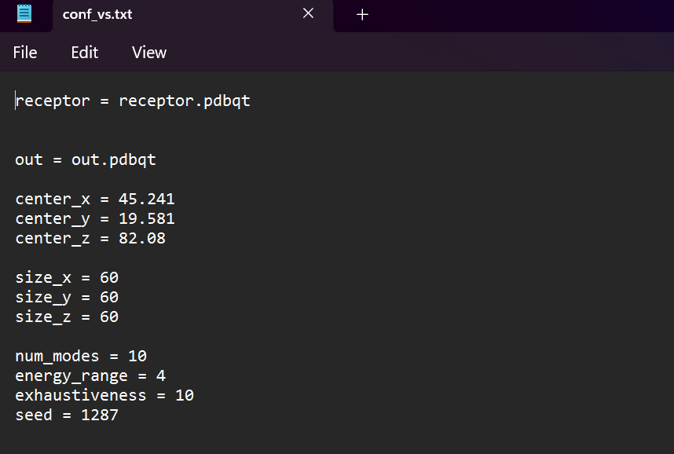

Running Autodock Vina:

Opened a terminal or command prompt and navigated to the directory containing the config.txt file and the Autodock Vina executable.



b. Ran Autodock Vina using the following commands:

1. Dir /p > ligand.txt



After ran this command ‘ligand.txt’ file generated in the folder that contained names of all ligands.



2. perl Vina_windows.pl



After this command was run, the software asks about ligand file name write ‘ligand.txt’ and Autodock Vina started running.

Analyze the Results:

After the docking was completed, Autodock Vina generated output files containing the predicted binding poses and their corresponding binding energies.

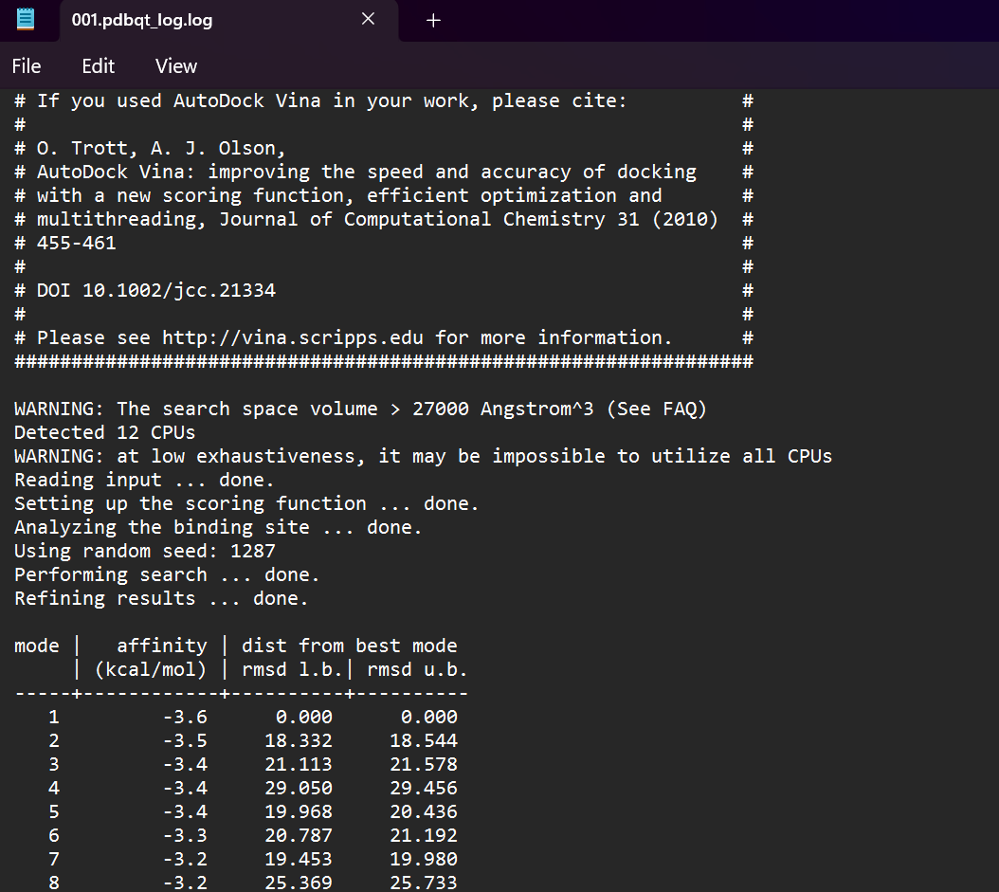

# Appendix III List of tools and databases

|  |  |  |  |
| --- | --- | --- | --- |
| S.No. | Database/tool | Purpose | Weblinks/Reference |
| 1. | Protein Data Bank (PDB) | Obtained 3D structure of proteins | <http://www.rcsb.org/pdb> |
| 2. | AlphaFold protein structure database | Obtained 3D structure of proteins | <https://alphafold.ebi.ac.uk/> |
| 3. | Protein Repair and Analysis Server (PRAS) | Repaired target proteins | <https://www.protein-science.com/> |
| 4. | COACH server | Active site prediction of target proteins | <https://zhanggroup.org/COACH/> |
| 5. | LOTUS database | Downloaded library of phytochemicals | <https://lotus.naturalproducts.net/download> |
| 6. | HelixADMET (H-ADMET) | ADMET properties prediction | <https://paddlehelix.baidu.com/app/drug/admet/train> |
| 7. | PubChem database | Downloaded structures of ligands | <https://pubchem.ncbi.nlm.nih.gov/> |
| 8. | Open babel GUI software | Preparation of ligands | <https://openbabel.org/wiki/Main_Page> |
| 9. | MGL Tools | Target proteins preparations | <https://ccsb.scripps.edu/mgltools/downloads/> |
| 10. | Autodock Vina | For molecular docking | <https://vina.scripps.edu/downloads/> |
| 11. | BIOVIA Discovery Studio Visualizer | For visualizing protein and ligand interactions | <https://discover.3ds.com/discovery-studio-visualizer-download> |

# Appendix IV Molecular docking results

| **Sr. No.** | **Name** | **EstA** | **OprG** | **OprD** | **OprF** | **ExoT** | **LasA** | **LasB** | **AprA** | **OprH** | **OprQ** | **PIV** | **PilA** | **PilB** | **PilY** | **FliC** | **PilT** | **FliD** | **ExoU** |
| --- | --- | --- | --- | --- | --- | --- | --- | --- | --- | --- | --- | --- | --- | --- | --- | --- | --- | --- | --- |
| 1 | Xylitol | -4.9 | -4.1 | -4.7 | -4.1 | -4.7 | -5.0 | -4.5 | -4.9 | -4.2 | -4.8 | -5.8 | -3.9 | -5.1 | -5.1 | -4.6 | -4.5 | -3.7 | -5.4 |
| 2 | (-)-Citronellol | -6.0 | -4.0 | -4.7 | -3.9 | -4.4 | -4.5 | -4.3 | -5.1 | -4.4 | -5.0 | -4.3 | -3.9 | -4.3 | -4.6 | -4.0 | -5.1 | -4.0 | -5.4 |
| 3 | Citronellal | -5.8 | -4.5 | -5.0 | -4.0 | -5.4 | -5.4 | -4.5 | -4.7 | -4.2 | -4.6 | -4.3 | -3.6 | -4.7 | -4.8 | -4.3 | -4.8 | -4.0 | -5.4 |
| 4 | beta-Terpineol | -6.5 | -4.9 | -5.3 | -4.5 | -5.9 | -5.2 | -5.0 | -5.8 | -4.9 | -5.2 | -5.1 | -3.9 | -4.8 | -5.2 | -4.6 | -4.9 | -4.2 | -5.6 |
| 5 | Conhydrine | -5.0 | -4.5 | -4.9 | -5.2 | -5.5 | -5.0 | -4.7 | -4.6 | -4.6 | -5.0 | -5.3 | -4.0 | -4.8 | -5.7 | -4.2 | -4.9 | -4.0 | -5.2 |
| 6 | Cyclohexene, 1-methyl-3-(1-methylethenyl)- | -7.0 | -4.9 | -5.3 | -4.3 | -6.4 | -6.7 | -4.7 | -5.5 | -5.2 | -5.2 | -4.9 | -4.4 | -5.1 | -6.1 | -5.0 | -5.4 | -4.2 | -6.5 |
| 7 | Terpinolene | -7.2 | -5.2 | -5.8 | -4.7 | -5.1 | -6.1 | -4.6 | -5.6 | -5.1 | -5.4 | -5.3 | -4.8 | -5.0 | -6.6 | -4.8 | -5.3 | -4.7 | -6.5 |
| 8 | 3-Methylcyclohexanol | -5.2 | -4.5 | -4.5 | -4.2 | -5.8 | -4.4 | -4.1 | -4.5 | -4.4 | -4.4 | -4.2 | -3.6 | -4.5 | -5.6 | -4.7 | -4.2 | -4.2 | -5.0 |
| 9 | Isopropylcyclohexane | -6.5 | -4.4 | -5.0 | -4.3 | -6.1 | -6.1 | -4.4 | -4.9 | -4.7 | -4.8 | -4.6 | -3.9 | -4.6 | -6.1 | -4.8 | -4.6 | -3.9 | -5.0 |
| 10 | (2R,3R,4S,5S)-2,3,4,5-tetrahydroxyhexanal | -5.1 | -4.1 | -4.7 | -4.4 | -5.3 | -5.3 | -4.8 | -5.2 | -4.6 | -4.9 | -6.1 | -4.0 | -5.1 | -5.3 | -3.7 | -4.8 | -3.5 | -5.7 |
| 11 | L-xylulose | -4.9 | -4.3 | -4.7 | -4.6 | -4.5 | -3.8 | -4.5 | -4.8 | -4.0 | -4.3 | -5.8 | -3.9 | -4.2 | -4.8 | -3.6 | -5.2 | -4.1 | -5.6 |
| 12 | Limonene | -7.0 | -5.0 | -5.3 | -4.3 | -6.4 | -6.0 | -4.7 | -5.4 | -4.9 | -5.3 | -5.0 | -4.3 | -5.0 | -5.4 | -4.9 | -5.2 | -4.2 | -5.8 |
| 13 | 2-Piperidineethanamine | -4.8 | -3.9 | -4.5 | -4.6 | -5.2 | -4.6 | -4.0 | -4.5 | -4.2 | -4.5 | -5.2 | -3.5 | -4.6 | -5.6 | -4.2 | -4.9 | -3.9 | -5.2 |
| 14 | 5-methylheptan-2-one | -5.3 | -3.8 | -4.5 | -3.6 | -5.1 | -5.8 | -4.1 | -4.0 | -4.0 | -4.0 | -4.2 | -3.1 | -4.3 | -4.2 | -3.6 | -4.4 | -3.7 | -4.8 |
| 15 | 2,6-Dimethyl-5-heptenal | -5.9 | -4.3 | -4.8 | -3.8 | -5.5 | -5.4 | -4.3 | -4.1 | -4.0 | -4.5 | -4.7 | -3.8 | -4.3 | -5.0 | -3.8 | -4.7 | -4.0 | -5.1 |
| 16 | dec-4-enal | -5.5 | -4.2 | -4.5 | -3.4 | -4.0 | -5.2 | -4.0 | -4.8 | -4.2 | -4.4 | -4.3 | -3.5 | -4.3 | -4.3 | -3.9 | -5.0 | -3.6 | -5.1 |
| 17 | (2z)-non-2-en-1-ol | -5.5 | -4.0 | -4.3 | -3.8 | -4.0 | -4.9 | -4.0 | -4.2 | -4.0 | -4.2 | -4.3 | -3.4 | -4.1 | -4.6 | -3.7 | -4.3 | -3.6 | -5.0 |
| 18 | (2S,3S,4R)-2,3,4,5-tetrahydroxypentanal | -4.7 | -4.1 | -4.8 | -4.2 | -5.1 | -4.8 | -4.5 | -5.0 | -4.4 | -4.6 | -5.8 | -4.0 | -4.7 | -4.6 | -3.6 | -4.9 | -4.1 | -5.6 |
| 19 | (2S,3R,4R)-2,3,4,5-tetrahydroxypentanal | -4.6 | -3.9 | -4.5 | -3.9 | -4.7 | -5.0 | -4.3 | -4.8 | -4.1 | -4.6 | -5.6 | -3.9 | -4.4 | -5.3 | -4.6 | -4.9 | -3.9 | -5.6 |
| 20 | (S)-3,7-Dimethyl-1,6-octadien-3-ol | -5.8 | -4.9 | -4.8 | -4.0 | -4.4 | -4.6 | -4.3 | -4.7 | -4.4 | -4.7 | -4.3 | -3.4 | -4.6 | -4.5 | -4.3 | -4.7 | -3.7 | -5.0 |
| 21 | 3-Cyclohepten-1-one | -5.4 | -4.1 | -4.8 | -3.9 | -4.6 | -4.6 | -4.1 | -4.3 | -4.5 | -4.5 | -4.5 | -3.6 | -4.6 | -5.5 | -3.9 | -4.4 | -3.9 | -5.3 |
| 22 | Fagomine | -5.1 | -4.1 | -5.1 | -4.5 | -5.2 | -5.4 | -4.5 | -5.1 | -4.4 | -5.0 | -4.7 | -4.3 | -5.2 | -5.7 | -4.2 | -5.0 | -4.7 | -5.8 |
| 23 | (R)-(+)-Citronellal | -5.8 | -4.5 | -4.9 | -3.8 | -4.0 | -5.9 | -4.5 | -4.8 | -4.3 | -4.9 | -4.4 | -3.2 | -4.6 | -4.5 | -4.2 | -5.0 | -4.2 | -5.1 |
| 24 | 4-Ethylcyclohexanone | -6.0 | -4.0 | -4.8 | -3.8 | -5.8 | -4.8 | -4.4 | -4.8 | -4.6 | -4.5 | -4.5 | -3.6 | -4.8 | -4.8 | -3.9 | -4.8 | -4.0 | -5.2 |
| 25 | p-Menth-1-en-9-ol | -6.9 | -5.0 | -5.8 | -4.6 | -6.4 | -6.5 | -5.2 | -5.5 | -5.1 | -5.5 | -6.0 | -4.3 | -5.2 | -6.0 | -4.8 | -5.2 | -4.5 | -5.9 |
| 26 | L-Ribose | -4.5 | -4.1 | -4.8 | -4.1 | -4.7 | -4.8 | -4.5 | -5.2 | -4.2 | -4.5 | -5.9 | -4.0 | -4.3 | -5.2 | -4.0 | -4.6 | -3.9 | -5.3 |
| 27 | 4-Acetyl-1-methylcyclohexene | -5.4 | -4.4 | -5.4 | -4.3 | -5.3 | -5.2 | -5.0 | -5.0 | -4.5 | -4.9 | -4.8 | -4.0 | -4.7 | -5.4 | -4.2 | -4.7 | -4.5 | -5.9 |
| 28 | 6-Deoxyglucose | -4.9 | -4.1 | -4.5 | -4.2 | -5.0 | -5.4 | -4.8 | -4.8 | -4.1 | -5.2 | -5.8 | -4.1 | -4.6 | -4.7 | -4.3 | -4.9 | -4.0 | -5.6 |
| 29 | (2S,3R,4R,5R)-2,3,4,5,6-pentahydroxyhexanal | -5.1 | -4.1 | -4.8 | -4.6 | -4.9 | -5.2 | -4.2 | -4.8 | -4.1 | -5.1 | -6.1 | -3.9 | -4.9 | -5.2 | -4.3 | -4.6 | -4.0 | -5.8 |
| 30 | 3,4-Dimethylcyclohexanol | -5.8 | -4.5 | -5.3 | -4.4 | -6.2 | -5.6 | -4.5 | -4.8 | -4.4 | -4.8 | -5.8 | -3.7 | -5.2 | -5.1 | -4.2 | -5.1 | -4.1 | -5.7 |
| 31 | aldehydo-D-talose | -5.0 | -4.1 | -4.9 | -4.6 | -5.0 | -5.5 | -4.3 | -5.5 | -4.6 | -4.9 | -6.2 | -4.1 | -4.6 | -5.1 | -5.0 | -4.7 | -4.2 | -5.5 |
| 32 | D-Citronellol | -5.8 | -4.2 | -5.3 | -3.8 | -4.2 | -5.1 | -4.5 | -4.9 | -4.5 | -4.5 | -4.4 | -3.6 | -4.6 | -4.5 | -3.7 | -4.7 | -3.6 | -5.4 |
| 33 | (2R,3R,4R,5R)-2,3,4,5,6-pentahydroxyhexanal | -5.0 | -4.2 | -4.6 | -4.5 | -5.1 | -5.0 | -4.0 | -5.1 | -4.3 | -5.1 | -5.8 | -3.9 | -4.8 | -5.6 | -3.9 | -5.0 | -3.8 | -6.0 |
| 34 | (2R,3S,4R,5R)-2,3,4,5,6-pentahydroxyhexanal | -5.0 | -4.3 | -5.0 | -4.2 | -5.4 | -5.7 | -4.6 | -4.7 | -4.4 | -5.3 | -6.4 | -4.0 | -4.7 | -5.2 | -4.9 | -4.6 | -3.9 | -5.7 |
| 35 | 2-deoxy-D-glucose | -4.9 | -3.9 | -4.2 | -4.3 | -4.7 | -5.3 | -4.2 | -5.3 | -4.2 | -5.0 | -5.9 | -3.9 | -4.9 | -5.0 | -4.3 | -4.9 | -3.9 | -5.6 |
| 36 | 3,7-dimethyl-3,6-octadienal | -6.2 | -4.6 | -4.8 | -4.4 | -5.3 | -4.4 | -4.1 | -5.0 | -4.7 | -4.6 | -4.6 | -3.6 | -4.6 | -4.8 | -4.3 | -5.0 | -3.9 | -5.4 |
| 37 | (3z)-3,7-dimethylocta-3,6-dienal | -6.3 | -4.6 | -5.0 | -4.4 | -5.6 | -4.3 | -4.6 | -5.3 | -4.4 | -4.8 | -5.1 | -3.9 | -4.6 | -5.2 | -3.6 | -4.8 | -4.1 | -5.6 |
| 38 | (1R,2S,5R)-2-methyl-5-[(2S)-1-oxopropan-2-yl]cyclopentane-1-carboxylic acid | -5.5 | -4.8 | -5.9 | -5.1 | -6.1 | -5.6 | -5.6 | -5.0 | -4.8 | -5.3 | -5.1 | -4.4 | -5.0 | -5.9 | -4.5 | -5.7 | -4.2 | -6.0 |
| 39 | 2-Cyclohexen-1-ol, 1-methyl-4-(1-methylethyl)-, trans- | -6.8 | -4.8 | -5.7 | -4.9 | -6.5 | -4.7 | -5.1 | -5.4 | -5.0 | -5.2 | -5.1 | -4.1 | -5.2 | -6.0 | -5.2 | -5.2 | -4.5 | -6.0 |
| 40 | cis-4-(Isopropyl)-1-methylcyclohex-2-en-1-ol | -6.7 | -4.9 | -5.5 | -4.7 | -6.4 | -5.2 | -5.2 | -5.6 | -5.0 | -5.2 | -5.9 | -4.3 | -5.0 | -6.0 | -4.9 | -5.2 | -4.4 | -5.8 |
| 41 | 2,5-Dideoxy-2,5-imino-D-mannitol | -5.2 | -4.3 | -5.0 | -4.6 | -5.6 | -5.5 | -4.6 | -5.3 | -4.5 | -5.3 | -6.5 | -4.3 | -5.0 | -5.1 | -4.3 | -5.2 | -4.3 | -5.8 |
| 42 | (1S,3R,4S,6R)-4-amino-6-(hydroxymethyl)cyclohexane-1,3-diol | -5.1 | -4.1 | -5.3 | -4.7 | -5.3 | -5.2 | -4.8 | -5.1 | -4.9 | -5.5 | -5.3 | -4.2 | -5.1 | -5.5 | -4.3 | -5.3 | -4.2 | -5.8 |
| 43 | 2,6-Dimethylocta-2,6-diene | -6.3 | -4.9 | -4.7 | -3.9 | -5.4 | -4.4 | -4.5 | -4.6 | -4.7 | -5.0 | -4.6 | -4.0 | -4.1 | -4.2 | -4.1 | -4.4 | -4.3 | -5.6 |
| 44 | 3-Methylhept-3-en-2-one | -5.4 | -4.0 | -4.6 | -4.0 | -5.3 | -5.5 | -4.3 | -4.4 | -4.4 | -4.4 | -4.4 | -3.4 | -4.6 | -5.4 | -3.9 | -4.7 | -3.9 | -5.3 |
| 45 | N-Methylglucosamine | -5.0 | -4.3 | -4.9 | -4.7 | -5.3 | -5.7 | -5.1 | -5.5 | -4.3 | -5.0 | -4.8 | -3.8 | -4.8 | -5.5 | -4.8 | -5.0 | -4.1 | -6.0 |
| 46 | Ribulose | -4.6 | -4.0 | -4.7 | -4.1 | -4.7 | -5.1 | -4.4 | -4.8 | -4.0 | -4.4 | -5.7 | -3.7 | -4.4 | -5.0 | -4.5 | -4.8 | -3.9 | -5.6 |
| 47 | 6-Deoxyglucitol | -5.3 | -4.5 | -5.1 | -4.5 | -4.9 | -5.3 | -5.1 | -4.8 | -4.3 | -5.0 | -5.8 | -3.7 | -4.6 | -5.4 | -4.1 | -4.7 | -4.4 | -5.7 |
| 48 | (2S,3S,4R,5R)-2,3,4,5,6-pentahydroxyhexanal | -5.2 | -4.5 | -4.8 | -4.5 | -5.5 | -5.2 | -4.7 | -4.7 | -4.4 | -4.9 | -6.3 | -4.0 | -5.0 | -5.7 | -3.8 | -5.1 | -4.2 | -6.0 |
| 49 | 3-Amino-3-deoxyglucose | -5.3 | -4.3 | -4.7 | -4.2 | -5.2 | -5.6 | -4.4 | -5.3 | -4.3 | -5.3 | -5.1 | -4.0 | -4.9 | -5.1 | -4.6 | -5.2 | -4.4 | -5.8 |
| 50 | Mycarose | -4.6 | -3.9 | -4.7 | -4.1 | -4.9 | -4.7 | -4.8 | -5.0 | -4.2 | -4.8 | -5.6 | -3.9 | -4.7 | -5.2 | -4.0 | -4.7 | -4.3 | -5.0 |
| 51 | (-)-Isopulegol | -6.7 | -5.1 | -5.5 | -4.7 | -6.6 | -5.0 | -5.1 | -5.2 | -5.2 | -5.2 | -5.3 | -4.0 | -4.9 | -5.9 | -4.9 | -4.9 | -5.1 | -6.1 |
| 52 | Mycosamine | -4.8 | -4.2 | -5.0 | -4.7 | -4.9 | -5.3 | -4.6 | -5.1 | -4.2 | -4.9 | -5.7 | -4.0 | -5.3 | -5.7 | -4.2 | -5.2 | -3.8 | -5.6 |
| 53 | Vicodiol | -5.5 | -4.8 | -6.1 | -4.7 | -4.9 | -5.2 | -4.8 | -5.0 | -4.8 | -5.3 | -5.0 | -4.1 | -5.2 | -6.1 | -4.5 | -4.7 | -4.5 | -5.9 |
| 54 | Pinidinol | -5.7 | -4.5 | -5.2 | -4.7 | -5.7 | -4.5 | -4.6 | -4.9 | -4.6 | -5.0 | -5.5 | -4.2 | -5.1 | -5.5 | -4.6 | -5.1 | -4.1 | -5.5 |
| 55 | 2-C-Hydroxymethyl-D-ribose | -4.7 | -4.3 | -4.9 | -3.9 | -5.2 | -5.0 | -4.3 | -5.0 | -4.3 | -5.0 | -5.7 | -3.8 | -4.7 | -4.8 | -4.1 | -5.0 | -4.1 | -6.1 |
| 56 | Octa-1,5-dien-3-ol | -5.2 | -4.1 | -4.2 | -4.1 | -4.2 | -5.5 | -4.2 | -4.5 | -4.1 | -4.3 | -4.5 | -3.4 | -4.2 | -5.3 | -4.0 | -4.4 | -3.7 | -4.7 |
| 57 | (-)-Limonene | -7.0 | -5.1 | -5.2 | -4.4 | -6.4 | -6.1 | -4.7 | -5.3 | -4.9 | -5.2 | -5.2 | -4.1 | -5.1 | -6.7 | -4.9 | -5.2 | -4.3 | -5.4 |
| 58 | L-arabinitol | -4.9 | -4.1 | -4.8 | -4.6 | -4.8 | -4.0 | -4.7 | -5.2 | -4.1 | -4.8 | -5.7 | -3.9 | -4.2 | -5.0 | -4.6 | -4.9 | -4.1 | -5.3 |
| 59 | 6-deoxy-L-sorbose | -4.9 | -4.3 | -4.3 | -4.4 | -4.8 | -5.6 | -4.4 | -4.7 | -4.2 | -4.5 | -5.7 | -3.7 | -5.1 | -5.6 | -3.6 | -5.1 | -3.6 | -5.8 |
| 60 | (2S)-2-hydroxy-2-methyl-3-oxobutanoic acid | -5.0 | -3.9 | -4.9 | -4.5 | -5.2 | -5.2 | -4.5 | -4.8 | -4.2 | -4.5 | -4.7 | -3.9 | -4.7 | -5.3 | -4.1 | -4.9 | -4.1 | -5.6 |
| 61 | D-Limonene | -7.1 | -5.1 | -5.3 | -4.3 | -6.4 | -6.4 | -4.7 | -5.4 | -4.9 | -5.2 | -4.9 | -4.1 | -5.1 | -5.2 | -5.0 | -5.4 | -4.2 | -5.9 |
| 62 | (R)-Linalyl acetate | -5.8 | -4.8 | -5.3 | -4.3 | -6.3 | -4.7 | -5.1 | -4.8 | -5.1 | -5.2 | -5.0 | -4.2 | -5.1 | -5.7 | -4.5 | -5.2 | -3.9 | -6.0 |
| 63 | (S)-(-)-Citronellal | -5.4 | -4.3 | -5.0 | -4.2 | -5.7 | -5.3 | -4.4 | -4.5 | -4.4 | -4.5 | -4.4 | -3.6 | -4.9 | -4.9 | -4.2 | -5.0 | -3.8 | -5.0 |
| 64 | (-)-Linalool | -6.1 | -4.6 | -4.5 | -3.8 | -5.3 | -4.1 | -4.3 | -4.4 | -4.3 | -4.9 | -4.7 | -3.4 | -4.1 | -4.8 | -3.9 | -4.2 | -3.6 | -5.3 |
| 65 | (1R,2S,4R)-Neo-dihydrocarveol | -5.8 | -5.0 | -5.4 | -4.6 | -4.9 | -4.9 | -5.4 | -5.6 | -5.0 | -5.3 | -5.5 | -4.1 | -5.2 | -5.6 | -4.3 | -5.0 | -4.1 | -5.4 |
| 66 | L-Fucitol | -5.2 | -4.4 | -4.9 | -4.4 | -5.0 | -5.1 | -4.5 | -4.9 | -4.4 | -5.0 | -6.2 | -4.1 | -4.8 | -5.7 | -4.9 | -4.8 | -3.7 | -5.7 |
| 67 | 1,4-Dideoxy-1,4-imino-D-ribitol | -4.6 | -4.0 | -4.9 | -4.3 | -4.6 | -5.1 | -4.6 | -4.6 | -4.4 | -4.8 | -5.5 | -3.8 | -4.7 | -5.1 | -4.1 | -4.6 | -3.7 | -5.6 |
| 68 | P-Menth-1-en-9-al | -7.0 | -4.8 | -5.3 | -4.5 | -6.5 | -4.9 | -5.1 | -5.2 | -4.9 | -5.4 | -5.5 | -4.0 | -5.4 | -6.4 | -4.8 | -5.3 | -4.6 | -6.1 |
| 69 | 3-Methylcyclohex-3-en-1-one | -5.5 | -3.9 | -4.9 | -3.9 | -5.6 | -5.0 | -4.5 | -4.4 | -4.1 | -4.6 | -4.3 | -3.6 | -4.5 | -5.8 | -4.1 | -4.7 | -3.7 | -5.4 |
| 70 | 1-Cyclopentyl-1-propanol | -5.6 | -4.4 | -4.9 | -4.3 | -5.9 | -4.7 | -4.7 | -4.5 | -4.5 | -4.7 | -5.3 | -3.7 | -4.5 | -5.2 | -4.3 | -4.5 | -3.8 | -5.1 |
| 71 | Oct-6-EN-2-one | -5.3 | -3.9 | -4.4 | -3.8 | -4.9 | -5.5 | -4.2 | -3.9 | -4.1 | -4.2 | -4.2 | -3.1 | -4.4 | -4.3 | -3.9 | -4.3 | -3.9 | -5.0 |
| 72 | (-)-6,7-seco-Eudesm-7(11)-en-6-al | -6.4 | -5.4 | -6.4 | -4.8 | -5.6 | -5.4 | -5.2 | -5.3 | -5.5 | -5.8 | -5.2 | -4.7 | -5.7 | -6.4 | -5.3 | -5.5 | -4.6 | -6.5 |
| 73 | trans-3-Methylcyclohexanol | -5.2 | -4.5 | -4.5 | -4.2 | -5.8 | -4.4 | -4.1 | -4.5 | -4.4 | -4.4 | -4.2 | -3.6 | -4.5 | -5.6 | -4.7 | -4.2 | -4.2 | -5.0 |
| 74 | DL-Xylose | -4.7 | -3.6 | -4.8 | -4.6 | -4.9 | -5.1 | -4.6 | -5.0 | -4.2 | -4.9 | -5.8 | -4.0 | -4.7 | -4.8 | -3.7 | -4.9 | -3.9 | -5.1 |
| 75 | (2R,3R,4S,5R)-2-amino-3,4,5,6-tetrahydroxyhexanal | -5.2 | -4.3 | -4.8 | -4.7 | -5.2 | -4.7 | -4.5 | -4.8 | -4.3 | -5.2 | -5.0 | -3.6 | -4.9 | -5.4 | -4.0 | -4.5 | -3.7 | -5.9 |
| 76 | (2S,3R,4R,5S)-2,3,4,5-tetrahydroxyhexanal | -4.9 | -4.2 | -4.6 | -4.7 | -4.9 | -5.3 | -4.7 | -5.3 | -4.4 | -4.9 | -4.5 | -4.1 | -4.9 | -5.3 | -4.7 | -5.0 | -4.2 | -5.8 |
| 77 | (2R,3S,4S,5R)-2,3,4,5,6-pentahydroxyhexanal | -4.7 | -4.3 | -5.1 | -4.6 | -5.3 | -4.9 | -4.2 | -4.8 | -4.5 | -5.3 | -6.4 | -3.9 | -4.7 | -5.4 | -5.1 | -4.8 | -4.0 | -5.6 |
| 78 | Fucosamine | -5.1 | -3.8 | -4.9 | -4.1 | -4.9 | -4.9 | -4.9 | -5.4 | -4.5 | -4.9 | -4.6 | -4.0 | -4.8 | -5.5 | -3.9 | -4.7 | -3.8 | -5.7 |
| 79 | (2R,3R,4R)-2,3,4,5-tetrahydroxypentanal | -4.8 | -3.7 | -4.7 | -4.2 | -4.6 | -4.8 | -4.3 | -4.7 | -4.1 | -4.6 | -5.8 | -3.7 | -4.6 | -5.0 | -4.0 | -4.5 | -4.2 | -5.5 |
| 80 | 6-Deoxy-L-altrose | -5.1 | -3.9 | -4.5 | -4.7 | -4.9 | -5.3 | -4.4 | -4.7 | -4.2 | -4.9 | -5.7 | -3.7 | -4.7 | -5.4 | -5.1 | -4.8 | -3.9 | -5.8 |
| 81 | (-)-Terpinen-4-ol | -6.8 | -4.8 | -5.5 | -4.7 | -6.2 | -5.5 | -5.3 | -5.5 | -4.9 | -5.3 | -5.7 | -4.4 | -5.0 | -5.7 | -4.9 | -4.9 | -4.5 | -5.8 |
| 82 | D-Rhamnose | -4.7 | -4.2 | -4.8 | -3.8 | -4.6 | -5.2 | -5.0 | -5.0 | -4.8 | -4.9 | -5.9 | -3.8 | -4.8 | -5.5 | -4.8 | -5.0 | -4.0 | -5.6 |
| 83 | L-(+)-Arabinose | -4.8 | -4.0 | -4.6 | -4.4 | -4.9 | -5.5 | -4.7 | -5.1 | -4.3 | -4.7 | -5.6 | -3.8 | -4.8 | -5.0 | -3.7 | -4.4 | -3.6 | -5.2 |
| 84 | (R)-Lavandulol | -6.1 | -4.5 | -5.1 | -4.5 | -6.1 | -5.6 | -5.0 | -5.0 | -4.5 | -4.9 | -4.7 | -3.8 | -4.7 | -4.6 | -4.8 | -4.8 | -3.7 | -5.3 |
| 85 | Nepetalic acid | -5.4 | -5.0 | -5.8 | -5.1 | -6.0 | -5.7 | -5.7 | -5.5 | -5.0 | -5.2 | -5.3 | -4.2 | -5.2 | -6.2 | -4.6 | -5.7 | -4.5 | -6.5 |
| 86 | 4-Thujanol | -6.6 | -4.9 | -5.4 | -4.6 | -6.6 | -5.3 | -5.4 | -5.1 | -4.9 | -5.2 | -5.1 | -4.3 | -5.0 | -5.8 | -4.8 | -4.8 | -4.6 | -5.9 |
| 87 | gamma-Elemene | -6.5 | -5.7 | -6.5 | -5.5 | -5.4 | -5.3 | -5.4 | -5.6 | -5.7 | -6.1 | -5.9 | -4.8 | -5.7 | -5.6 | -4.8 | -6.0 | -5.1 | -6.6 |
| 88 | 6-Deoxyaltritol | -5.0 | -4.1 | -4.9 | -4.5 | -5.1 | -5.1 | -4.5 | -4.9 | -4.3 | -5.2 | -4.8 | -3.9 | -4.8 | -5.6 | -4.9 | -4.8 | -4.4 | -5.6 |
| 89 | L-fuculose | -4.9 | -4.2 | -4.5 | -4.0 | -5.0 | -5.6 | -4.5 | -4.8 | -4.5 | -4.8 | -6.4 | -3.7 | -4.7 | -5.3 | -4.6 | -4.9 | -4.1 | -5.5 |
| 90 | butyl (2R)-2-methylbutanoate | -5.5 | -4.0 | -4.2 | -3.7 | -3.8 | -4.1 | -3.9 | -4.4 | -4.0 | -3.8 | -4.2 | -3.1 | -3.9 | -4.2 | -3.2 | -4.8 | -3.3 | -5.1 |
| 91 | (3S)-7-methoxy-3,7-dimethyloctanal | -5.9 | -4.2 | -4.7 | -3.8 | -5.4 | -4.3 | -4.7 | -4.3 | -4.3 | -4.4 | -4.9 | -3.4 | -4.8 | -4.2 | -4.2 | -4.4 | -3.9 | -5.0 |
| 92 | (+)-Linalyl acetate | -5.8 | -4.9 | -5.0 | -4.3 | -4.5 | -4.8 | -5.0 | -5.1 | -4.6 | -4.8 | -4.8 | -3.8 | -4.9 | -4.9 | -4.5 | -5.2 | -4.2 | -5.2 |
| 93 | (1R,2R,5R)-5-Methyl-2-(prop-1-en-2-yl)cyclohexanol | -5.9 | -4.6 | -5.3 | -4.7 | -5.2 | -4.4 | -4.8 | -5.1 | -5.0 | -5.1 | -5.0 | -4.0 | -4.8 | -5.3 | -4.6 | -4.7 | -3.8 | -5.6 |
| 94 | (4S,5R)-5-(hydroxymethyl)oxolane-2,4-diol | -4.6 | -3.8 | -4.6 | -4.3 | -5.5 | -5.2 | -4.5 | -4.9 | -4.2 | -5.1 | -5.8 | -4.0 | -4.6 | -5.1 | -4.5 | -4.6 | -4.1 | -5.3 |
| 95 | (2r,3s,4s)-2-(Hydroxymethyl)pyrrolidine-3,4-diol | -4.7 | -4.0 | -4.4 | -4.2 | -4.9 | -5.0 | -4.3 | -4.9 | -4.3 | -4.7 | -5.8 | -3.7 | -4.6 | -5.3 | -4.6 | -4.7 | -4.0 | -5.3 |
| 96 | 6-Deoxy-DMDP | -5.2 | -4.0 | -4.9 | -4.5 | -5.3 | -5.3 | -4.6 | -4.7 | -4.5 | -5.2 | -4.6 | -4.2 | -5.2 | -5.2 | -4.4 | -4.8 | -4.5 | -5.7 |
| 97 | (-)-Valeranone | -6.8 | -5.7 | -6.6 | -5.6 | -5.0 | -6.1 | -6.1 | -5.9 | -6.0 | -6.4 | -6.0 | -4.7 | -6.5 | -5.9 | -5.5 | -5.8 | -5.2 | -6.7 |
| 98 | alpha-1-C-Ethylfagomine | -5.7 | -4.3 | -5.9 | -4.8 | -5.8 | -5.3 | -5.0 | -5.1 | -5.3 | -5.3 | -6.3 | -4.3 | -5.5 | -6.0 | -4.6 | -5.4 | -4.4 | -6.2 |
| 99 | 2,5-imino-2,5,6-trideoxy-D-manno-heptitol | -5.3 | -4.2 | -5.0 | -4.4 | -5.7 | -5.7 | -4.7 | -5.4 | -4.6 | -5.4 | -6.1 | -4.8 | -5.3 | -6.2 | -5.1 | -5.0 | -4.5 | -6.1 |
| 100 | 3,6-Dideoxy-D-arabino-hexose | -4.6 | -3.9 | -4.4 | -4.3 | -5.5 | -5.1 | -4.3 | -4.9 | -3.9 | -4.6 | -4.5 | -3.7 | -4.6 | -5.0 | -5.0 | -4.7 | -4.0 | -4.9 |
| 101 | 1-[(1R,3R)-1,3-dimethyl-2-methylidenecyclohexyl]-4-methylpentan-3-one | -6.6 | -5.2 | -6.0 | -4.7 | -5.2 | -5.9 | -5.3 | -5.6 | -5.6 | -5.7 | -5.3 | -4.6 | -5.3 | -6.3 | -4.8 | -5.5 | -4.5 | -6.2 |
| 102 | (+)-5-Deoxyadeenophorine | -5.5 | -4.0 | -5.2 | -4.9 | -5.8 | -5.2 | -4.8 | -5.0 | -4.8 | -5.6 | -5.8 | -4.3 | -5.4 | -5.4 | -5.0 | -4.9 | -4.8 | -6.3 |
| 103 | 3,4-epi-Fagomine | -5.0 | -4.2 | -4.7 | -4.7 | -5.3 | -5.3 | -4.7 | -4.7 | -4.5 | -5.0 | -5.1 | -3.9 | -4.9 | -5.3 | -4.0 | -4.9 | -4.1 | -5.6 |
| 104 | 1-Deoxy-d-glucitol | -5.2 | -4.2 | -4.9 | -4.3 | -4.7 | -5.3 | -4.6 | -5.0 | -4.4 | -5.0 | -5.9 | -4.0 | -4.7 | -5.7 | -4.2 | -4.7 | -3.9 | -5.6 |
| 105 | 1-Deoxy-D-xylitol | -4.8 | -4.1 | -4.8 | -4.1 | -4.8 | -4.6 | -4.6 | -4.5 | -4.0 | -4.6 | -5.5 | -4.0 | -4.5 | -4.9 | -4.4 | -4.6 | -3.7 | -5.3 |
| 106 | 2-Deoxy-D-erythro-pentitol | -4.6 | -3.9 | -4.2 | -4.0 | -4.3 | -4.8 | -4.0 | -4.4 | -3.9 | -4.5 | -5.8 | -3.6 | -4.6 | -4.9 | -3.8 | -4.4 | -3.6 | -4.9 |
| 107 | (1S,3R,4R,5R)-4-(2-hydroxyethyl)-5-(hydroxymethyl)-1-methylcyclopentane-1,3-diol | -5.3 | -4.1 | -5.4 | -4.7 | -4.8 | -4.8 | -4.6 | -5.3 | -4.6 | -5.2 | -4.8 | -4.5 | -5.4 | -5.2 | -4.7 | -5.6 | -4.1 | -6.2 |
| 108 | D-arabinofuranose | -5.2 | -4.1 | -5.1 | -4.6 | -5.3 | -5.3 | -4.3 | -5.1 | -4.5 | -5.0 | -6.4 | -4.2 | -4.9 | -5.6 | -4.3 | -4.9 | -4.2 | -5.7 |
| 109 | Z7Myl7H1AA | -5.9 | -4.3 | -5.3 | -4.3 | -5.1 | -5.6 | -4.9 | -5.0 | -4.7 | -4.8 | -5.3 | -3.8 | -5.1 | -5.3 | -4.5 | -4.7 | -4.7 | -5.8 |
| 110 | (2R,3R,4R,5S,6R)-2-(hydroxymethyl)-6-methylpiperidine-3,4,5-triol | -5.5 | -4.4 | -5.3 | -4.8 | -5.5 | -5.3 | -4.8 | -5.8 | -5.0 | -5.6 | -5.2 | -4.4 | -5.5 | -6.0 | -4.7 | -5.4 | -4.6 | -6.3 |
| 111 | (2s,6r)-2,6-Dimethyl-1,8-octanediol | -5.5 | -4.3 | -4.8 | -4.3 | -4.3 | -4.6 | -4.3 | -4.9 | -4.3 | -4.6 | -4.8 | -3.6 | -4.4 | -4.9 | -4.2 | -4.8 | -3.7 | -5.3 |
| 112 | Methyl (r)-citronellate | -6.2 | -4.5 | -5.0 | -4.0 | -4.2 | -4.7 | -4.7 | -4.9 | -4.3 | -4.8 | -5.0 | -3.7 | -5.5 | -4.8 | -4.3 | -4.7 | -4.1 | -5.3 |
| 113 | (-)-Dihydromyrcene | -6.3 | -4.7 | -4.5 | -3.8 | -4.0 | -5.2 | -4.4 | -4.6 | -4.5 | -4.4 | -4.1 | -3.7 | -4.5 | -4.5 | -4.3 | -4.6 | -3.8 | -5.2 |
| 114 | (2R)-2-[(1S)-4-methylcyclohex-3-en-1-yl]propane-1,2-diol | -6.7 | -5.1 | -5.9 | -4.7 | -5.4 | -5.5 | -5.4 | -5.9 | -5.0 | -5.7 | -6.0 | -4.4 | -6.2 | -6.0 | -5.5 | -5.1 | -4.3 | -6.2 |
| 115 | 1-Methyl-4-((hydroxymethyl)vinyl)-cyclohex-1-ene | -6.9 | -5.3 | -5.6 | -4.8 | -6.5 | -5.2 | -5.2 | -5.3 | -5.2 | -5.6 | -5.7 | -4.2 | -5.3 | -5.6 | -4.5 | -5.4 | -4.0 | -5.9 |
| 116 | (2R,5R)-5-[(2R)-1,2-dihydroxypropan-2-yl]-2-methyl-2-(4-oxopentyl)cyclohexan-1-one | -6.9 | -5.4 | -6.2 | -4.9 | -5.7 | -6.2 | -5.9 | -5.7 | -5.2 | -6.0 | -6.4 | -4.9 | -6.4 | -6.0 | -5.7 | -6.4 | -4.9 | -6.6 |
| 117 | (3R,6S)-6-hydroxymethylpiperidin-3-ol | -4.7 | -3.9 | -4.8 | -4.5 | -5.4 | -4.6 | -4.1 | -4.6 | -4.4 | -4.5 | -5.9 | -3.9 | -4.8 | -5.3 | -4.4 | -5.0 | -3.9 | -5.3 |
| 118 | 2-Pyrrolidinemethanol, 3-hydroxy-, (2R,3S)- | -4.5 | -3.8 | -4.3 | -4.2 | -4.8 | -4.8 | -4.1 | -4.4 | -4.2 | -4.5 | -5.6 | -3.7 | -4.6 | -4.8 | -4.3 | -4.3 | -3.7 | -5.1 |
| 119 | (2S,3S,4S,5S)-2,5-bis(hydroxymethyl)pyrrolidine-3,4-diol | -5.0 | -4.2 | -5.1 | -4.6 | -5.9 | -5.5 | -4.6 | -5.6 | -4.6 | -5.4 | -6.4 | -4.0 | -5.4 | -5.7 | -4.4 | -5.0 | -4.4 | -5.6 |
| 120 | 2-Cyclohexene-1-methanol | -5.2 | -4.2 | -4.8 | -4.2 | -5.6 | -5.1 | -4.6 | -4.4 | -4.2 | -4.3 | -5.1 | -3.6 | -4.9 | -5.2 | -4.3 | -4.7 | -4.3 | -5.1 |
| 121 | 2-Cyclohexene-1-ethanol | -5.7 | -4.2 | -4.9 | -4.4 | -5.6 | -4.4 | -4.6 | -4.6 | -4.5 | -4.8 | -5.6 | -3.8 | -5.0 | -5.0 | -4.7 | -4.8 | -4.0 | -5.6 |
| 122 | 2-C-methyl-D-erythritol | -4.6 | -3.9 | -4.4 | -4.1 | -4.8 | -4.8 | -4.3 | -4.6 | -4.0 | -4.7 | -5.7 | -4.1 | -4.3 | -4.9 | -3.4 | -4.4 | -4.0 | -5.3 |
| 123 | Methyl (3s)-3,7-dimethyloct-6-enoate | -6.1 | -4.3 | -5.1 | -4.2 | -5.0 | -4.9 | -4.9 | -4.5 | -4.5 | -4.6 | -5.4 | -3.7 | -4.8 | -4.7 | -3.8 | -4.8 | -3.5 | -5.7 |
| 124 | (+)-Lasiol | -6.6 | -4.6 | -5.2 | -4.2 | -4.8 | -5.2 | -4.4 | -4.7 | -4.7 | -4.8 | -5.4 | -3.8 | -4.5 | -4.9 | -4.1 | -4.6 | -4.3 | -5.5 |
| 125 | 6-Octene-1,3-diol, 3,7-dimethyl-, (3R)- | -5.6 | -4.3 | -5.2 | -4.4 | -5.9 | -4.9 | -4.9 | -4.8 | -4.5 | -5.1 | -5.7 | -3.8 | -4.9 | -5.5 | -4.6 | -5.2 | -4.3 | -5.2 |
| 126 | (6S)-3-methyl-6-propan-2-ylcyclohex-3-en-1-one | -6.2 | -4.6 | -5.5 | -4.3 | -5.0 | -5.8 | -4.8 | -5.3 | -4.6 | -5.4 | -4.9 | -3.8 | -5.2 | -5.2 | -4.4 | -5.0 | -4.2 | -5.4 |
| 127 | (2S,3S,4S,5R)-2-(Hydroxymethyl)-5-methylpyrrolidine-3,4-diol | -5.5 | -4.2 | -4.8 | -4.8 | -5.5 | -5.2 | -4.4 | -5.3 | -4.6 | -5.1 | -5.7 | -3.9 | -5.2 | -5.4 | -5.1 | -5.1 | -3.9 | -5.6 |
| 128 | (+)-m-Mentha-1(6),8-diene | -6.0 | -4.9 | -5.3 | -4.4 | -6.8 | -6.4 | -4.7 | -5.0 | -5.0 | -5.2 | -4.9 | -4.4 | -5.2 | -6.0 | -4.9 | -5.3 | -4.3 | -6.0 |
| 129 | 6-deoxy-3-O-methyl-allose | -4.7 | -4.0 | -4.8 | -4.7 | -5.2 | -4.9 | -4.3 | -4.6 | -4.2 | -4.9 | -6.3 | -3.7 | -5.0 | -5.3 | -4.8 | -4.8 | -3.7 | -5.2 |
| 130 | Secothujene | -5.7 | -4.5 | -5.6 | -4.4 | -4.5 | -5.1 | -4.7 | -4.9 | -4.8 | -5.1 | -5.2 | -4.1 | -4.9 | -4.8 | -4.7 | -5.0 | -4.3 | -6.6 |
| 131 | (+)-p-Menta-1-en-9-ol | -7.0 | -5.0 | -5.5 | -4.5 | -6.5 | -4.9 | -5.1 | -5.5 | -5.1 | -5.4 | -5.6 | -4.2 | -5.3 | -5.6 | -5.2 | -5.3 | -4.7 | -6.0 |
| 132 | Santolinic acid methyl | -5.7 | -4.5 | -5.4 | -4.3 | -4.4 | -4.7 | -4.7 | -4.7 | -4.6 | -4.9 | -5.2 | -3.8 | -4.8 | -4.4 | -3.9 | -4.7 | -4.1 | -5.3 |
| 133 | (Z)-p-Menth-2-en-1-ol | -6.7 | -4.9 | -5.4 | -4.7 | -6.4 | -5.0 | -5.4 | -5.7 | -5.0 | -5.2 | -5.3 | -4.2 | -5.0 | -6.3 | -4.7 | -5.1 | -4.3 | -5.8 |
| 134 | (4R)-4-[(3S,4R,5R,10S,13R,14R,17R)-3-hydroxy-4-(hydroxymethyl)-4,10,13,14-tetramethyl-7,11,15-trioxo-1,2,3,5,6,12,16,17-octahydrocyclopenta[a]phenanthren-17-yl]pentanoic acid | -8.6 | -6.6 | -8.1 | -6.1 | -7.4 | -6.4 | -7.9 | -8.8 | -7.6 | -8.7 | -7.2 | -6.5 | -7.4 | -8.5 | -6.7 | -7.9 | -6.3 | -8.6 |
| 135 | L-rhamnulose | -5.2 | -3.9 | -4.8 | -3.8 | -5.0 | -5.1 | -4.4 | -5.1 | -4.5 | -4.8 | -5.9 | -3.9 | -5.0 | -5.4 | -4.6 | -5.3 | -4.1 | -5.8 |
| 136 | 2-o-Methylxylose | -4.5 | -3.8 | -4.4 | -4.4 | -4.4 | -4.3 | -4.1 | -4.6 | -3.9 | -4.4 | -5.8 | -3.9 | -4.6 | -4.7 | -4.1 | -4.8 | -4.0 | -5.4 |
| 137 | (2R)-2-[(1R)-4-methylcyclohex-3-en-1-yl]propane-1,2-diol | -6.8 | -5.2 | -6.0 | -5.0 | -6.8 | -5.4 | -5.3 | -5.8 | -5.1 | -5.7 | -5.5 | -4.4 | -5.5 | -5.9 | -5.2 | -5.4 | -5.2 | -6.2 |
| 138 | 3-Cyclohexene-1-carboxaldehyde, 4-(1-methylethyl)- | -6.4 | -4.5 | -5.5 | -4.5 | -6.0 | -5.3 | -4.7 | -5.2 | -4.8 | -5.2 | -5.0 | -4.0 | -4.7 | -5.3 | -4.8 | -5.0 | -4.1 | -5.9 |
| 139 | 3-Hydroxy-2-(hydroxymethyl)pyrrolidine | -4.5 | -3.8 | -4.3 | -4.2 | -4.8 | -4.8 | -4.1 | -4.4 | -4.2 | -4.5 | -5.6 | -3.7 | -4.6 | -4.8 | -4.3 | -4.3 | -3.7 | -5.1 |
| 140 | (betaR,3S)-3alpha-Acetyl-3aalpha,beta-dihydroxy-7aalpha,beta-dimethyl-5alpha-hydrindaneethanol | -6.4 | -5.6 | -6.4 | -5.4 | -6.1 | -6.1 | -6.2 | -6.7 | -5.7 | -6.8 | -6.4 | -5.3 | -6.5 | -6.6 | -5.8 | -6.2 | -5.3 | -7.6 |
| 141 | 6-(Hydroxymethyl)piperidin-3-ol | -4.8 | -4.0 | -4.6 | -4.0 | -5.4 | -4.8 | -4.4 | -5.0 | -4.1 | -4.6 | -6.1 | -4.1 | -4.8 | -5.1 | -4.5 | -4.7 | -4.1 | -5.4 |
| 142 | 5-Thio-d-mannose | -4.7 | -4.1 | -4.3 | -4.0 | -4.8 | -4.7 | -4.9 | -4.8 | -4.3 | -5.0 | -6.0 | -3.7 | -4.8 | -4.7 | -3.8 | -4.9 | -4.3 | -5.6 |
| 143 | 2-o-Methylgalactose | -4.8 | -4.3 | -4.8 | -4.6 | -4.9 | -5.3 | -5.1 | -5.4 | -4.4 | -5.0 | -5.7 | -3.9 | -4.8 | -5.4 | -3.7 | -4.9 | -4.1 | -5.8 |
| 144 | 2,5-dideoxy-2,5-imino-D-fucitol | -4.8 | -4.0 | -4.8 | -3.8 | -5.2 | -5.3 | -4.5 | -5.1 | -4.4 | -5.1 | -4.7 | -3.8 | -5.1 | -5.2 | -4.8 | -4.8 | -4.2 | -5.5 |
| 145 | (3R)-3-methyl-5-[(1S,6R)-1,2,6-trimethylcyclohex-2-en-1-yl]pent-1-en-3-ol | -6.5 | -5.4 | -5.8 | -4.5 | -5.0 | -5.4 | -5.3 | -5.8 | -5.5 | -6.1 | -5.9 | -4.3 | -5.3 | -6.0 | -5.4 | -5.1 | -4.6 | -6.2 |
| 146 | Ampelomin F | -5.3 | -4.4 | -4.9 | -4.4 | -6.3 | -4.9 | -4.8 | -5.1 | -4.6 | -5.2 | -6.1 | -4.0 | -5.0 | -5.8 | -4.7 | -4.7 | -4.5 | -5.5 |
| 147 | Lucinone | -6.5 | -5.4 | -6.6 | -5.2 | -5.4 | -5.9 | -6.4 | -6.2 | -6.1 | -6.9 | -6.2 | -5.1 | -6.9 | -6.7 | -5.9 | -6.1 | -5.0 | -7.6 |
| 148 | (2R,3S,4S,5S)-2-(2-hydroxyethyl)-5-(hydroxymethyl)pyrrolidine-3,4-diol | -5.4 | -4.6 | -5.0 | -4.6 | -5.9 | -5.1 | -4.4 | -5.7 | -4.7 | -5.3 | -6.1 | -3.9 | -5.2 | -6.2 | -4.2 | -5.1 | -4.4 | -6.1 |
| 149 | Methyl (3e)-3-methylpent-3-enoate | -5.0 | -4.0 | -4.5 | -3.8 | -4.7 | -5.6 | -4.3 | -4.1 | -4.1 | -4.2 | -4.6 | -3.3 | -4.2 | -4.3 | -3.7 | -4.6 | -3.8 | -4.7 |
| 150 | (1S,2R,3R)-3-(2-hydroxyethyl)-2-(hydroxymethyl)-1-methylcyclopentan-1-ol | -5.2 | -4.4 | -5.3 | -4.3 | -5.6 | -4.8 | -4.7 | -5.5 | -4.5 | -5.3 | -4.8 | -4.3 | -5.1 | -5.4 | -4.7 | -4.8 | -4.4 | -5.9 |
| 151 | (3R)-1,3-dihydroxydec-8-en-5-one | -5.8 | -4.4 | -4.9 | -4.1 | -6.0 | -4.8 | -4.7 | -4.8 | -4.2 | -5.2 | -5.3 | -3.6 | -4.7 | -5.0 | -4.1 | -5.1 | -3.9 | -5.5 |
| 152 | (2R,3S,4S,5R)-2,4,5,6-Tetrahydroxy-3-methoxyhexanal | -4.9 | -4.1 | -4.7 | -4.6 | -4.7 | -5.5 | -4.6 | -5.3 | -4.7 | -4.9 | -5.6 | -4.0 | -5.1 | -5.3 | -4.2 | -4.9 | -3.9 | -5.7 |
| 153 | Deoxyribulose | -4.8 | -3.5 | -4.4 | -4.4 | -4.5 | -5.0 | -4.2 | -4.6 | -4.0 | -4.4 | -4.5 | -3.5 | -4.7 | -4.8 | -3.9 | -4.6 | -3.8 | -5.5 |
| 154 | (3S,5S)-dec-8-ene-1,3,5-triol | -5.2 | -4.2 | -5.2 | -4.6 | -4.8 | -5.1 | -4.8 | -5.3 | -4.4 | -5.3 | -4.7 | -3.7 | -4.9 | -5.7 | -3.6 | -4.9 | -4.4 | -5.6 |
| 155 | D-Glucose-13C6,C-d7 | -5.1 | -4.5 | -4.9 | -4.7 | -4.8 | -5.7 | -4.2 | -4.9 | -4.1 | -5.1 | -6.2 | -3.9 | -4.8 | -5.5 | -3.9 | -5.0 | -4.4 | -5.8 |
| 156 | 2-Methyl-2-hepten-6-one-1-ol | -5.5 | -4.3 | -4.9 | -4.0 | -5.7 | -4.7 | -4.3 | -4.7 | -4.5 | -4.6 | -5.3 | -3.7 | -4.9 | -4.7 | -4.5 | -5.0 | -3.7 | -5.0 |
| 157 | 2,6-dimethylocta-2,7-diene-1,6-diol | -5.8 | -4.7 | -5.0 | -4.3 | -4.5 | -5.2 | -5.2 | -5.0 | -4.6 | -4.9 | -4.8 | -3.7 | -4.7 | -5.2 | -4.3 | -4.7 | -3.9 | -5.3 |
| 158 | (2e,6s)-2,6-dimethylocta-2,7-diene-1,6-diol | -5.8 | -4.7 | -5.0 | -4.3 | -4.5 | -5.2 | -5.2 | -5.0 | -4.6 | -4.9 | -4.8 | -3.7 | -4.7 | -5.2 | -4.3 | -4.7 | -3.9 | -5.3 |
| 159 | (6e)-8-hydroxylinalool | -5.8 | -4.7 | -5.0 | -4.3 | -4.5 | -5.2 | -5.2 | -5.0 | -4.6 | -4.9 | -4.8 | -3.7 | -4.7 | -5.2 | -4.3 | -4.7 | -3.9 | -5.3 |
| 160 | (2z,6s)-2,6-dimethylocta-2,7-diene-1,6-diol | -5.8 | -4.5 | -5.0 | -3.9 | -5.4 | -4.9 | -4.7 | -5.1 | -4.7 | -4.9 | -4.8 | -4.1 | -4.7 | -5.6 | -4.6 | -5.0 | -3.9 | -5.4 |
| 161 | (1S)-1-methyl-4-propan-2-ylcyclohex-3-en-1-ol | -6.5 | -5.0 | -5.4 | -4.7 | -6.4 | -4.7 | -4.9 | -5.6 | -5.0 | -5.3 | -5.0 | -4.2 | -5.0 | -5.2 | -4.1 | -5.1 | -4.3 | -5.8 |
| 162 | (S)-alpha-Citronellal | -5.8 | -4.2 | -4.9 | -4.0 | -5.4 | -5.3 | -4.3 | -4.1 | -4.0 | -4.3 | -4.2 | -3.5 | -4.7 | -4.8 | -4.1 | -4.6 | -3.8 | -5.3 |
| 163 | (2S)-2-[(1R)-4-methylcyclohex-3-en-1-yl]propanal | -6.8 | -5.0 | -5.5 | -4.4 | -6.5 | -5.7 | -5.0 | -5.3 | -5.0 | -5.4 | -5.5 | -4.2 | -5.2 | -5.3 | -4.6 | -5.2 | -4.6 | -5.7 |
| 164 | 3-methylbutyl (2R)-2-methylbutanoate | -5.8 | -4.2 | -5.0 | -4.0 | -4.3 | -4.2 | -4.4 | -4.8 | -4.1 | -4.8 | -4.6 | -3.7 | -4.3 | -4.4 | -3.7 | -4.8 | -4.1 | -4.9 |
| 165 | (2S,5R,10R)-6,10-Dimethyl-2-(1-methylethenyl)spiro[4.5]dec-6-ene | -7.3 | -5.8 | -6.3 | -5.4 | -5.5 | -5.9 | -5.7 | -6.0 | -6.1 | -6.2 | -6.2 | -4.9 | -6.0 | -6.5 | -5.6 | -5.6 | -5.0 | -6.6 |
| 166 | (1S,2R,5S)-2-(2-hydroxyethyl)-2,5-bis(hydroxymethyl)cyclohexan-1-ol | -5.4 | -4.4 | -5.4 | -4.9 | -4.8 | -4.9 | -5.3 | -5.4 | -4.5 | -5.4 | -5.4 | -4.5 | -5.2 | -5.5 | -4.7 | -5.3 | -5.0 | -6.1 |
| 167 | CID 91884924 | -5.6 | -4.6 | -5.6 | -4.4 | -6.0 | -4.9 | -4.9 | -4.7 | -4.6 | -5.0 | -5.4 | -4.0 | -5.3 | -5.2 | -4.2 | -4.9 | -4.7 | -5.7 |
| 168 | (2S,3R,4R,5S)-2-amino-3,4,5-trihydroxyhexanal | -4.8 | -4.1 | -4.9 | -4.2 | -5.0 | -5.3 | -4.7 | -4.8 | -4.0 | -4.9 | -4.9 | -3.9 | -4.8 | -5.8 | -4.8 | -4.8 | -4.1 | -5.9 |
| 169 | 5,15-Rosadiene-3,19-diol | -8.1 | -6.4 | -7.6 | -6.4 | -6.0 | -6.3 | -6.9 | -7.0 | -6.9 | -7.5 | -6.9 | -5.3 | -7.1 | -8.7 | -7.0 | -6.7 | -5.9 | -8.0 |
| 170 | Isofaurinone | -6.8 | -5.7 | -6.5 | -5.0 | -5.1 | -5.7 | -5.8 | -5.8 | -5.7 | -6.1 | -6.1 | -4.8 | -6.3 | -6.3 | -5.2 | -5.2 | -4.7 | -6.7 |
| 171 | 2beta-Methyl-6alpha-(hydroxymethyl)piperidine-3alpha,4alpha,5beta-triol | -5.3 | -4.4 | -5.2 | -4.8 | -5.6 | -5.7 | -4.7 | -5.5 | -5.1 | -6.0 | -6.1 | -4.7 | -5.4 | -5.7 | -4.8 | -5.3 | -4.6 | -6.2 |
| 172 | 5alpha-(Hydroxymethyl)cyclohexane-1beta,2alpha,3alpha-triol | -5.2 | -4.2 | -5.4 | -4.6 | -5.9 | -5.3 | -4.7 | -5.3 | -4.6 | -5.4 | -5.3 | -4.2 | -5.0 | -5.3 | -4.6 | -5.0 | -4.5 | -6.3 |
| 173 | (1S)-1-(Hydroxymethyl)-2alpha,3alpha-methano-3-isopropylcyclopentan-1alpha-ol | -5.7 | -4.5 | -5.8 | -4.7 | -5.6 | -5.0 | -4.7 | -5.5 | -4.8 | -5.2 | -5.0 | -4.0 | -5.2 | -5.5 | -5.0 | -5.0 | -5.1 | -6.7 |
| 174 | (S)-1-Methyl-3-isopropenyl-1-cyclohexene | -7.0 | -4.9 | -5.4 | -4.4 | -5.1 | -6.6 | -4.8 | -5.5 | -5.1 | -5.2 | -4.9 | -4.4 | -5.1 | -5.6 | -4.3 | -5.0 | -4.3 | -6.2 |
| 175 | p-Menthan-9-ol | -7.1 | -5.0 | -5.6 | -4.7 | -6.3 | -6.2 | -5.0 | -5.4 | -5.0 | -5.4 | -5.6 | -4.3 | -5.4 | -5.6 | -4.4 | -5.2 | -4.5 | -5.8 |
| 176 | (1R,2S,5S)-2-methyl-5-[(2R)-1-oxopropan-2-yl]cyclopentane-1-carboxylic acid | -6.6 | -4.9 | -5.9 | -5.1 | -4.7 | -5.8 | -5.5 | -5.2 | -5.1 | -5.2 | -5.6 | -4.5 | -5.7 | -5.6 | -4.7 | -5.5 | -4.6 | -6.5 |
| 177 | (1S,2S,5R)-2-acetyl-5-methylcyclopentane-1-carboxylic acid | -5.8 | -4.9 | -6.0 | -5.1 | -6.0 | -5.0 | -5.3 | -5.3 | -5.5 | -5.3 | -5.4 | -4.3 | -5.5 | -5.7 | -5.0 | -5.5 | -4.9 | -6.1 |
| 178 | (2S,3S,4S,5R)-2-(2-hydroxyethyl)-5-(hydroxymethyl)pyrrolidine-3,4-diol | -5.0 | -4.4 | -5.4 | -5.2 | -6.2 | -5.5 | -4.6 | -5.1 | -4.9 | -5.3 | -6.2 | -4.3 | -5.2 | -6.0 | -4.9 | -5.1 | -4.2 | -5.9 |
| 179 | (1S,2S,4S,7S)-7-(hydroxymethyl)-1,7-dimethylbicyclo[2.2.1]heptan-2-ol | -5.4 | -4.9 | -6.0 | -4.4 | -5.1 | -5.2 | -4.7 | -5.2 | -4.8 | -5.4 | -5.0 | -4.1 | -5.1 | -5.9 | -5.0 | -5.1 | -4.8 | -5.3 |
| 180 | Dl-fucosamin | -4.8 | -4.1 | -4.9 | -4.2 | -5.0 | -5.3 | -4.7 | -4.8 | -4.0 | -4.9 | -4.9 | -3.9 | -4.8 | -5.8 | -4.8 | -4.8 | -4.1 | -5.9 |
| 181 | (3R,6S)-2,6-dimethylocta-1,7-diene-3,6-diol | -5.8 | -4.6 | -4.7 | -3.9 | -5.8 | -4.8 | -4.8 | -4.9 | -4.5 | -5.2 | -5.3 | -3.3 | -4.7 | -4.7 | -4.5 | -4.8 | -3.9 | -5.2 |
| 182 | (2R)-2-ethenyl-6-methylhept-5-ene-1,2-diol | -5.8 | -4.8 | -4.7 | -4.6 | -4.2 | -5.0 | -4.3 | -5.2 | -4.2 | -5.1 | -5.6 | -3.9 | -4.8 | -5.0 | -4.6 | -4.9 | -4.0 | -5.8 |
| 183 | [(2R,4aR,8S,8aR)-2,5-dimethyl-8-propan-2-yl-3,4,4a,7,8,8a-hexahydro-1H-naphthalen-2-yl] thiocyanate | -6.9 | -5.3 | -6.2 | -5.2 | -5.2 | -5.4 | -5.8 | -6.1 | -5.8 | -6.3 | -5.9 | -4.7 | -6.0 | -6.8 | -6.0 | -5.9 | -4.6 | -6.7 |
| 184 | [(2S,3aS,4R,5R,7aS)-3a,4,5,7a-tetramethyl-3-methylidene-1,2,4,5,6,7-hexahydroinden-2-yl]methanol | -6.7 | -5.4 | -6.8 | -5.6 | -5.1 | -5.3 | -5.9 | -6.2 | -6.1 | -6.5 | -5.8 | -4.7 | -6.2 | -6.6 | -5.9 | -5.7 | -5.4 | -6.4 |
| 185 | (3R,6S)-6-methyl-2-methylideneoct-7-ene-1,3,6-triol | -5.6 | -4.2 | -4.9 | -4.3 | -5.0 | -4.8 | -5.0 | -5.4 | -5.0 | -4.9 | -5.2 | -3.8 | -4.8 | -5.3 | -4.5 | -5.0 | -4.0 | -5.6 |
| 186 | (2R,6R)-2-acetyl-4,4,6-trimethylcyclohexane-1,3-dione | -5.8 | -4.8 | -6.2 | -4.8 | -5.0 | -6.4 | -5.8 | -5.6 | -6.1 | -5.5 | -5.8 | -4.2 | -5.6 | -5.9 | -4.4 | -6.5 | -4.7 | -6.3 |
| 187 | (3R,4S)-3,7-dimethyloct-6-ene-1,4-diol | -6.0 | -4.5 | -5.1 | -4.5 | -5.9 | -4.8 | -4.8 | -4.9 | -4.6 | -5.3 | -4.9 | -3.9 | -5.0 | -5.6 | -4.5 | -5.0 | -4.1 | -5.6 |
| 188 | (3S,4S)-3,7-dimethyloct-6-ene-1,4-diol | -6.1 | -4.4 | -5.0 | -4.3 | -5.4 | -4.9 | -4.6 | -5.1 | -4.8 | -4.8 | -6.0 | -3.9 | -4.8 | -5.5 | -4.4 | -5.0 | -4.3 | -5.8 |
| 189 | (2R,4aR,4bS,8R,8aR,10aR)-2-ethenyl-8-(hydroxymethyl)-2,4a,8-trimethyl-1,3,4,4b,5,6,7,9,10,10a-decahydrophenanthren-8a-ol | -7.9 | -5.9 | -7.4 | -5.8 | -6.6 | -6.5 | -6.5 | -6.6 | -6.4 | -8.0 | -6.6 | -5.5 | -6.9 | -7.0 | -6.1 | -6.6 | -5.6 | -8.2 |
| 190 | (1R,3S,4aR,4bS,7R,10aR)-7-ethenyl-1-(hydroxymethyl)-1,4a,7-trimethyl-3,4,4b,5,6,9,10,10a-octahydro-2H-phenanthren-3-ol | -8.1 | -6.4 | -7.9 | -6.1 | -6.4 | -6.7 | -7.1 | -7.6 | -6.8 | -7.7 | -7.0 | -5.6 | -6.7 | -7.0 | -6.5 | -6.7 | -5.8 | -8.0 |
| 191 | (2S)-2-[4-(hydroxymethyl)cyclohexyl]propane-1,2-diol | -6.4 | -4.9 | -5.5 | -4.5 | -6.7 | -5.3 | -5.4 | -5.5 | -5.0 | -5.9 | -5.3 | -4.5 | -5.4 | -6.4 | -4.9 | -5.3 | -4.6 | -6.1 |
| 192 | (2S,3R,4R,5S,6S)-2-(hydroxymethyl)-6-methylpiperidine-3,4,5-triol | -5.4 | -4.3 | -5.1 | -4.7 | -6.0 | -5.5 | -4.8 | -5.3 | -5.0 | -5.5 | -5.3 | -4.3 | -5.8 | -5.9 | -4.9 | -5.5 | -4.4 | -6.0 |
| 193 | methyl (2R)-2,7-dimethyloct-6-enoate | -5.7 | -4.6 | -4.9 | -3.9 | -5.7 | -5.0 | -4.6 | -4.4 | -4.6 | -5.0 | -4.5 | -3.8 | -4.8 | -4.7 | -4.3 | -5.1 | -4.1 | -5.3 |
| 194 | (4aS,7S,8aR)-4a,8a-dimethyl-7-propan-2-yl-3,4,5,6,7,8-hexahydro-2H-naphthalen-1-one | -7.2 | -5.8 | -6.6 | -5.7 | -7.0 | -6.0 | -6.2 | -6.2 | -5.9 | -6.3 | -6.1 | -4.8 | -6.4 | -6.6 | -5.5 | -5.7 | -4.8 | -7.0 |
| 195 | (1S,2R,5R)-2-methyl-5-[(2R)-1-oxopropan-2-yl]cyclopentane-1-carboxylic acid | -6.1 | -4.9 | -6.0 | -5.2 | -6.1 | -5.7 | -5.6 | -5.5 | -5.1 | -5.4 | -5.6 | -4.4 | -5.6 | -6.3 | -4.9 | -5.6 | -4.9 | -6.5 |
| 196 | (6S)-6-hydroxy-6-methylocta-3,7-dien-2-one | -5.1 | -4.3 | -4.7 | -4.4 | -5.8 | -5.0 | -4.9 | -4.7 | -4.5 | -4.5 | -4.5 | -3.9 | -4.8 | -4.9 | -4.0 | -4.7 | -4.2 | -5.0 |
| 197 | (2S,5S)-5-methyl-2-(4-methylphenyl)heptan-4-one | -7.9 | -6.2 | -5.4 | -5.0 | -6.1 | -6.3 | -5.5 | -5.8 | -5.4 | -6.5 | -6.2 | -5.3 | -4.9 | -5.3 | -5.0 | -5.8 | -4.7 | -5.8 |
| 198 | 2-[(1S,2S)-1-methyl-2-prop-1-en-2-ylcyclobutyl]ethyl (2R)-2-methylbutanoate | -6.1 | -4.9 | -6.1 | -4.6 | -5.0 | -5.9 | -4.7 | -5.6 | -5.1 | -5.3 | -5.4 | -4.5 | -5.5 | -5.9 | -4.3 | -5.3 | -4.4 | -5.6 |
| 199 | 4-hydroxy-4-(3-hydroxybut-1-en-1-yl)-3-(hydroxymethyl)-3,5-dimethylcyclohexan-1-one | -5.4 | -5.0 | -6.3 | -4.9 | -4.6 | -4.7 | -5.1 | -5.6 | -5.2 | -5.9 | -4.9 | -4.4 | -5.3 | -6.5 | -4.7 | -5.7 | -5.0 | -6.1 |
| 200 | (3r,4s,5r)-4-hydroxy-4-[(1e,3r)-3-hydroxybut-1-en-1-yl]-3-(hydroxymethyl)-3,5-dimethylcyclohexan-1-one | -6.0 | -4.9 | -6.3 | -5.4 | -4.6 | -5.1 | -5.8 | -5.3 | -5.1 | -6.0 | -5.2 | -4.5 | -5.1 | -5.7 | -5.0 | -5.5 | -5.2 | -6.6 |
| 201 | Ribitol | -4.9 | -4.1 | -4.7 | -4.1 | -4.7 | -5.0 | -4.5 | -4.9 | -4.2 | -4.8 | -5.8 | -3.9 | -5.1 | -5.1 | -4.6 | -4.5 | -3.7 | -5.4 |
| 202 | 4-ethenyl-2,5-dimethylhexa-2,5-dien-1-ol | -6.0 | -4.4 | -5.3 | -4.5 | -5.0 | -4.8 | -4.4 | -4.8 | -4.9 | -4.9 | -4.9 | -3.8 | -4.8 | -4.6 | -3.5 | -4.8 | -4.0 | -5.5 |
| 203 | (2e,4r)-4-ethenyl-2,5-dimethylhexa-2,5-dien-1-ol | -5.3 | -4.3 | -5.3 | -4.0 | -4.4 | -5.6 | -4.3 | -4.4 | -4.8 | -4.9 | -4.6 | -3.9 | -4.6 | -4.5 | -3.9 | -4.8 | -4.3 | -5.7 |
| 204 | (2e)-4-ethenyl-2,5-dimethylhexa-2,5-dien-1-ol | -6.0 | -4.4 | -5.3 | -4.5 | -5.0 | -4.8 | -4.4 | -4.8 | -4.9 | -4.9 | -4.9 | -3.8 | -4.8 | -4.6 | -3.5 | -4.8 | -4.0 | -5.5 |
| 205 | 2,6-dimethylocta-3,6-diene-1,2,8-triol | -6.1 | -4.6 | -5.4 | -4.6 | -5.1 | -5.2 | -5.4 | -5.2 | -4.8 | -5.4 | -5.3 | -4.2 | -5.5 | -5.2 | -5.1 | -5.0 | -4.3 | -5.7 |
| 206 | (3e,6e)-2,6-dimethylocta-3,6-diene-1,2,8-triol | -5.8 | -4.6 | -5.5 | -4.3 | -6.3 | -5.0 | -4.9 | -4.9 | -4.7 | -5.5 | -5.5 | -4.2 | -5.5 | -5.5 | -4.6 | -5.2 | -4.2 | -5.8 |
| 207 | (2s,3e,6e)-2,6-dimethylocta-3,6-diene-1,2,8-triol | -5.9 | -4.9 | -5.4 | -4.4 | -6.4 | -5.1 | -5.5 | -4.8 | -4.6 | -5.2 | -5.1 | -4.1 | -5.4 | -5.8 | -4.5 | -5.0 | -4.6 | -6.0 |
| 208 | (2r,3e,6e)-2,6-dimethylocta-3,6-diene-1,2,8-triol | -6.0 | -4.6 | -5.4 | -4.5 | -5.3 | -5.2 | -5.2 | -5.3 | -4.6 | -5.6 | -5.5 | -4.2 | -5.5 | -5.7 | -4.5 | -5.0 | -3.9 | -5.7 |
| 209 | 6-hydroxy-6-methylocta-3,7-dien-2-one | -5.6 | -4.3 | -5.0 | -4.3 | -5.8 | -4.2 | -4.4 | -4.3 | -4.5 | -4.6 | -4.8 | -3.7 | -4.7 | -5.3 | -4.2 | -4.6 | -3.9 | -5.2 |
| 210 | (3e,6s)-6-hydroxy-6-methylocta-3,7-dien-2-one | -5.1 | -4.3 | -4.7 | -4.4 | -5.8 | -5.0 | -4.9 | -4.7 | -4.5 | -4.5 | -4.5 | -3.9 | -4.8 | -4.9 | -4.0 | -4.7 | -4.2 | -5.0 |
| 211 | (3e,6r)-6-hydroxy-6-methylocta-3,7-dien-2-one | -5.8 | -4.3 | -5.0 | -4.2 | -5.1 | -5.0 | -5.1 | -4.8 | -4.5 | -4.7 | -4.6 | -3.8 | -4.8 | -5.3 | -4.3 | -4.6 | -3.8 | -5.4 |
| 212 | (1s,4r)-4-ethylcyclohexan-1-ol | -5.7 | -4.3 | -5.0 | -4.2 | -6.1 | -5.2 | -4.3 | -4.6 | -4.3 | -4.7 | -4.7 | -4.2 | -4.9 | -4.7 | -4.1 | -5.0 | -4.1 | -5.2 |
| 213 | 1,3-dihydroxydec-8-en-5-one | -5.5 | -3.9 | -5.1 | -4.4 | -5.0 | -4.8 | -4.3 | -4.7 | -4.3 | -5.0 | -5.6 | -3.6 | -4.9 | -5.4 | -4.1 | -5.1 | -3.9 | -6.0 |
| 214 | (3r,8e)-1,3-dihydroxydec-8-en-5-one | -5.4 | -4.5 | -5.3 | -4.2 | -6.2 | -4.9 | -5.0 | -5.3 | -4.7 | -5.0 | -5.6 | -3.5 | -5.2 | -4.9 | -3.9 | -4.7 | -3.9 | -5.9 |
| 215 | (3s,8e)-1,3-dihydroxydec-8-en-5-one | -5.9 | -4.0 | -4.9 | -4.4 | -5.2 | -5.4 | -4.9 | -4.5 | -4.6 | -4.6 | -4.3 | -3.9 | -4.9 | -5.1 | -4.4 | -5.0 | -4.1 | -5.9 |